Chart Review



User Manual

Version 1.0

Oct 2014

Department of Veterans Affairs (VA)

VINCI

Revision History

Table . Documentation revision history

| Date | Revision | Description | Author |
| --- | --- | --- | --- |
| 10/20/2014 | 1.0 | * Initial version | * Brad Adams |

 **REF:** This is an initial version of the user manual

Contents

User Manual i

Figures v

Tables viii

What is Chart Review? xi

How to Use this Manual xii

Intended Audience xii

Legal Requirements xii

Disclaimers xii

Documentation Conventions xiii

Assumptions xiii

References / Online Demo xiii

1 Introduction 1

1.1 System Architecture Must-Knows 1

1.2 System Integration Must-Knows 2

1.3 The Chart Review Home Page 3

1.4 Setting up your Browser for Chart Review 6

1.4.1 General Setup 6

1.4.2 Single Sign On (SSO) Setup 6

2 Admin 7

2.1 Overview 7

2.2 Project Clinical Element Configurations (User/Admin) 8

2.3 Projects (User/Admin) 22

2.4 Reports (User/Admin) 36

2.5 Schemas (User/Admin) 49

2.6 Failed Jobs (Admin only) 61

2.7 Process Templates (Admin only) 62

2.8 Tools and Utilities (Admin only) 63

2.9 Users (Admin only) 65

2.10 About (Admin only) 69

2.11 Log Level (Admin only) 71

2.12 Performance Monitoring (Admin only) 72

3 Chart Review 75

3.1 Overview 75

3.2 Quick-Start 76

3.3 Initiating a Chart Review 76

3.4 Layout Options 78

3.4.1 Two Column Mode 78

3.4.2 Variable Height Views 80

3.4.3 View Detail Docking/Hiding Options 81

3.4.4 Optional Column Inclusion 82

3.4.5 List Sorting 84

3.4.6 List Grouping 84

3.4.7 Variable Column Order and Size 86

3.4.8 Collapsible Views 87

3.4.9 Delete View 88

3.4.10 Add View 89

3.4.11 Multiple Instances of the Same View (comparison) and the Auto-select Toggle 90

3.4.12 Closable Annotation Panel 91

3.5 Workflow Support 92

3.5.1 View In New Tab 92

3.5.2 Marking Records As Done 94

3.5.3 Optional Text Wrapping 94

3.5.4 Description Hiding 96

3.6 Annotation Workflow 97

3.7 Annotation Schema 98

3.8 Annotation of Clinical Element Text 99

3.9 Annotation of Whole Context Clinical Element (i.e. Note, Lab) 101

3.10 Annotation of Principal Clinical Element (i.e. Patient) 102

3.11 The Annotation List 103

3.12 Editing Annotation Attributes 105

Figures and Tables

Figures

Figure 1: Chart Review Data Sources 2

Figure 2: Chart Review Integrations 3

Figure 3: Chart Review Home Page 4

Figure 4. Admin – Project Clinical Element Configurations 8

Figure 5. Admin – Show Clinical Element Configuration – General Configuration 10

Figure 6. Admin – Show Clinical Element Configuration – General Configuration – Edit 12

Figure 7. Admin – Show Clinical Element Configuration – Columns 14

Figure 8. Admin – Show Clinical Element Configuration – Content Template 15

Figure 9. Admin – Create Clinical Element Configuration – Step 1 – Define Test Connection and Queries 16

Figure 10. Admin – Create Clinical Element Configuration – Step 2 – Data Set Column Definition & Other Metadata 18

Figure 11. Admin – Create Clinical Element Configuration – Step 3 – Preview Output 20

Figure 12. Admin – Create Clinical Element Configuration – Step 4 – Name and Description 21

Figure 13. Admin – Project List 22

Figure 14. Admin – Project – Show – General Configuration 23

Figure 15. Admin – Project – Show – Documents 25

Figure 16. Admin – Project – Show – Project Users 26

Figure 17. Admin – Project – Show – Processes 27

Figure 18. Admin – Project – Edit – General Configuration 28

Figure 19. Admin – Project – Edit - Project Users 29

Figure 20. Admin – Project – Add Process – Step 1 – Choose the Process to Add 30

Figure 21. Admin – Project – Add Process – Step 2 – Process Parameters 31

Figure 22. Admin – Project – Add Process – Step 3 – Users and Clinical Elements In This Process 34

Figure 23. Admin – Project – Run SQL Query 35

Figure 24. Admin – Chose Project and Processes For Reports 36

Figure 25. Admin – Reports 37

Figure 26. Admin – Report – Annotations Per Annotator Detail 38

Figure 27. Admin – Report – Annotations Per Annotator Detail – Clinical Element 40

Figure 28. Admin – Report – How Many Annotations By Type 41

Figure 29. Admin – Report – How Many Annotations By Annotator And Type 42

Figure 30. Admin – Report – Patients Per Annotator and Process 43

Figure 31. Admin – Report – Patients Per Annotator And Process DETAIL 44

Figure 32. Admin – Report – Patients Reviewed More Than Once 46

Figure 33. Admin – Report – Inter-Annotator Agreement – Original Report 47

Figure 34. Admin – Report – Inter-Annotator Agreement – New Report 48

Figure 35. Admin – Schema List 49

Figure 36. Admin – Schema – General Configuration 51

Figure 37. Admin – Schema – Attributes 52

Figure 38. Admin – Schema – Attribute – Create/Edit 53

Figure 39. Admin – Schema – Attribute – Create/Edit - Numeric 54

Figure 40. Admin – Schema – Attribute – Create/Edit - Date 55

Figure 41. Admin – Schema – Attribute – Create/Edit - Option 56

Figure 42. Admin – Schema – Attribute – Create/Edit - Option - Create/Edit Option 57

Figure 43. Admin – Schema – Classifications 58

Figure 44. Admin – Schema – Classification – Create/Edit – General Configuration 59

Figure 45. Admin – Schema – Classification – Create/Edit – Attributes 60

Figure 46. Admin – Failed Jobs 61

Figure 47. Admin – Process Templates 62

Figure 48. Admin - Tools and Utilities 63

Figure 49. Admin - Tools and Utilities – API Docs 64

Figure 50. Admin - Users 65

Figure 51. Admin – Show User 66

Figure 52. Admin – Edit User 67

Figure 53. Admin - About 69

Figure 54. Admin - About – API Docs 70

Figure 55. Admin - Log Level 71

Figure 56. Admin – Performance Monitoring – Top 72

Figure 57. Admin – Performance Monitoring - Bottom 73

Figure 58. Chart Review 75

Figure 59. Chart Review – Initiating a Chart Review 77

Figure 60. Chart Review – Two Column Mode 79

Figure 61. Chart Review – Single Column Mode 79

Figure 62. Chart Review – Variable Height Views 81

Figure 63. Chart Review – View Detail Docking/Hiding Options 82

Figure 64. Chart Review – Optional Column Inclusion 83

Figure 65. Chart Review – List Sorting 84

Figure 66. Chart Review – List Grouping 85

Figure 67. Chart Review – Variable Column Order and Size 86

Figure 68. Chart Review – Collapsible Views 87

Figure 69. Chart Review – Delete View 88

Figure 70. Chart Review – Add View 89

Figure 71. Chart Review – Multiple Instances of the Same View (Comparison) 90

Figure 72. Chart Review – Auto-select Toggle 91

Figure 73. Chart Review – Closable Annotation Panel 92

Figure 74. Chart Review – View in New Tab 93

Figure 75. Chart Review – Marking Records As Done 94

Figure 76. Chart Review – Optional Text Wrapping 95

Figure 77. Chart Review – Description Hiding 96

Figure 78. Chart Review – Task Panel and Toolbar 97

Figure 79. Chart Review – Annotation Schema 99

Figure 80. Chart Review – Annotation of Clinical Element Text 100

Figure 81. Chart Review – Annotation of Whole Clinical Element 101

Figure 82. Chart Review – Annotation of Principal Clinical Element 102

Figure 83. Chart Review – Annotation List 104

Figure 84. Chart Review – Editing Annotation Attributes 106

Tables

Table 1. Documentation revision history ii

Table 2: Chart Review Main Toolbar 4

Table 3: Admin – Project Clinical Element Configuration List 8

Table 4: Admin – Show Clinical Element Configuration – General Configuration 10

Table 5: Admin – Show Clinical Element Configuration – General Configuration - Edit 12

Table 6: Admin – Show Clinical Element Configuration – Columns 14

Table 7: Admin – Show Clinical Element Configuration – Content Template 15

Table 8: Admin – Create Clinical Element Configuration – Step 1 – Define Test Connection and Queries 16

Table 9: Admin – Create Clinical Element Configuration – Step 2 – Data Set Column Definition & Other Metadata 18

Table 10: Admin – Create Clinical Element Configuration – Step 3 – Preview Output 20

Table 11: Admin – Create Clinical Element Configuration – Step 4 – Name and Description 21

Table 12: Admin – Show Project – General Configuration 22

Table 13: Admin – Project – Show – General Configuration 23

Table 14: Admin – Project – Show – Documents 25

Table 15: Admin – Project – Show – Project Users 26

Table 16: Admin – Project – Show – Project Users 27

Table 17: Admin – Project – Edit – General Configuration 28

Table 18: Admin – Project – Edit – Project Users 29

Table 19: Admin – Project – Add Process – Step 1 – Choose the Process to Add 30

Table 20: Admin – Project – Add Process – Step 2 – Process Parameters 32

Table 21: Admin – Project – Add Process – Step 3 – Users and Clinical Elements In This Process 34

Table 22: Admin – Project – Run SQL Query 36

Table 23: Admin – Chose Project and Processes For Reports 36

Table 24: Admin – Reports 37

Table 25: Admin – Report – Annotations Per Annotator Detail 38

Table 26: Admin – Annotations Per Annotator Detail – Clinical Element 40

Table 27: Admin – Report – How Many Annotations By Type 41

Table 28: Admin – Report – How Many Annotations By Annotator And Type 42

Table 29: Admin – Report – Patients Per Annotator and Process 43

Table 30: Admin – Report – Patients Per Annotator and Process DETAIL 45

Table 31: Admin – Report – Patients Reviewed More Than Once 46

Table 32: Admin – Report – Inter-Annotator Agreement – Original Report 47

Table 33: Admin – Report – Inter-Annotator Agreement – New Report 48

Table 34: Admin – Schema List 49

Table 35: Admin – Schema – General Configuration 51

Table 36: Admin – Schema – Attributes 52

Table 37: Admin – Schema – Attribute – Create/Edit 53

Table 38: Admin – Schema – Attribute – Create/Edit - Numeric 54

Table 39: Admin – Schema – Attribute – Create/Edit - Date 55

Table 40: Admin – Schema – Attribute – Create/Edit - Option 56

Table 41: Admin – Schema – Attribute – Create/Edit - Option 57

Table 42: Admin – Schema – Classifications 58

Table 43: Admin – Schema – Classification – Create/Edit – General Configuration 59

Table 44: Admin – Schema – Classification – Create/Edit - Attributes 60

Table 45: Admin – Process Templates 62

Table 46: Admin – Tools and Utilities 63

Table 47: Admin – Tools and Utilities – API Docs 64

Table 48: Admin – Users 65

Table 49: Admin – Show User 66

Table 50: Admin – Show User 68

Table 51: Admin – About 69

Table 52: Admin – About – API Docs 70

Table 53: Admin – Log Level 71

Table 54: Admin – Performance Monitoring 73

Table 55: Chart Review – Initiating a Chart Review 77

Table 56: Chart Review – Two Column Mode 80

Table 57: Chart Review – Variable Height Views 81

Table 58: Chart Review – Variable Height Views 82

Table 59: Chart Review – Optional Column Inclusion 83

Table 60: Chart Review – List Sorting 84

Table 61: Chart Review – List Grouping 85

Table 62: Chart Review – Variable Column Order and Size 86

Table 63: Chart Review – Collapsible Views 87

Table 64: Chart Review – Delete Views 88

Table 65: Chart Review – Add View 89

Table 66: Chart Review – Closable Annotation Panel 92

Table 67: Chart Review – View In New Tab 93

Table 68: Chart Review – Marking records as Done 94

Table 69: Chart Review – Optional Text Wrapping 95

Table 70: Chart Review – Description Hiding 97

Table 71: Chart Review – Task Panel and Toolbar 97

Table 72: Chart Review – Annotation Schema 99

Table 73: Chart Review – Annotation of Clinical Element Text 100

Table 74: Chart Review – Annotation of Clinical Element Text 101

Table 75: Chart Review – Annotation List 104

Table 76: Chart Review – Editing Annotation Attributes 107

Orientation

What is Chart Review?

Chart Review is a manual, multi-level annotation tool. Its configurable medical record interface, allows annotation at any level of the record (i.e. note part or whole, lab value part or whole, patient part or whole, etc.) in a configurable, multi-annotator workflow. Annotating within the context of the whole patient chart allows reviewers to follow a more natural clinical process of finding and aggregating patient information, while still supporting powerful annotation capabilities.

Chart Review displays all aspects of a medical record, from any database environment. Though Chart Review was built to specifically allow its use in the VINCI research environment (taking into account the VINCI project database configuration and policies), it can be used in any database environment where medical records may be kept. Access to the data layer is configurable in the UI, allowing the tool to access any database environment, with any database schema definition.

The tool also allows configuration of annotation workflow processes which make annotation tasks available to multiple annotators using the application simultaneously. Annotations are saved and viewable in downstream tasks and processes, whether inside or outside of the system. This tool can share inputs and outputs with other NLP processes and annotation tools through standard definitions and standard access of clinical elements (i.e. documents, records) and annotations. In addition, annotation statistics are provided for workflow analysis.

Chart Review provides features such as:

* Definition of clinical elements (notes, labs, radiology, problems, meds, etc.)
* Definition of available process types (single step, multi-step, graph, etc.)
* Definition of projects (users, workflow processes, tasks, views, cohorts, and mapping to the data source, etc.)
* Reports (workflow process, annotation activity, etc.)
* User definition
* Project workflow maintenance and trouble shooting tools and utilities
* System performance monitoring
* System help

The features of Chart Review listed above may only be accessible to users with certain roles and privileges. A typical annotator, for example, may not have access to the project definition features that are available to a project coordinator.

Chart Review is a public domain software package that is developed and maintained by the Department of Veterans Affairs. It is widely used in the VA VINCI research environment as well as in university settings. It may be used in commercial settings in the future.

How to Use this Manual

The *Chart Review User Manual* is designed to provide you, the Chart Review user, with screen-by-screen "*how to"* information on the usage of Chart Review.

This manual is divided into two main sections: Chart Review System and Project Administration, and Reviewing a Chart. The manual will provide explanations of each screen and of all user interface options within the context of an easy to understand demonstration data scenario.

 **NOTE:** This document is available in Microsoft Word (.doc), Adobe Acrobat Portable Document Format (PDF), and Hypertext Markup Language (HTML) format as online-help.

Intended Audience

This manual will distinguish features that are available to project administrators from those available to other project users (i.e. annotators).

Legal Requirements

There are no special legal requirements involved in the use of Chart Review.

Disclaimers

This manual provides an overall explanation of Chart Review and the functionality contained in Chart Review 1.0; however, no attempt is made to explain how the reader may access the VINCI environment or procure and view data within that environment. We suggest contacting VINCI management directly from the VA network at vaww.vinci.med.va.gov.

 DISCLAIMER: The appearance of external hyperlink references in this manual does *not* constitute endorsement by the Department of Veterans Affairs (VA) of this Website or the information, products, or services contained therein. The VA does *not* exercise any editorial control over the information you may find at these locations. Such links are provided and are consistent with the stated purpose of the VA.

Documentation Conventions

This manual uses several methods to highlight different aspects of the material:

* Various symbols are used throughout the documentation to alert the reader to special information. Table gives a description of each of these symbols:

Table 1. Documentation symbol descriptions

|  |  |
| --- | --- |
| Symbol | Description |
| Note | **NOTE/REF:** Used to inform the reader of general information including references to additional reading material. |
| Caution | **CAUTION/RECOMMENDATION/DISCLAIMER:** Used to caution the reader to take special notice of critical information. |

Assumptions

This manual is written with the assumption that the reader is familiar with the following:

* SQL – there will be many references to SQL code in setting up a project’s mapping to a data source.

References / Online Demo

Readers who wish to learn more about Chart Review should consult the following documents:

* *Chart Review Release Notes* (TBD)
* *Chart Review Installation Guide* (TBD)
* *Chart Review Technical Manual* (TBD)
* *Chart Review User Manual* (this manual; PDF and HTML format)
* *Chart Review Developer’s Guide* (TBD)

 **ONLINE DEMO:** A demo of Chart Review and its online help is available on the VA intranet at: <http://vhacdwweb03:8080/chart-review/> Using a Fire Fox (ver > 30) browser, open Chart Review and, after logging in as admin/admin (project administrator features) or project1/project1 (annotator features), access the help link at the top of the page.

# Introduction

## System Architecture Must-Knows

In defining annotation project workflow processes, it benefits the user to understand some basic concepts about the architecture of data sources in Chart Review. First, Chart Review stores information that is central to the application and shared by all projects, such as user profiles, the list of projects in a central database. This information is assumed to not require special security maintained by an outside security manager.

Next, Electronic Health Record information is usually stored in a database that is securely maintained by an outside security manager. In the case of VINCI data, for example, the VINCI data management team places the data in project specific databases and individual end users are given permissions to those databases and tables. When a user logs into Chart Review, his permissions are passed on to the database system when he tries to access project specific information. He will only be able to see EHR and project specific data, such as annotation process tasks and annotations in project databases for which he has been given permission by the data management team. In defining and annotation project workflow process in the Chart Review tool, a project coordinator will need to specify database connectivity information and provide SQL queries to access EHR information. Please note that errors in the definition of these configuration elements may be the result of database access permissions that are not controlled by the Chart Review tool.

Finally, Chart Review stores other annotation project information that is project specific in the project database along with the EHR information, including clinical element definitions, annotation schemas, workflow process tasks, as well as annotations. These data elements may contain secure information if, for example, a clinical element configuration (the SQL used to query/transform EHR data into data viewed in Chart Review) contained a list of patient ids as a criteria.

Figure : Chart Review Data Sources

Macintosh HD:Users:bradadams:Box Sync:ChartReview:ArchitectureMustKnow1.pdf

## System Integration Must-Knows

In defining annotation project workflow processes, it benefits the user to understand some basic concepts about the way other systems can be integrated with Chart Review. For example, an automated annotation system, like one based on the LEO or SIMON frameworks, may be used to automatically generate symptoms or other pre-annotations that can then be seen by a manual annotator in the Chart Review tool to help them with their annotation tasks. The LEO and SIMON frameworks allow these tools to share clinical element configurations and schemas, and to generate pre-annotations that can be seen in Chart Review. The automated annotator may first pull clinical element definitions from the project database. These elements allow the system to understand what a “document” that needs to be annotated looks like (i.e. its content and format). This document may be a traditional note, or it may be a lab, problem, medication list, patient demographic record, etc. It is important that both the automated annotation system and the Chart Review system agree on what a given clinical element looks like so that annotations created on that element by the one system can be seen correctly in the other system. Next, sharing schemas allows the automated annotator to generate annotations that relate to classifications and have class attributes and relationships that may then be understood and viewed in Chart Review. Process tasks could be utilized by both systems to sequence the pre-annotation task with the manual annotation task.

As another example of integration, there may be a validation tool that would take the manual annotations created in Chart Review and allow an analyst to do a quick validation of the given annotation in a validation tool like CHEX. Similar to an automated annotation tool, a validation tool would use the configuration information such as clinical element configurations, schemas, and process tasks as well as the manual annotations created in Chart Review to allow an analyst to validate the annotations and produce validation annotations, confirming the validity of the manual annotations. These validation annotations could subsequently be viewed in Chart Review.

Figure : Chart Review Integrations

Macintosh HD:Users:bradadams:Box Sync:ChartReview:SystemIntegrationMustKnow1.pdf

## The Chart Review Home Page

The Chart Review home page is the main screen from which any user can access all admin features or the chart reviewing features of the tool. The tool bar at the top of the page gives access to the various parts of the application and can be found on every page of the application, allowing the user to jump from one part of the application to another.

Figure : Chart Review Home Page

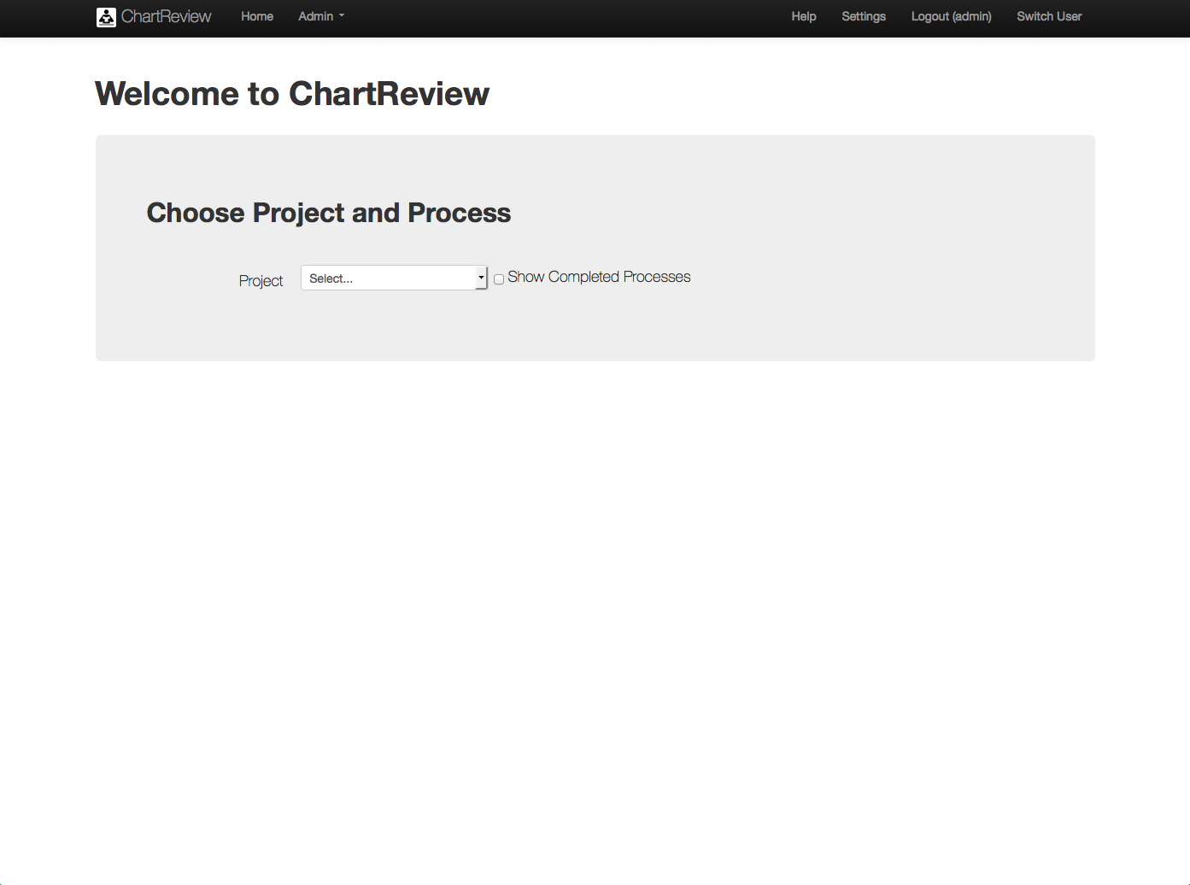

This table lists the features that can be access from the main Chart Review toolbar:

Table : Chart Review Main Toolbar

|  |  |
| --- | --- |
| Item/Action | Description/Result |
| ChartReview | Takes you to this home page again. |
| Home | Takes you to this home page again. |
| Admin -> Clinical Element Configurations | Takes you to the pages that allow definition of the various chart information views that will be available to view and annotate during chart review, for example, labs, notes, radiology reports, problems, medications, etc. |
| Admin -> Projects | Takes you to the pages that allow definition of a project, its processes, tasks, and database mappings, etc. |
| Admin -> Reports | Takes you to the pages that allow perusal of analytical reports about various aspects of the projects, including task completion, annotations made, inter-annotator agreement, etc. |
| Admin -> Schemas | Takes you to the pages that allow definition of classifications, class attributes, and class relationships that will be available to annotate the chart with for a each annotation workflow process task. |
| Admin -> Failed Jobs | Takes you to a list of failed workflow processes.  Macintosh HD:Users:bradadams:Desktop:Info.pngNote that different annotators may be participating in different annotation workflows simultaneously. |
| Admin -> Processes | Takes you to the pages that allow upload and definition of process pre-defined process templates that may be used in creating process instances for a given project. |
| Admin -> Tools and Utilities | Takes you to the pages that provide tools and utilities to, for example, kill processes, or view API documentation. |
| Admin -> Users | Takes you to the pages that allow user definition and maintenance. |
| Admin -> About | Takes you to the pages that show information about the application, its version, structure, dependencies, and components. |
| Admin -> Log Level | Takes you to the pages that allow control over the various levels of system logging available. |
| Admin – Performance Monitoring | Takes you to the pages that show performance monitoring analytics about the Chart Review system itself. |
| Help | Takes you to the help pages. |
| Settings | Takes you to the pages that allow system settings, for example, changing the current user’s password. |
| Logout (username) | Logs you out and takes you to the login screen. |
| Switch User | Takes you to the pages that allow switching between users without changing your database connection permissions. |

## Setting up your Browser for Chart Review

Chart Review us available on the Firefox browser only, version 30+.

### General Setup

Access to the server may take several seconds, or more, depending upon the underlying database schema and the queries defined in the project processes. Because of this, the browser java script timeout default needs to be set to infinity, to not timeout the scripts. This is done in the Firefox configuration screens by setting max_script_run to zero.

1) In the address area of Firefox, type the following:

About:config

2) In the search area, type the following:

Max_script_run

Double click on the value of this variable, and set it to zero.

### Single Sign On (SSO) Setup

See the User Guide for Single Sign On to setup single sign for the VINCI environment. Information in that document contains VA confidential environment information, so it is not include in this document.

# Admin

## Overview

The Admin pages in Chart Review allow a project administrator to set an annotation project, including: define clinical elements, annotation schemas, and annotation process templates and workflows. It also provides system administration functions such as user management, failure reports, database utilities, logging control and performance monitoring.

## Project Clinical Element Configurations (User/Admin)

The Clinical Element Configuration item in the Admin drop down menu takes you to the pages that allow definition of the various chart information views that will be available to view and annotate during chart review, for example, labs, notes, radiology reports, problems, medications, etc. Chart Review gives complete control to a project administrator over defining what the clinical elements are, what data they contain, how they are mapped from a data source, and how they will be viewed during chart review. While these configurations belong to a give project, a user that has permissions to multiple projects is able to copy (not share) configurations between those projects, in the event that data sources and configurations are similar between projects.

Figure . Admin – Project Clinical Element Configurations

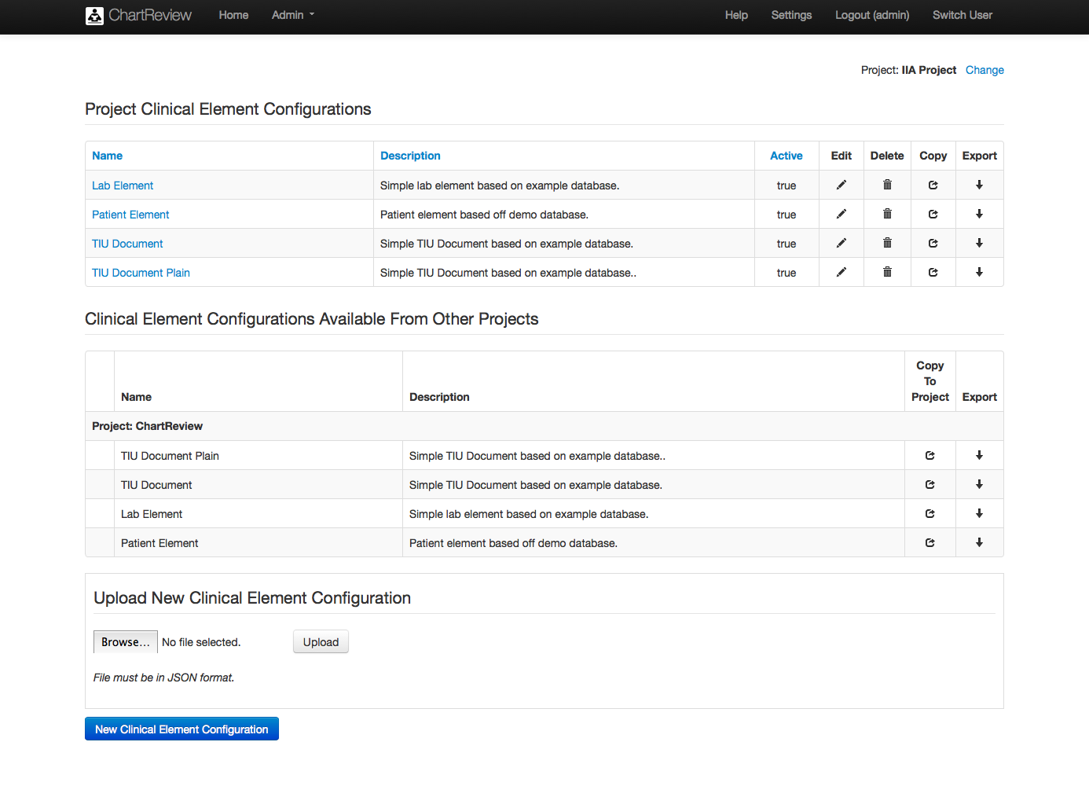

Table : Admin – Project Clinical Element Configuration List

|  |  |
| --- | --- |
| Item/Action | Description/Result |
| New Clinical Element Configuration | Creates a new clinical element configuration and takes you to the clinical element configuration editor. |
| Project Clinical Element Configurations | This section contains all configurations that belong to this project. |
| Change | Allows you to change which project’s clinical element configurations are listed. |
| Name link | Sorts table by project clinical element configuration name. |
| Name | The name of each clinical element configuration owned by the specified project. |
| List item name | Shows the selected clinical element. |
| Description link | Sorts table by project clinical element configuration name. |
| Description | A brief description of the clinical element configuration. |
| Active link | Sorts table by project clinical element configuration active status. |
| Active | Indicates if the user can choose this configuration when defining a process. As configurations age, they will be “turned off”. |
| Edit | Edits the specified configuration. |
| Delete | Deletes the specified configuration. |
| Copy | Copies the specified configuration. |
| Export | Exports the specified configuration to JSON in a separate tab. |
| Clinical Element Configurations Available From Other Projects | This section contains all configurations that belong to projects that the user has access to. |
| Name | The name of each clinical element configuration belonging to a project the user has access to. |
| Description | A brief description of the clinical element configuration. |
| Copy To Project | Copies the specified configuration into the current project. |
| Export | Exports the specified configuration to a JSON in a separate tab. |
| Upload New Clinical Element Configuration | Allows the user upload of a configuration specified in a JSON file. |
| Browse | Find the file in the local browser’s file system. |
| Upload | Upload the configuration. |

Figure . Admin – Show Clinical Element Configuration – General Configuration

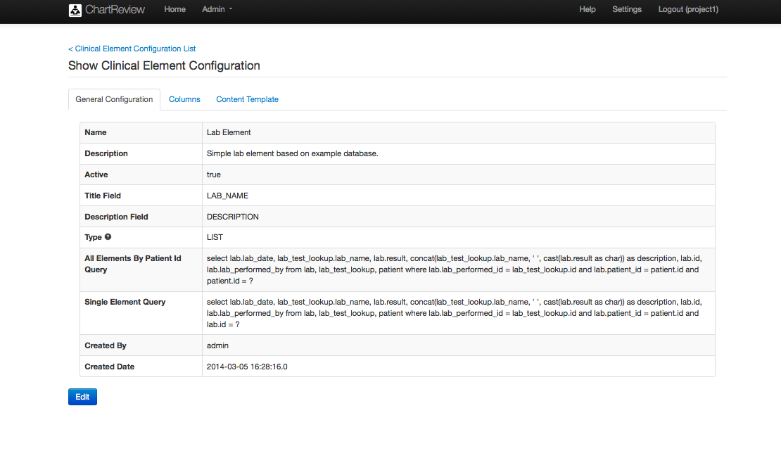

Table : Admin – Show Clinical Element Configuration – General Configuration

|  |  |
| --- | --- |
| Item/Action | Description/Result |
| Name | Name of the configuration. |
| Description | Simple description of the configuration. |
| Active | Indicates if the user can choose this configuration when defining a process. As configurations age, they will be “turned off”. |
| Title Field | The database field that is the title of this configuration. |
| Description Field | The database field that is the description of this configuration. |
| Type | The type of this clinical element configuration. Summary is one record per primary clinical element (patient), list is multiple records per principal clinical element (patient). |
| All Elements By Patient Id Query | Queries all context clinical elements by the principal clinical element id (i.e the patient id). For example, this query could return all elements of this type that belong to a given patient (plus any other desired criteria).  This SQL queries a project database. |
| Single Element Query | Queries a single clinical element of this type. The goal of this query is to return a single record by specifying any criteria in the where clause that are needed to identify the record uniquely. The criteria may include the relationship to the principal clinical element (i.e. the patient), but does not have to. The record id alone could be the only criteria, in the most simple case.  This SQL queries a project database. |
| Created By | The user that created the configuration. |
| Created Date | The date that the configuration was created. |

Figure . Admin – Show Clinical Element Configuration – General Configuration – Edit

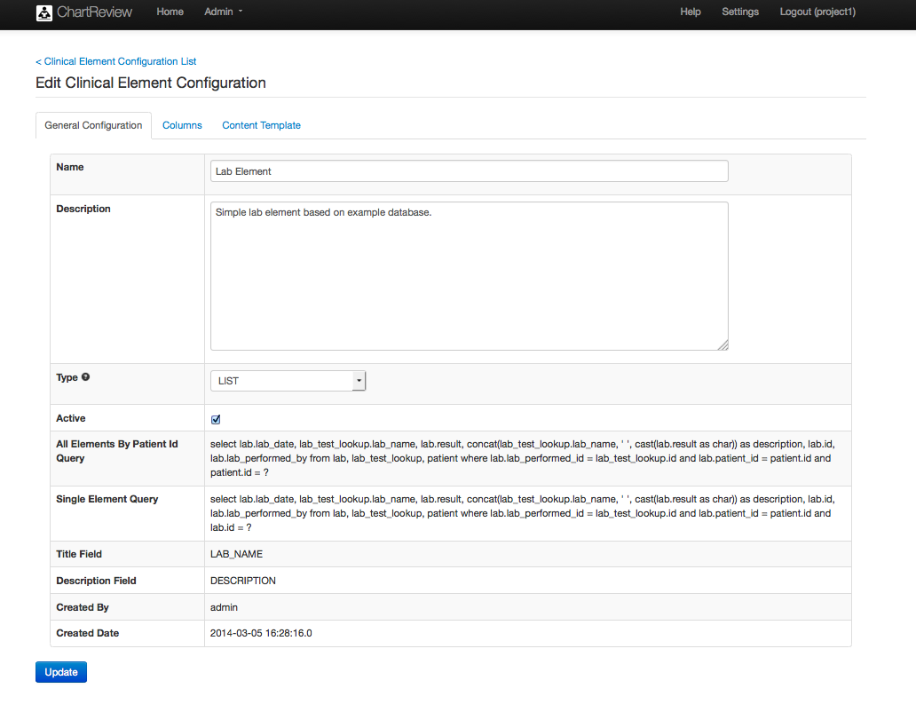

Table : Admin – Show Clinical Element Configuration – General Configuration - Edit

|  |  |
| --- | --- |
| Item/Action | Description/Result |
| Name | Name of the configuration. |
| Description | Simple description of the configuration. |
| Type | LIST – The clinical element view shows a list of clinical element items (like note documents), with a detail section that is displayed when an item is selected.  SUMMARY – The clinical element view shows only a summary of the clinical element item(s) (like an overview of a patient’s demographic information, or a graph of all labs through time). |
| Active | Indicates if the user can choose this configuration when defining a process. As configurations age, they will be “turned off”. |
| All Elements By Patient Id Query | Queries all context clinical elements by the principal clinical element id (i.e the patient id). For example, this query could return all elements of this type that belong to a given patient (plus any other desired criteria).  This SQL queries a project database. |
| Single Element Query | Queries a single clinical element of this type. The goal of this query is to return a single record by specifying any criteria in the where clause that are needed to identify the record uniquely. The criteria may include the relationship to the principal clinical element (i.e. the patient), but does not have to. The record id alone could be the only criteria, in the most simple case.  This SQL queries a project database. |
| Title Field | The database field that is the title of this configuration. |
| Description Field | The database field that is the description of this configuration. |
| Created By | The user that created the configuration. |
| Created Date | The date that the configuration was created. |
| Update | Saves the edits to the configuration. |

Figure . Admin – Show Clinical Element Configuration – Columns

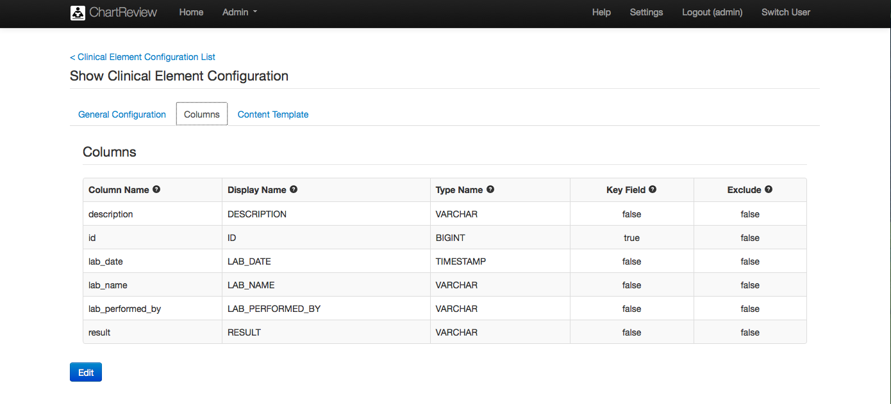

Table : Admin – Show Clinical Element Configuration – Columns

|  |  |
| --- | --- |
| Item/Action | Description/Result |
| Column Name | The column name from the result set |
| Display Name | The name that will be presented as the name of the clinical element view during chart review. |
| Type Name | The database type for the column. |
| Key Field | Key fields in the database should be true. Others, false. |
| Exclude | Excluded fields are not visible in the item grid during chart review, but are used as part of the detail content template. |
| Update | Saves the edits to the configuration. |

Figure . Admin – Show Clinical Element Configuration – Content Template

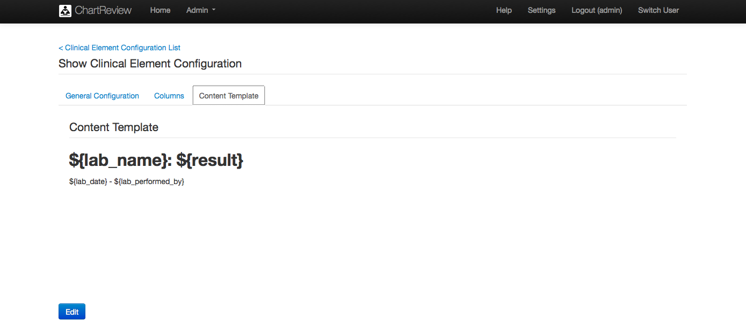

Table : Admin – Show Clinical Element Configuration – Content Template

|  |  |
| --- | --- |
| Item/Action | Description/Result |
| Content Template | The content template is a definition of the format of the detail display of the selected clinical element item during chart review. Database fields are specified as ${field_name}. Other characters are displayed in the detail view as-is. Style can be added to the content by applying it to the template, including the database fields. |

Figure . Admin – Create Clinical Element Configuration – Step 1 – Define Test Connection and Queries

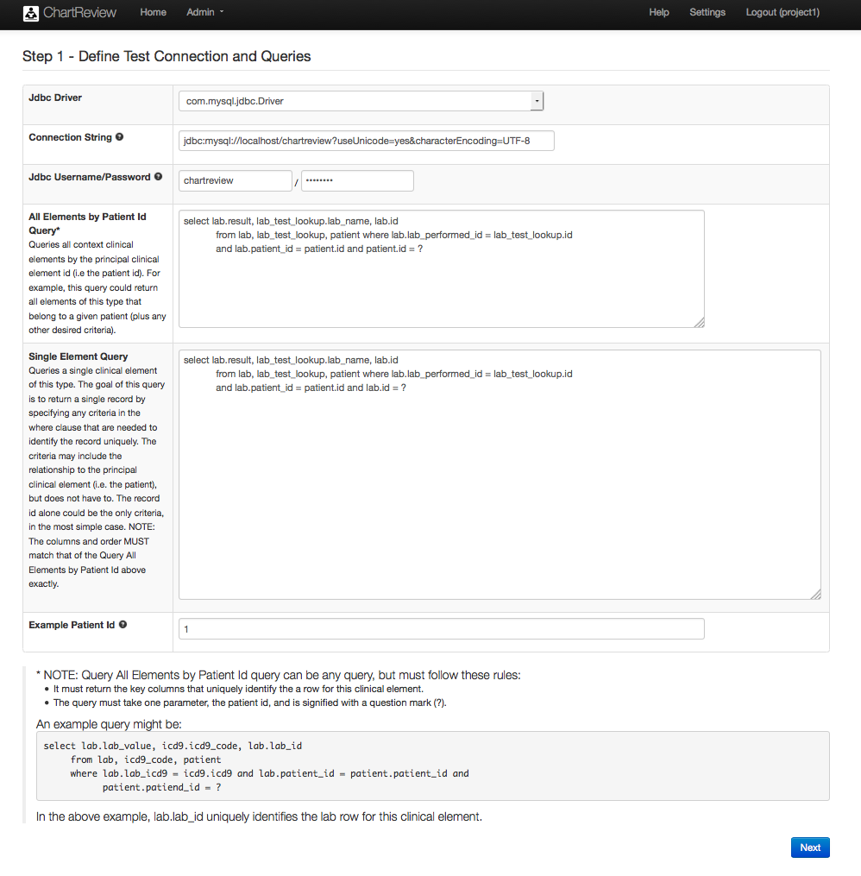

Table : Admin – Create Clinical Element Configuration – Step 1 – Define Test Connection and Queries

|  |  |
| --- | --- |
| Item/Action | Description/Result |
| Jdbc Driver | The jdbc driver that will be used to connect to the database. |
| Connection String | Standard jdbc database connection string (i.e. jdbc:mysql://localhost/chartreview?useUniode=yes&characterEncoding=UTF-8) |
| Jdbc Username/Password | Username and passw0rd to connect to the databse with. If using integrated authentication, these can be left blank. |
| All Elements by Patient Id Query | Queries all context clinical elements by the principal clinical element id (i.e the patient id). For example, this query could return all elements of this type that belong to a given patient (plus any other desired criteria).  Macintosh HD:Users:bradadams:Desktop:Warning.pngNOTE: Query All Elements by Patient Id query can be any query, but must follow these rules:   * It must return the key columns that uniquely identify a row for this clinical element. * The query must take one parameter, the principal clinical element id (i.e. the patient id), and is signified with a question mark (?).   An example query might be:  select lab.lab_value, icd9.icd9_code, lab.lab_id from lab, icd9_code, patient where lab.lab_icd9 = icd9.icd9 and lab.patient_id = patient.patient_id and patient.patiend_id = ?  In the above example, lab.lab_id uniquely identifies the lab row for this clinical element. |
| Single Element Query | Queries a single clinical element of this type. The goal of this query is to return a single record by specifying any criteria in the where clause that are needed to identify the record uniquely. The criteria may include the relationship to the principal clinical element (i.e. the patient), but does not have to. The record id alone could be the only criteria, in the most simple case.  Macintosh HD:Users:bradadams:Desktop:Warning.pngNOTE: The columns and order MUST match that of the Query All Elements by Patient Id above exactly. |
| Example Patient Id | An example patient id for querying the database to get table metadata. |
| Next | Go to the next step in the Create Clinical Element Configuration wizard. |

Figure . Admin – Create Clinical Element Configuration – Step 2 – Data Set Column Definition & Other Metadata

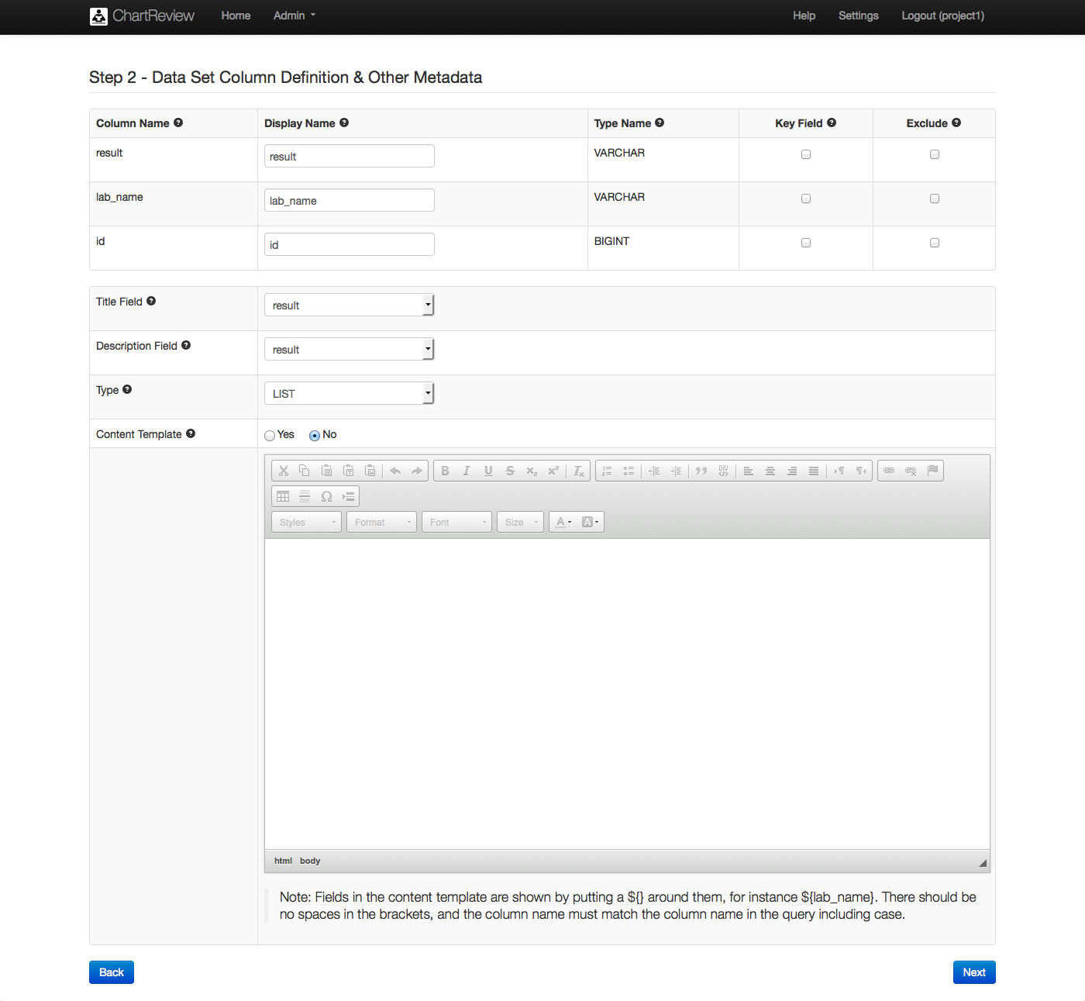

Table : Admin – Create Clinical Element Configuration – Step 2 – Data Set Column Definition & Other Metadata

|  |  |
| --- | --- |
| Item/Action | Description/Result |
| Column Name | The column name from the result set |
| Display Name | The name that will be presented as the name of the clinical element view during chart review. |
| Type Name | The database type for the column. |
| Key Field | Key fields in the database should be true. Others, false. |
| Exclude | Excluded fields are not visible in the item grid during chart review, but are used as part of the detail content template. |
| Title Field | The database field that is the title of this configuration. |
| Description Field | The database field that is the description of this configuration. |
| Type | LIST – The clinical element view shows a list of clinical element items (like note documents), with a detail section that is displayed when an item is selected.  SUMMARY – The clinical element view shows only a summary of the clinical element item(s) (like an overview of a patient’s demographic information, or a graph of all labs through time). |
| Content Template Toggle | Yes if this configuration has a content template, No otherwise.  A LIST type configuration usually has a content template that displays the detail of a clinical element record in a formatted document way. There may be cases where a LIST type configuration may just be displayed in a list, with no detailed, document view if a document view does not add any information that would not be seen in the columns of the clinical element grid in Chart Review, and if annotation never needed to occur on text within the detail. If there were no content template provided, an entire clinical element record could still be annotated as a whole within Chart Review.  A SUMMARY type configuration must have a content template. This template would display the only view available of the clinical element, because there will be no grid list of clinical element items displayed during Chart Review for a SUMMARY type clinical element configuration. |
| Content Template | The content template is a definition of the format of the detail display of the selected clinical element item during chart review. Database fields are specified as ${field_name}. Other characters are displayed in the detail view as-is. Style can be added to the content by applying it to the template, including the database fields. |
| Previous | Go to the previous step in the Create Clinical Element Configuration wizard. |
| Next | Go to the next step in the Create Clinical Element Configuration wizard. |

Figure . Admin – Create Clinical Element Configuration – Step 3 – Preview Output

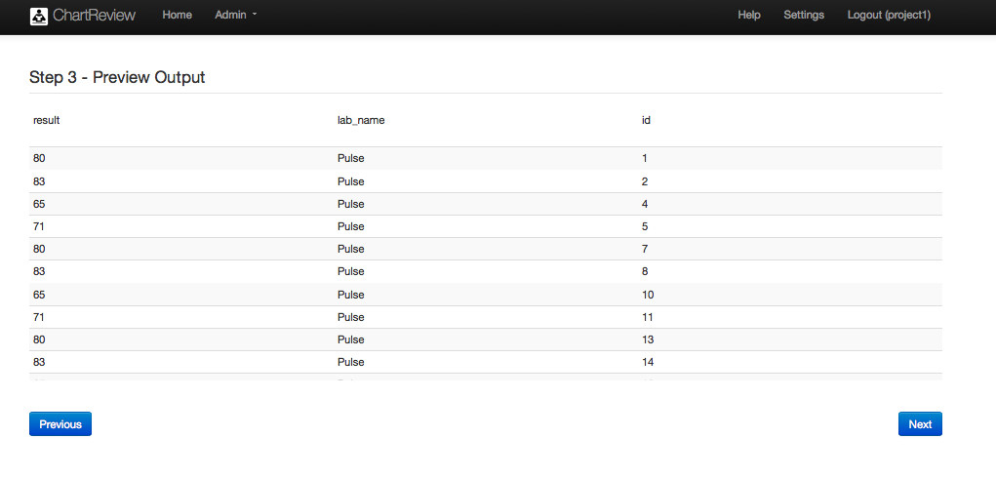

Table : Admin – Create Clinical Element Configuration – Step 3 – Preview Output

|  |  |
| --- | --- |
| Item/Action | Description/Result |
| Previous | Go to the previous step in the Create Clinical Element Configuration wizard. |
| Next | Go to the next step in the Create Clinical Element Configuration wizard. |

Figure . Admin – Create Clinical Element Configuration – Step 4 – Name and Description

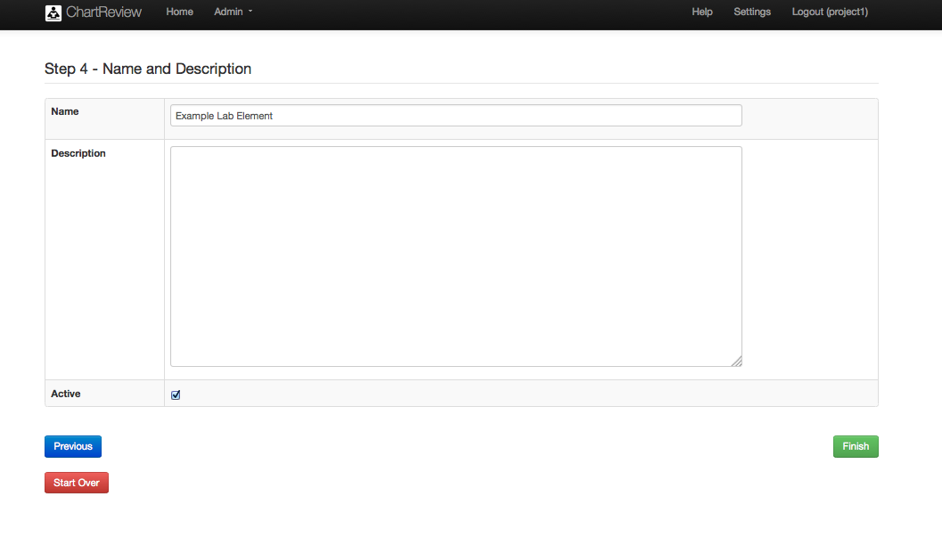

Table : Admin – Create Clinical Element Configuration – Step 4 – Name and Description

|  |  |
| --- | --- |
| Item/Action | Description/Result |
| Name | Name of the configuration. |
| Description | Simple description of the configuration. |
| Active | Indicates if the user can choose this configuration when defining a process. As configurations age, they will be “turned off”. |
| Previous | Go to the previous step in the Create Clinical Element Configuration wizard. |
| Next | Go to the next step in the Create Clinical Element Configuration wizard. |
| Start Over | Clear out all data from the wizard and start over defining the clinical element configuration. |

## Projects (User/Admin)

The Projects item in the Admin drop down menu takes you to the pages that allow you to define your projects, their processes, tasks, and database mappings, etc. First, an annotation project specifies a connection to a project database. This database will be used to pull clinical element information, the chart, notes, and records that are relevant to the planned chart review workflow. Next, a project has documents that describe the annotation work that is to be done on the project. These may be included as annotation task instructions that will be sent to an annotator that is assigned a task to perform. In addition, a project is associated with system users. While a project is owned by a particular user, other users can be assigned to a project with designated project roles which give them appropriate permissions on that project. Finally, a project defines the annotation process workflows that need to occur to get the work of annotation done on a project. These processes detail the tasks that need to be performed by the annotators, and which tasks require pre-annotations and how generated annotations will be grouped and used.

Project processes utilize pre-loaded process templates that give structure to the process and can be reused by multiple projects. In addition to a process templates, a library of annotation schemas is maintained at the system level, so that they may be reused in multiple projects.

Figure . Admin – Project List

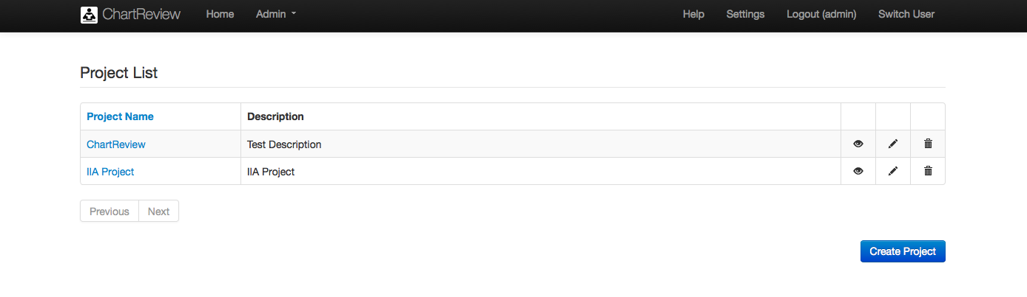

Table : Admin – Show Project – General Configuration

|  |  |
| --- | --- |
| Item/Action | Description/Result |
| Name Column | Sorts the table by project name. |
| Name link | Takes you to the pages that show the specified project. |
| Name | The name of the project |
| Description | A short description of the project. |
| View | Takes you to the pages show the specified project. |
| Edit | Takes you to the pages to edit the specified project. |
| Delete | Deletes the specified project. |
| Previous | Takes you to the previous page of projects. |
| Next | Takes you to the next page of projects. |
| Create Project | Creates a project and takes you to the pages to edit that project. |

Figure . Admin – Project – Show – General Configuration

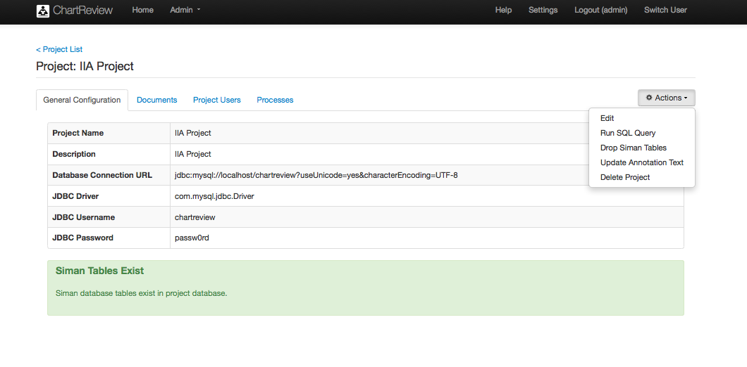

Table : Admin – Project – Show – General Configuration

|  |  |
| --- | --- |
| Item/Action | Description/Result |
| Project Name | The name of the project. |
| Description | A brief description of the project. |
| Database Connection URL | This is the jdbc connection string to the project database (i.e. jdbc:mysql://localhost/chartreview?useUnicode=yes&characterEncoding=UTF-8). |
| JDBC Driver | The jdbc driver used to connect to the project database (i.e. com.mysql.jdbc.Driver). |
| JDBC Username | Username to log into the project database. |
| JDBC Password | Password to log into the project database. |
| Edit | Takes you to the pages to edit the specified project. |
| Run SQL Query | Takes you to the page that allows you to run an SQL query against the project database. |
| Drop Siman Tables | Drops the Siman tables from the project database. |
| Update Annotation Text | Annotations save a copy of the text that was spanned with than annotation swipe, as well as the start and end offsets of that span. This utility function refreshes the copy of the spanned text in all annotations in the project by querying the original documents with the annotation span anew. This action may be used if annotations are imported that do not save spanned text, for example. |
| Delete Project | Deletes the entire project! |
| Siman Tables Exist | Siman tables exist in the project database – no action required. |
| Siman Tables Do Not Exist | Chart Review requires that Siman tables exist in the project database. Siman tables hold annotation information and are a standard integration framework for sharing annotations with other systems like UIMA NLP Pipelines and CHEX annotation validation. |
| Create Siman Tables | Creates the Siman tables in the project database. |

Figure . Admin – Project – Show – Documents

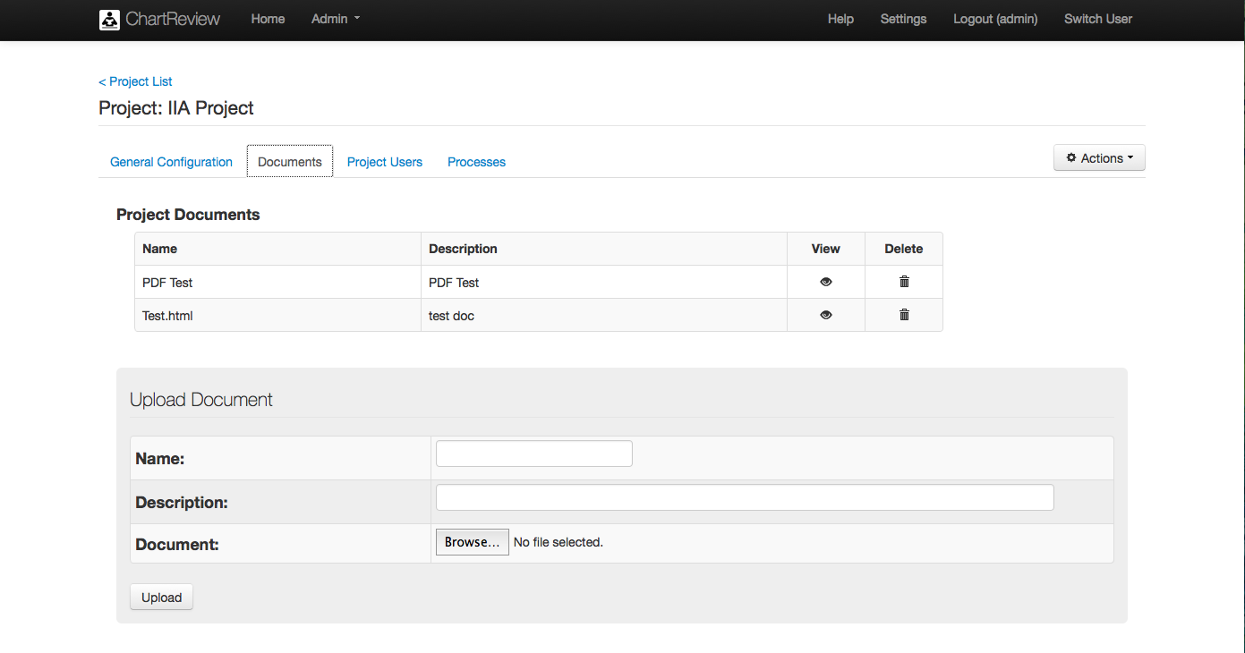

Table : Admin – Project – Show – Documents

|  |  |
| --- | --- |
| Item/Action | Description/Result |
| Name | The name of the documents that are associated with the project. Project documents can be included in an annotation workflow process task to allow an annotator to better understand the annotation task given him. |
| Description | A brief description of the project document. |
| View | Opens a new browser tab to display the selected project document. |
| Delete | Deletes the project document from the project database. |
| Upload Document |  |
| Name | Name of the document to upload to the project. |
| Description | A brief description of the document that will be displayed during Chart Review to an annotator if this document is included as a task description. |
| Document | The document to upload. |
| Browse | Browse the local browser file system for a document to upload. |
| Upload | Uploads the document to the project database. |

Figure . Admin – Project – Show – Project Users

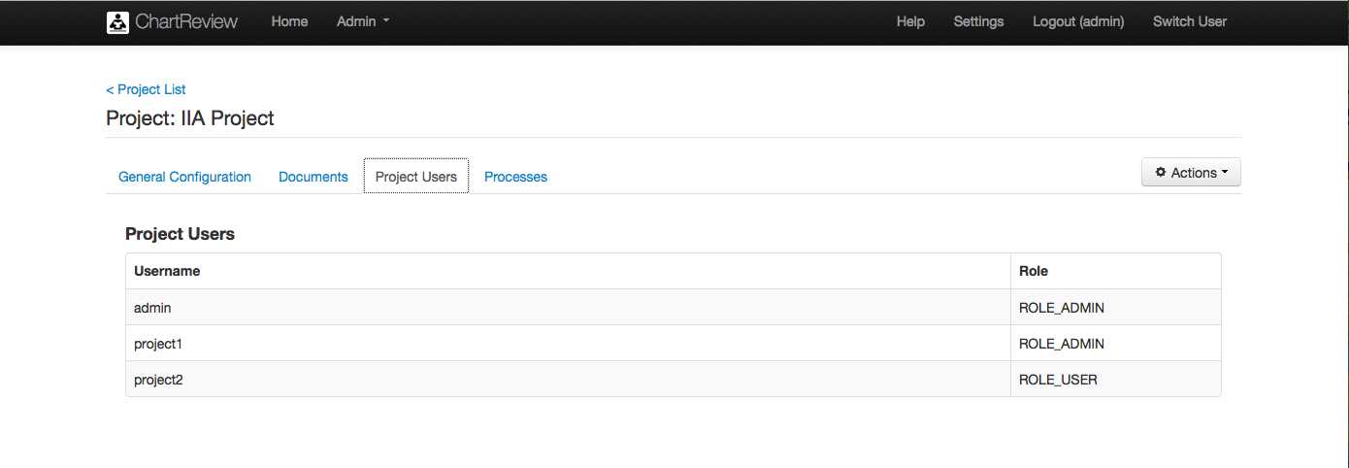

Table : Admin – Project – Show – Project Users

|  |  |
| --- | --- |
| Item/Action | Description/Result |
| Username | The name of a user that has a role in this project. |
| Role | The role of a user on this project (i.e. ROLE_ADMIN, ROLE_USER). |

Figure . Admin – Project – Show – Processes

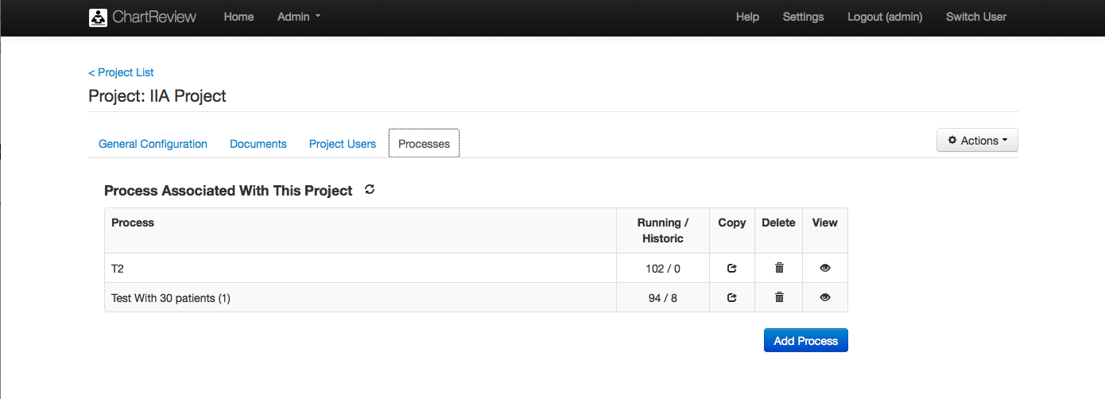

Table : Admin – Project – Show – Project Users

|  |  |
| --- | --- |
| Item/Action | Description/Result |
| Refresh | Refreshes the list of process of this project. |
| Process | The name of a user that has a role in this project. |
| Running/Historic | The role of a user on this project (i.e. ROLE_ADMIN, ROLE_USER). |
| Copy | Copies the specified process and takes you to the pages to edit that process. |
| Delete | Deletes the process! |
| View | Takes you to the pages to view the specified process. |
| Add Process | Adds a process to the project and takes you to the pages to edit that process. |

Figure . Admin – Project – Edit – General Configuration

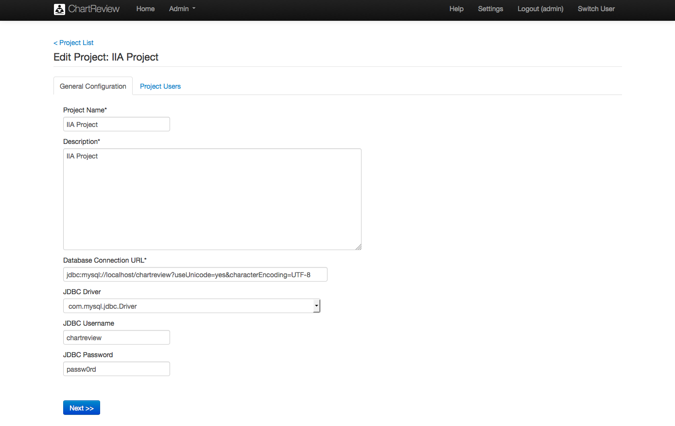

Table : Admin – Project – Edit – General Configuration

|  |  |
| --- | --- |
| Item/Action | Description/Result |
| Project Name | The name of the project. |
| Description | A brief description of the project. |
| Database Connection URL | This is the jdbc connection string to the project database (i.e. jdbc:mysql://localhost/chartreview?useUnicode=yes&characterEncoding=UTF-8). |
| JDBC Driver | The jdbc driver used to connect to the project database (i.e. com.mysql.jdbc.Driver). |
| JDBC Username | Username to log into the project database. |
| JDBC Password | Password to log into the project database. |
| Next | Takes you to the Project Users tab in the project editor. |

Figure . Admin – Project – Edit - Project Users

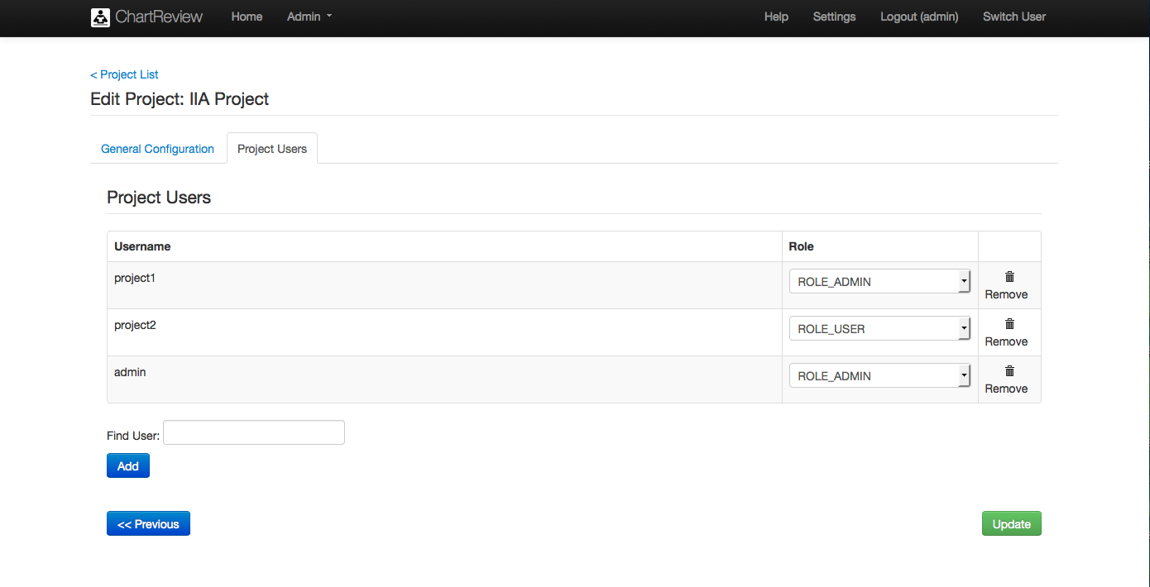

Table : Admin – Project – Edit – Project Users

|  |  |
| --- | --- |
| Item/Action | Description/Result |
| Username | The name of a user that has a role in this project. |
| Role | The role of a user on this project (i.e. ROLE_ADMIN, ROLE_USER). |
| Remove | Removes the user from the project. |
| Find User | Name of the user to find in the system. |
| Add | Adds username in the text field Find User as a user in the project.  Macintosh HD:Users:bradadams:Desktop:Warning.png Note: If the user is not a valid system user, an error message will be displayed. |
| Previous | Takes you to the General Configuration tab. |
| Update | Updates the project with the edited project values. |

Figure . Admin – Project – Add Process – Step 1 – Choose the Process to Add

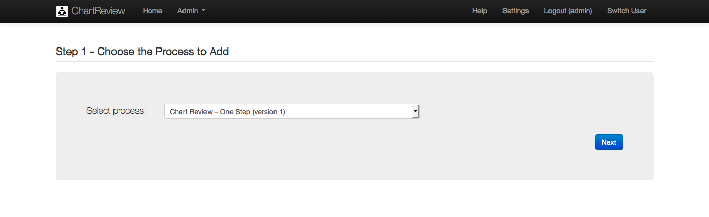

Table : Admin – Project – Add Process – Step 1 – Choose the Process to Add

|  |  |
| --- | --- |
| Item/Action | Description/Result |
| Select process | The process template type that the process will be modeled from. For example, a single step process or a multi-step process, etc. Process templates can be uploaded in the Admin -> Process menu. |
| Next | Takes you to the next step in the process creation wizard. |

Figure . Admin – Project – Add Process – Step 2 – Process Parameters

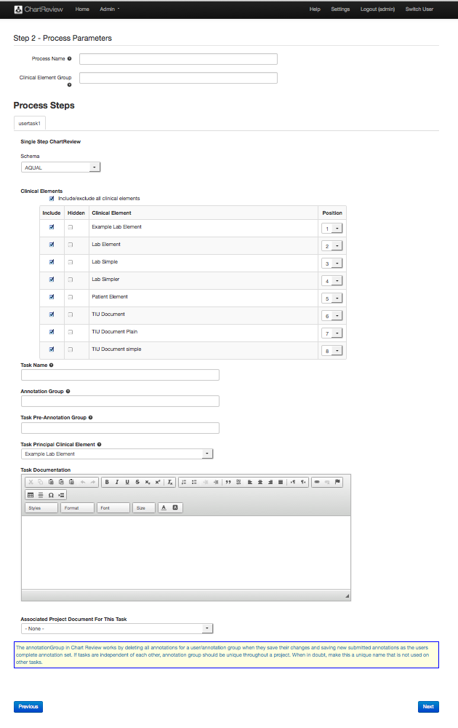

Table : Admin – Project – Add Process – Step 2 – Process Parameters

|  |  |
| --- | --- |
| Item/Action | Description/Result |
| Process Name | The name of the process that is presented in Chart Review |
| Clinical Element Group | This is an optional grouping that will keep all clinical elements grouped under a specified group. Generally this should be left blank. This essentially allows for multiple copies of the same clinical element “document”. Annotations created on one copy of a clinical element could never be seen on another copy of the clinical element, in, for example, a subsequent “downstream” process. |
| Process Steps | There will be one tab for each step (task) that is defined in the chosen process type workflow. |
| Schema | The annotation schema that an annotator will use during Chart Review to perform the annotation task required in this step of the annotation process workflow. Schemas are defined through the Admin -> Schema menu item. |
| Clinical Elements | The clinical elements that will be displayed as context to the principal clinical element displayed in Chart Review. The principal clinical element is the clinical element that the task is focused on, for example a patient is a common principal clinical element. Along with the principal clinical element, an annotator may need to see other contextual clinical information that would support the annotation of the principal clinical element. For example, to classify a patient for a given study, an annotator may need to see clinical notes, lab values, and radiology reports, but he may not need to see medication or problem lists.  Macintosh HD:Users:bradadams:Desktop:Info.pngNote that in Chart Review, context clinical elements may be annotated as well as the principal. |
| Include/exclude all clinical elements | A convenience toggle for including/excluding all listed clinical elements. |
| Include | If checked, the specified clinical element will be available to be displayed in Chart Review when an annotator performs this task. |
| Hidden | If checked, the specified clinical element will not be displayed automatically when an annotator initially retrieves this task. |
| Clinical Element | Name of the clinical element. |
| Position | The order in which the specified clinical element view will appear in Chart Review. For example, a clinical element with position 1 will appear in the top priority visual position in the application browser window layout. Positions do not have to be sequential: included clinical elements with positions of 1, 3, and 5 will be seen in the same order as if they had positions 1, 2, and 3. |
| Task Name | The name of the task that is presented in Chart Review |
| Annotation Group | Annotations created for this task will be stored with this annotation group. Annotations may be included in downstream process tasks as pre-annotations by specifying this annotation group as the Task Pre-Annotation Group of the subsequent process task. |
| Task Pre-Annotation Group | The annotation group to load as pre-annotations to this task. If there are multiple pre-annotation groups, separate them with a SEMI-COLON AND NO SPACES. For example: group1;group2;group3. |
| Task Principal Clinical Element | Usually this is the patient clinical element. More generally, this is the clinical element for which a task is created. The purpose of the task is to present for annotation this clinical element. All other clinical element information is contextual to performing the task on this clinical element. |
| Task Documentation | A description of what needs to be done to accomplish this task. The target audience is an annotator. This description is displayed in the Chart Review task panel. If this description is long or needs graphics, consider uploading a document to the project (Admin -> Project -> Documents) and selecting that document in Associated Project Document For This Task below. |
| Associated Project Document For This Task | A project document that describes what needs to be done to accomplish this task. The target audience is an annotator. |
| Previous | Takes you to the previous page in the Create Process wizard. |
| Next | Takes you to the next step in the Create Process wizard. |

Figure . Admin – Project – Add Process – Step 3 – Users and Clinical Elements In This Process

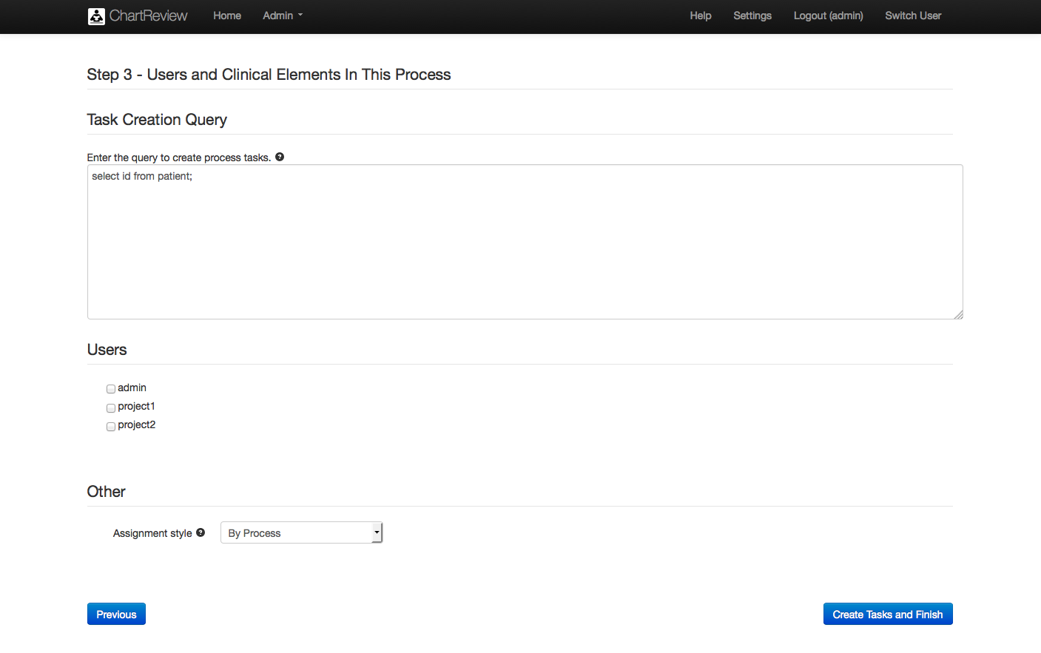

Table : Admin – Project – Add Process – Step 3 – Users and Clinical Elements In This Process

|  |  |
| --- | --- |
| Item/Action | Description/Result |
| Task Creation Query | Query to select a list of principal clinical element ids (i.e. patient ids). A task is created for each clinical element id returned. |
| Users | Select all users that could perform this task. Users may be added to a project in Admin -> Project. |
| Other |  |
| Assignment Style | When an annotator gets a new assignment in Chart Review, an assignment style of BY PROCESS dedicates all tasks in a process to the annotator. That annotator must complete all tasks in the assigned process. An assignment style of BY TASK dedicates only one task to the annotator. Other tasks in the process may be completed by other annotators, or by this annotator, whoever is available first. |
| Previous | Takes you to the previous page of the Create Process wizard. |
| Create Tasks and Finish | Saves the process information and creates all tasks for the process. These tasks are saved in a queue waiting for an annotator to get a new assignment in Chart Review. |

Figure . Admin – Project – Run SQL Query

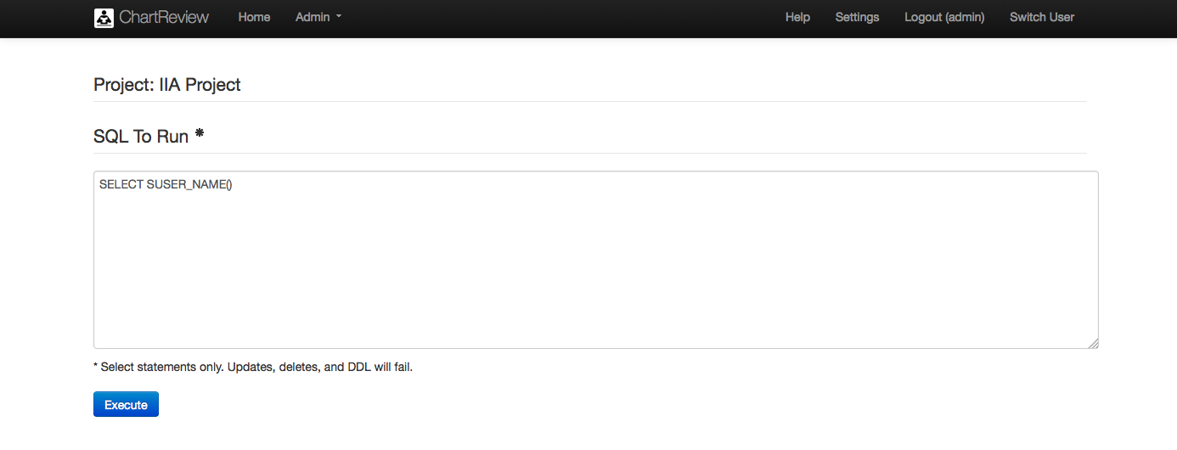

Table : Admin – Project – Run SQL Query

|  |  |
| --- | --- |
| Item/Action | Description/Result |
| SQL To Run | Any select statement to run against the project database. This is a convenience feature, allowing discovery of project database data that may be needed for project definition, management, or maintenance.  Macintosh HD:Users:bradadams:Desktop:Warning.pngNote: Updates and deletes and DDL with fail. |
| Execute | Execute the query |

## Reports (User/Admin)

The Reports item in the Admin drop down menu takes you to pages that allow perusal of analytical reports about various aspects of any of your projects, including task completion, annotations made, inter-annotator agreement, etc.

Figure . Admin – Chose Project and Processes For Reports

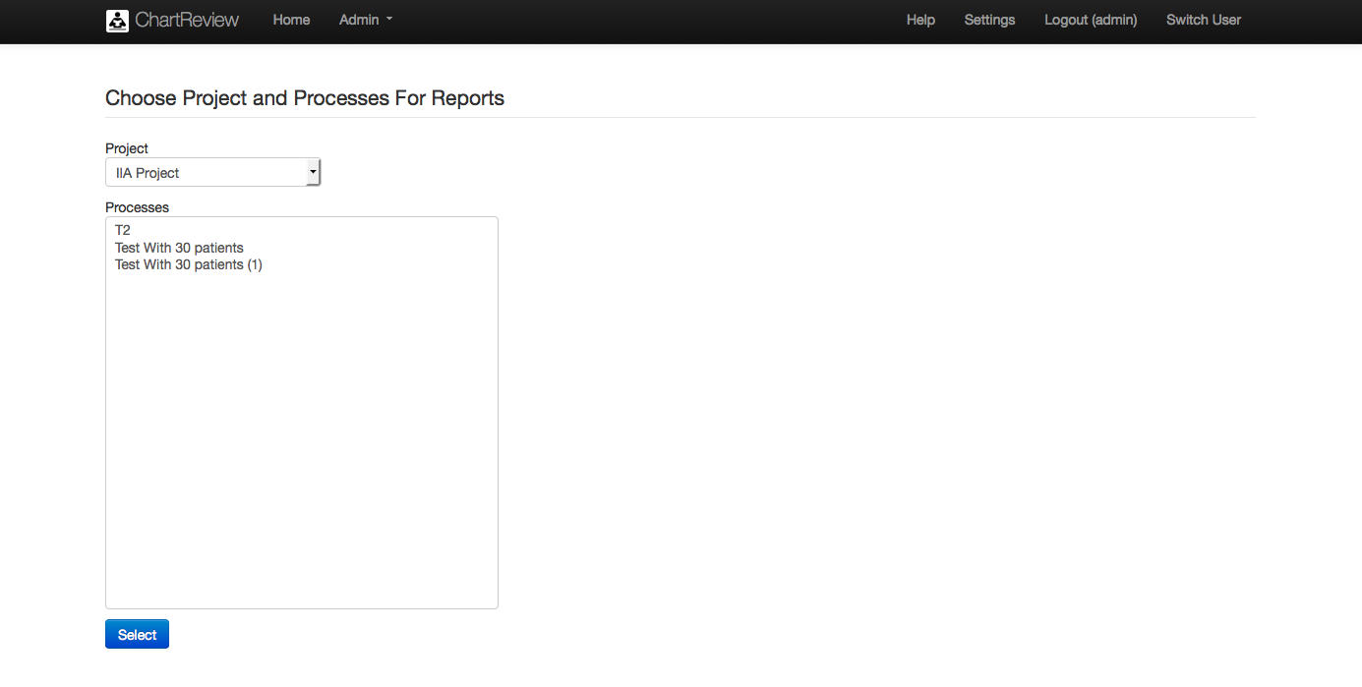

Table : Admin – Chose Project and Processes For Reports

|  |  |
| --- | --- |
| Item/Action | Description/Result |
| Project | The project to be reported on. |
| Processes | The processes of the project to be reported on. |
| Select | Sets the project and processes for which reports from the report page will be given. |

Figure . Admin – Reports

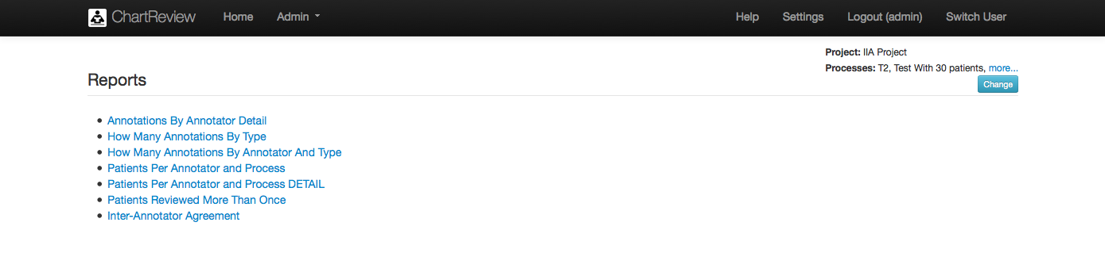

Table : Admin – Reports

|  |  |
| --- | --- |
| Item/Action | Description/Result |
| More… | Takes you to a popup displaying the project name and a list of all processes in that project. |
| Change | Takes you back to the Choose Project and Processes For Reports page to pick another project and processes to report on. |
| Back to reports | Takes you back to the list of reports available. |
| How Many Annotations By Type | A report of how many annotations were created for each classification found in the process task schemas. |
| How Many Annotations By Annotator And Type | A report of how many annotations were created for each classification found in the process task schemas, listed by which annotator created the annotations. |
| Patients Per Annotator and Process | A report of how many patients were annotated by each annotator for each process. |
| Patients Per Annotator and Process Detail | A report of which principal clinical elements (i.e. patients) that were annotated by which annotators for the process tasks. |
| Patients Reviewed by More Than One Annotator | A report of how many times each principal clinical element (i.e. patient) has been reviewed by an annotator. |
| Inter-Annotator Agreement | A report of inter annotator agreement using a Fleiss’ kappa by principal clinical element (i.e. patient), by classification, by annotator. |

Figure . Admin – Report – Annotations Per Annotator Detail

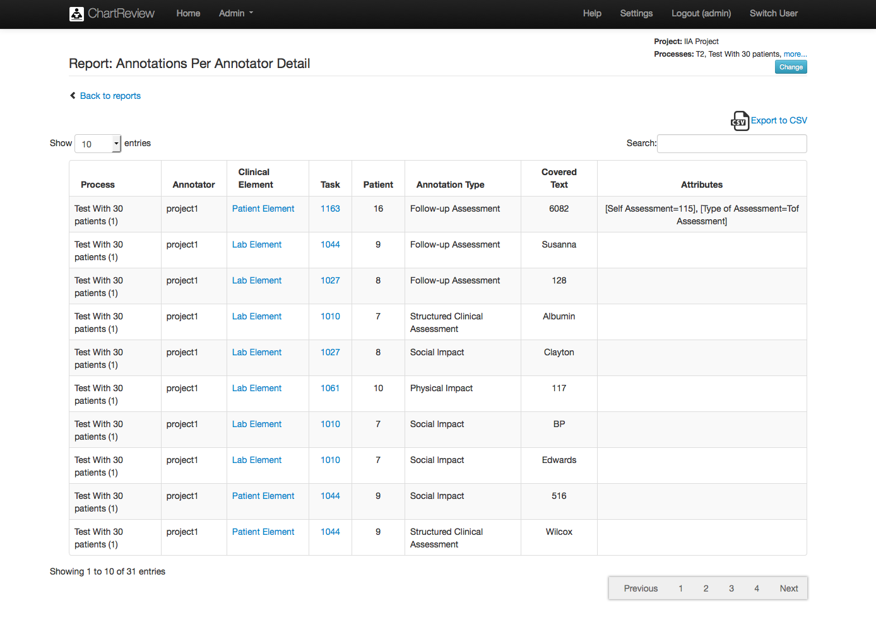

Table : Admin – Report – Annotations Per Annotator Detail

|  |  |
| --- | --- |
| Item/Action | Description/Result |
| More… | Takes you to a popup displaying the project name and a list of all processes in that project. |
| Change | Takes you back to the Choose Project and Processes For Reports page to pick another project and processes to report on. |
| Back to reports | Takes you back to the list of reports available. |
| Export to CSV | Opens the report in Microsoft Excel or saves a CSV to the local file system. |
| Show N entries | The number of rows to display per page. |
| Search | Filters the list by the given string (word/partial word).  Macintosh HD:Users:bradadams:Desktop:Info.pngNote: The string can be found in any of the columns of the table. |
| Process | The process for which the report was generated. |
| Annotator | The annotator that created the annotation. |
| Clinical Element | The name of the clinical element configuration type of the clinical element of the annotation. Clicking on this name allows you to view the content of the clinical element that was annotated. |
| Task | The id of the task the annotation was created for. Clicking on this id takes you into Chart Review to review or change that completed task. |
| Patient | The principal clinical element (i.e patient) that was annotated. |
| Annotation Type | The classification from the project task annotation schemas of the annotation. |
| Covered Text | The clinical element content text that was highlighted by the annotation (if any). |
| Attributes | A list of the annotation features (name/value pairs). |
| Showing x to y of N entries | The current location of the page within the data. |
| Previous…Page Numbers…Next | Move between pages of the report. |

Figure . Admin – Report – Annotations Per Annotator Detail – Clinical Element

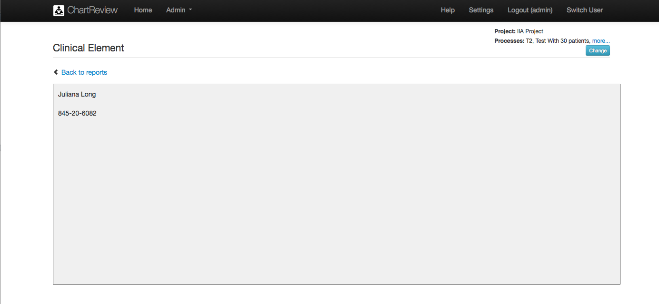

Table : Admin – Annotations Per Annotator Detail – Clinical Element

|  |  |
| --- | --- |
| Item/Action | Description/Result |
| More… | Takes you to a popup displaying the project name and a list of all processes in that project. |
| Change | Takes you back to the Choose Project and Processes For Reports page to pick another project and processes to report on. |
| Back to reports | Takes you back to the list of reports available. |
| Clinical Element Content | The content of the clinical element. |

Figure . Admin – Report – How Many Annotations By Type

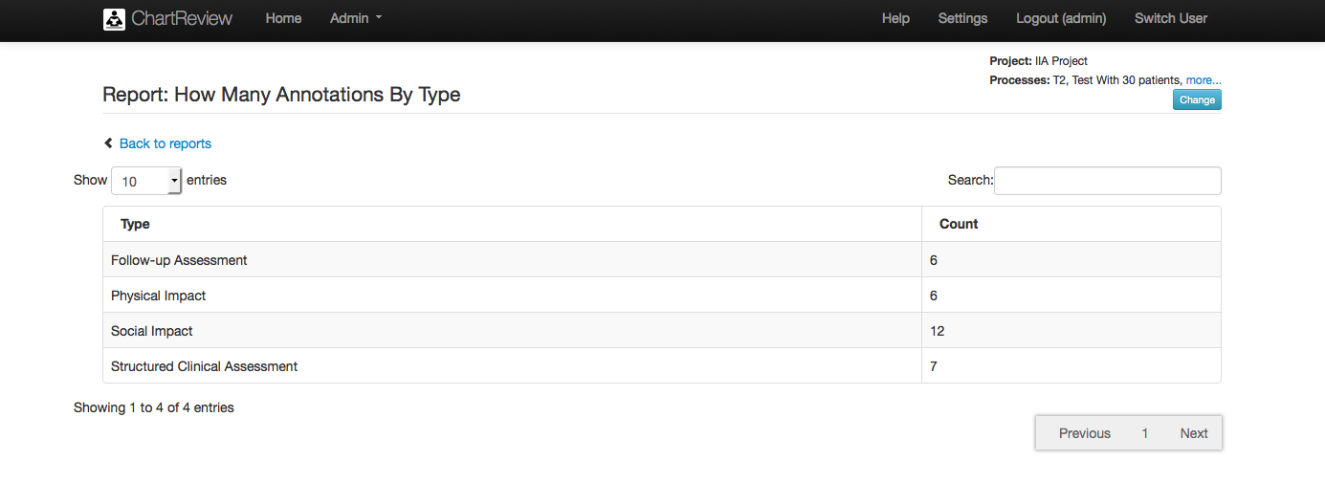

Table : Admin – Report – How Many Annotations By Type

|  |  |
| --- | --- |
| Item/Action | Description/Result |
| More… | Takes you to a popup displaying the project name and a list of all processes in that project. |
| Change | Takes you back to the Choose Project and Processes For Reports page to pick another project and processes to report on. |
| Back to reports | Takes you back to the list of reports available. |
| Export to CSV | Opens the report in Microsoft Excel or saves a CSV to the local file system. |
| Show N entries | The number of rows to display per page. |
| Search | Filters the list by the given string (word/partial word). Note: The string can be found in any of the columns of the table. |
| Type | The classification type of the annotations counted. |
| Count | The number of annotations of the given classification type. |
| Showing x to y of N entries | The current location of the page within the data. |
| Previous…Page Numbers…Next | Move between pages of the report. |

Figure . Admin – Report – How Many Annotations By Annotator And Type

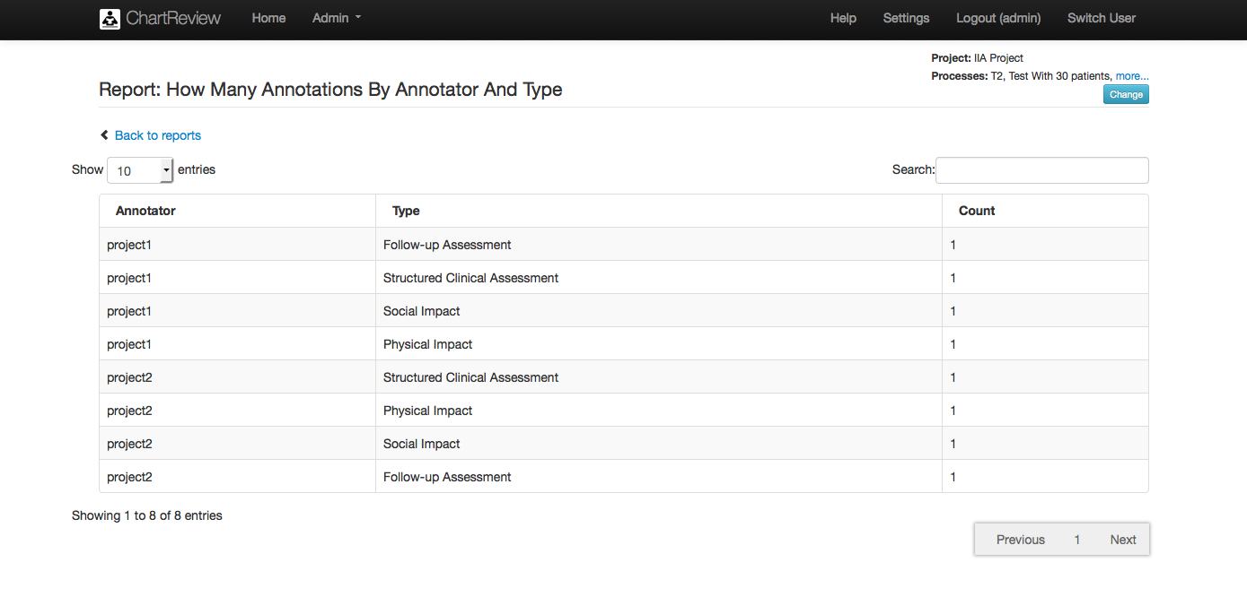

Table : Admin – Report – How Many Annotations By Annotator And Type

|  |  |
| --- | --- |
| Item/Action | Description/Result |
| More… | Takes you to a popup displaying the project name and a list of all processes in that project. |
| Change | Takes you back to the Choose Project and Processes For Reports page to pick another project and processes to report on. |
| Back to reports | Takes you back to the list of reports available. |
| Export to CSV | Opens the report in Microsoft Excel or saves a CSV to the local file system. |
| Show N entries | The number of rows to display per page. |
| Search | Filters the list by the given string (word/partial word).  Macintosh HD:Users:bradadams:Desktop:Info.png Note: The string can be found in any of the columns of the table. |
| Annotator | The annotator that created the annotations represented in the count by type. |
| Type | The classification type of the annotations counted. |
| Count | The number of annotations of the given classification type. |
| Showing x to y of N entries | The current location of the page within the data. |
| Previous…Page Numbers…Next | Move between pages of the report. |

Figure . Admin – Report – Patients Per Annotator and Process

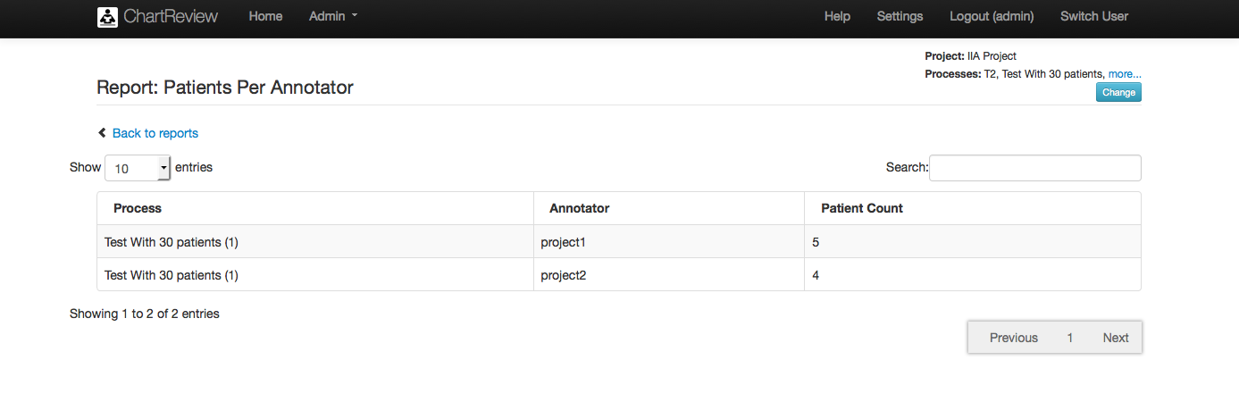

Table : Admin – Report – Patients Per Annotator and Process

|  |  |
| --- | --- |
| Item/Action | Description/Result |
| More… | Takes you to a popup displaying the project name and a list of all processes in that project. |
| Change | Takes you back to the Choose Project and Processes For Reports page to pick another project and processes to report on. |
| Back to reports | Takes you back to the list of reports available. |
| Export to CSV | Opens the report in Microsoft Excel or saves a CSV to the local file system. |
| Show N entries | The number of rows to display per page. |
| Search | Filters the list by the given string (word/partial word).  Macintosh HD:Users:bradadams:Desktop:Info.pngNote: The string can be found in any of the columns of the table. |
| Process | The process from which the patient count by annotator is found. |
| Annotator | The annotator that created the annotations represented in the count. |
| Patient Count | The number of annotations created by the given annotator for the given process. |
| Showing x to y of N entries | The current location of the page within the data. |
| Previous…Page Numbers…Next | Move between pages of the report. |

Figure . Admin – Report – Patients Per Annotator And Process DETAIL

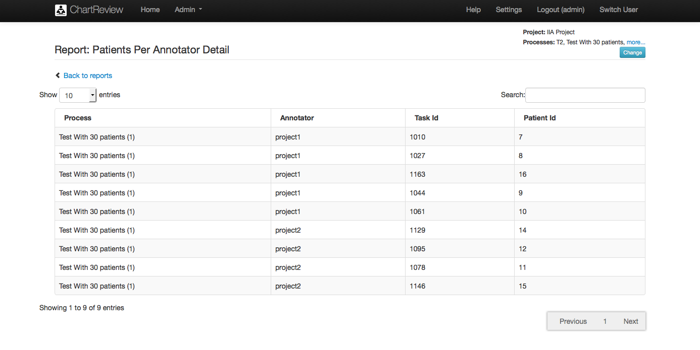

Table : Admin – Report – Patients Per Annotator and Process DETAIL

|  |  |
| --- | --- |
| Item/Action | Description/Result |
| More… | Takes you to a popup displaying the project name and a list of all processes in that project. |
| Change | Takes you back to the Choose Project and Processes For Reports page to pick another project and processes to report on. |
| Back to reports | Takes you back to the list of reports available. |
| Export to CSV | Opens the report in Microsoft Excel or saves a CSV to the local file system. |
| Show N entries | The number of rows to display per page. |
| Search | Filters the list by the given string (word/partial word).  Macintosh HD:Users:bradadams:Desktop:Info.pngNote: The string can be found in any of the columns of the table. |
| Process | The process from which the principal clinical element (i.e. patient) annotation task was performed. |
| Annotator | The annotator that performed the principal clinical element (i.e. patient) annotation task. |
| Task Id | The id of the annotation task from which the principal clinical element (i.e. patient) annotation task was performed. |
| Patient Id | The id of the principal clinical element (i.e. patient) on which the annotation task was performed. |
| Showing x to y of N entries | The current location of the page within the data. |
| Previous…Page Numbers…Next | Move between pages of the report. |

Figure . Admin – Report – Patients Reviewed More Than Once

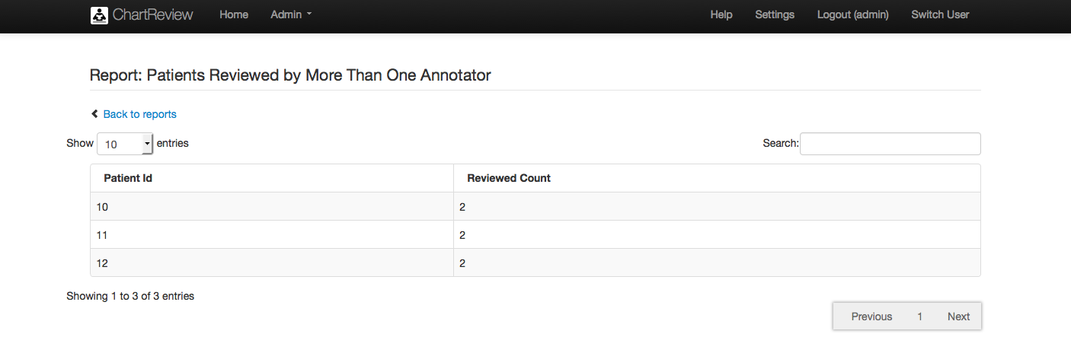

Table : Admin – Report – Patients Reviewed More Than Once

|  |  |
| --- | --- |
| Item/Action | Description/Result |
| More… | Takes you to a popup displaying the project name and a list of all processes in that project. |
| Change | Takes you back to the Choose Project and Processes For Reports page to pick another project and processes to report on. |
| Back to reports | Takes you back to the list of reports available. |
| Export to CSV | Opens the report in Microsoft Excel or saves a CSV to the local file system. |
| Show N entries | The number of rows to display per page. |
| Search | Filters the list by the given string (word/partial word).  Macintosh HD:Users:bradadams:Desktop:Info.pngNote: The string can be found in any of the columns of the table. |
| Patient Id | The principal clinical element (i.e. patient) that was reviewed more than once. |
| Reviewed Count | The count of times that the principal clinical element (i.e. patient) was reviewed. |
| Showing x to y of N entries | The current location of the page within the data. |
| Previous…Page Numbers…Next | Move between pages of the report. |

Figure . Admin – Report – Inter-Annotator Agreement – Original Report

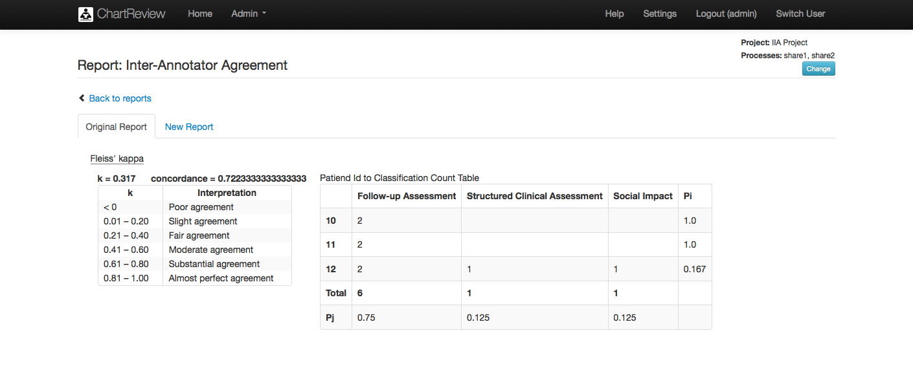

Table : Admin – Report – Inter-Annotator Agreement – Original Report

|  |  |
| --- | --- |
| Item/Action | Description/Result |
| More… | Takes you to a popup displaying the project name and a list of all processes in that project. |
| Change | Takes you back to the Choose Project and Processes For Reports page to pick another project and processes to report on. |
| Back to reports | Takes you back to the list of reports available. |
| k (Fleiss’ kappa) | A statistica measure for assessing the reliability of agreement between a fixed number of annotators when assigning categories to a number of patients. See: en.wikipedia.org/wiki/Fleiss’_kappa |
| concordence | The average of the Pi column. |
| Left column values | The principal clinical element ids (i.e. patient). |
| Top row values | Annotation schema categories of annotations. |
| Cell | Number of annotators annotating an annotation schema category. |

Figure . Admin – Report – Inter-Annotator Agreement – New Report

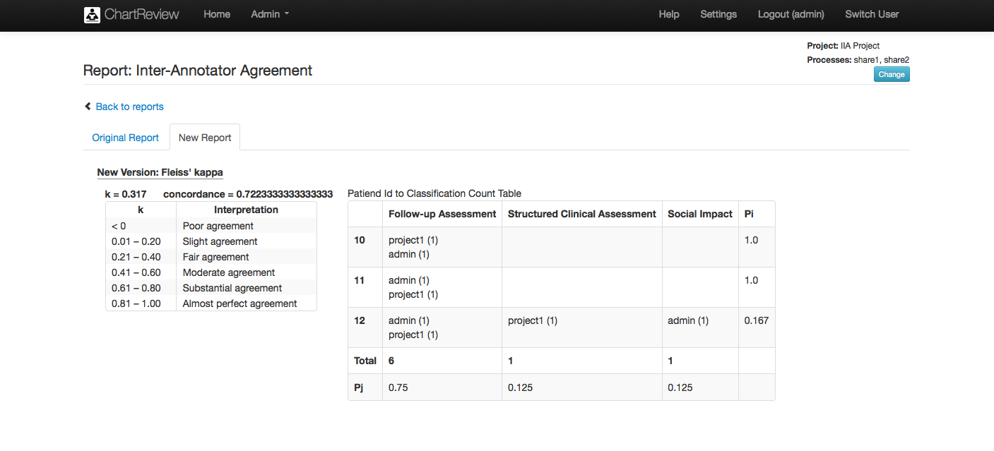

Table : Admin – Report – Inter-Annotator Agreement – New Report

|  |  |
| --- | --- |
| Item/Action | Description/Result |
| More… | Takes you to a popup displaying the project name and a list of all processes in that project. |
| Change | Takes you back to the Choose Project and Processes For Reports page to pick another project and processes to report on. |
| Back to reports | Takes you back to the list of reports available. |
| k (Fleiss’ kappa) | A statistica measure for assessing the reliability of agreement between a fixed number of annotators when assigning categories to a number of patients. See: en.wikipedia.org/wiki/Fleiss’_kappa |
| concordence | The average of the Pi column. |
| Left column values | The principal clinical element ids (i.e. patient). |
| Top row values | Annotation schema categories of annotations. |
| Cell | Number of annotators annotating an annotation schema category listed by annotator. |

## Schemas (User/Admin)

The Schemas item in the Admin drop down menu takes you to the pages that allow perusal and definition of a library of annotation schemas that is shared by all users and all projects. These annotation schemas define the classifications, and class attributes that will be used to perform the work of an annotation task.

Chart Review annotation schemas provide the following basic entities:

* Classifications
* Attributes (text, numeric, date, option list) – can be reused on classifications

Figure . Admin – Schema List

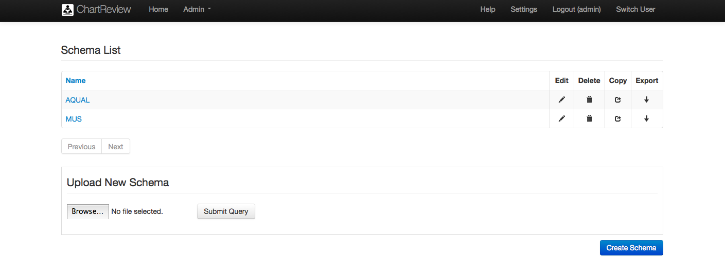

Table : Admin – Schema List

|  |  |
| --- | --- |
| Item/Action | Description/Result |
| Name Column | Sorts the schema list by schema name. |
| Name link | Takes you to the pages that edit the specified schema. |
| Name | The name of the schema. |
| Edit | Takes you to pages to edit the specified schema. |
| Delete | Deletes the specified schema! |
| Copy | Copes the specified schema and takes you to the pages to edit it. |
| Export | Opens a new tab in the browser and displays the specified schema in XML format. This format can be uploaded in another project or another Chart Review system deployment. |
| Previous…123…Next | Standard list paging mechanism. |
| Create Schema | Creates a schema and takes you to the pages to edit it. |
| Upload New Schema | Uploads a new schema from XML file to the database. |
| Browse | Brows the local browser file system for a schema file to upload. |
| Submit Query | Uploads the schema file. |

Figure . Admin – Schema – General Configuration

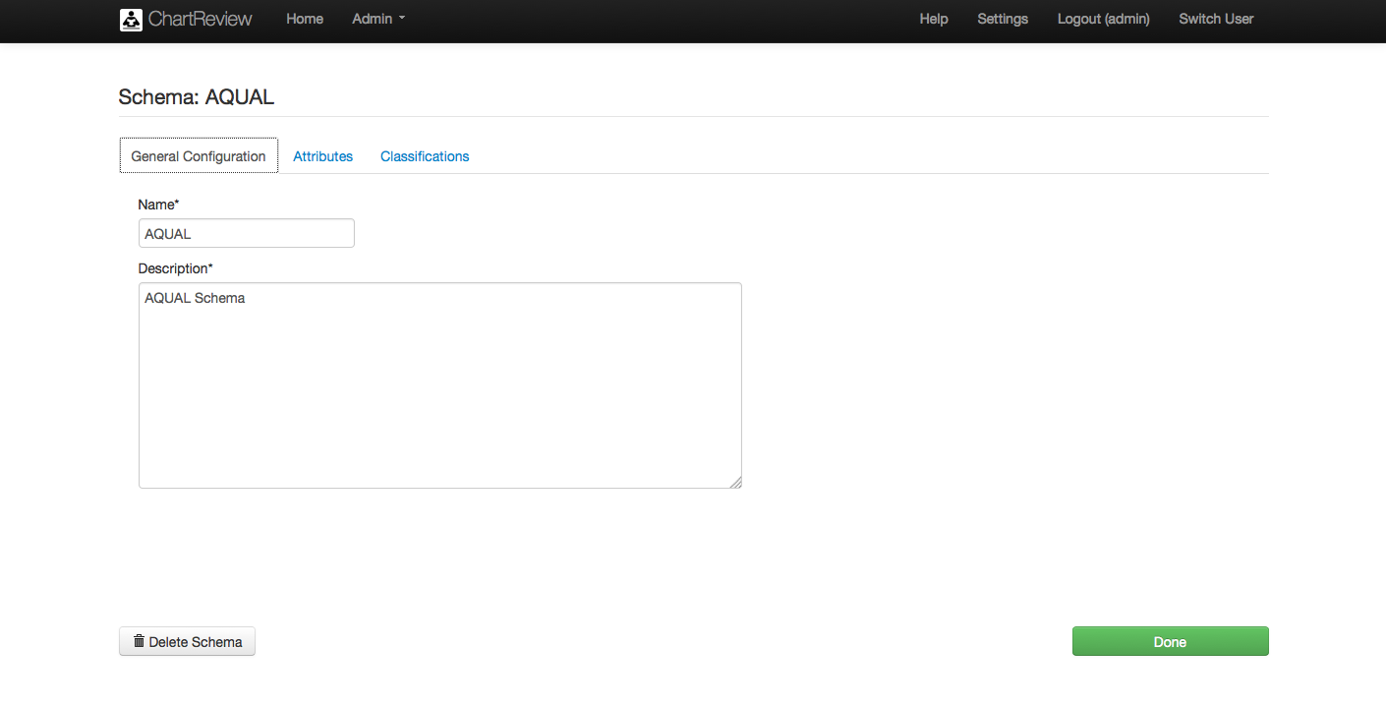

Table : Admin – Schema – General Configuration

|  |  |
| --- | --- |
| Item/Action | Description/Result |
| Name | The name of the schema. |
| Description | A brief description of the schema. |
| Delete Schema | Deletes the schema! |
| Done | Saves the changes to the schema and takes you to the Schema List page. |

Figure . Admin – Schema – Attributes

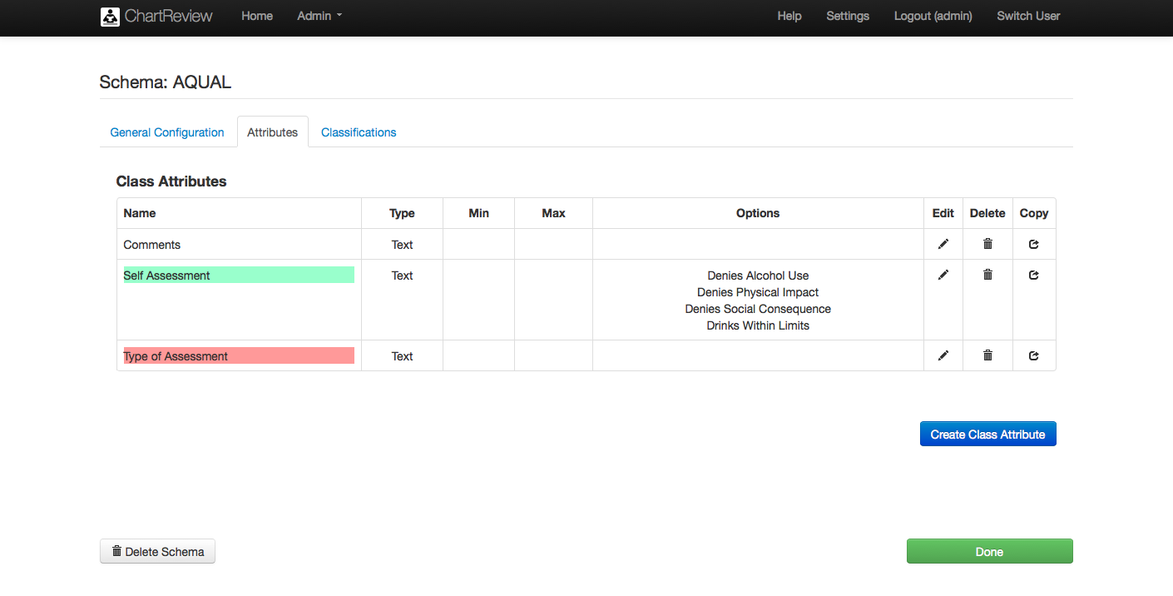

Table : Admin – Schema – Attributes

|  |  |
| --- | --- |
| Item/Action | Description/Result |
| Name | The name of the class attributes. |
| Type | The type of class attribute (i.e. Text/Numeric/Date/Options). |
| Min | The minimum valid numeric or date value. |
| Max | The maximum valid numeric or date value. |
| Options | The list of options for an option type class attribute. |
| Edit | Takes you to pages to edit the specified class attribute. |
| Delete | Deletes the specified class attribute! |
| Copy | Copes the specified class attribute and takes you to the pages to edit it. |
| Create Class Attribute | Creates a new class attribute and takes you to the pages to edit it. |
| Delete Schema | Deletes the schema! |
| Done | Saves the changes to the schema and takes you to the Schema List page. |

Figure . Admin – Schema – Attribute – Create/Edit

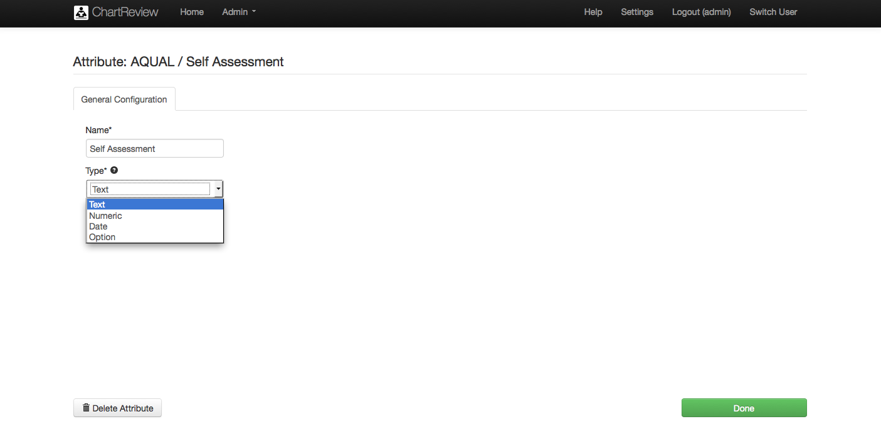

Table : Admin – Schema – Attribute – Create/Edit

|  |  |
| --- | --- |
| Item/Action | Description/Result |
| Name | The name of the class attribute. |
| Type | The type of the class attribute (i.e. Text/Numeric/Date/Option). An option attribute is presents a list of valid options from which to choose during Chart Review). |
| Delete Attribute | Deletes the attribute! |
| Done | Saves the changes to the attribute and takes you to the Create/Edit Schema page. |

Figure . Admin – Schema – Attribute – Create/Edit - Numeric

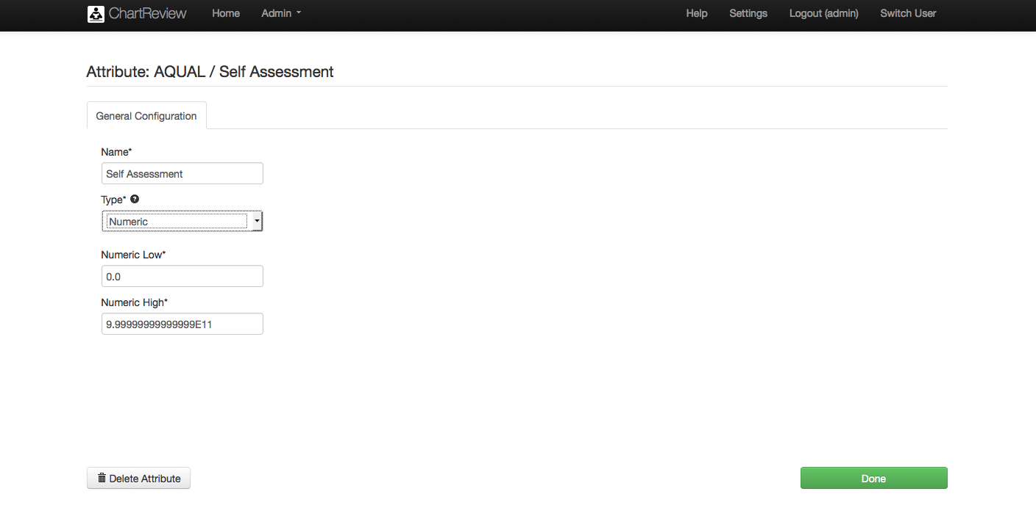

Table : Admin – Schema – Attribute – Create/Edit - Numeric

|  |  |
| --- | --- |
| Item/Action | Description/Result |
| Name | The name of the class attribute. |
| Type | When numeric type is chosen, Numeric Low and Numeric High fields appear to specify a valid numeric range for the attribute. |
| Numeric Low | The minimum valid numeric value. |
| Numeric High | The maximum valid numeric value. |
| Delete Attribute | Deletes the attribute! |
| Done | Saves the changes to the attribute and takes you to the Create/Edit Schema page. |

Figure . Admin – Schema – Attribute – Create/Edit - Date

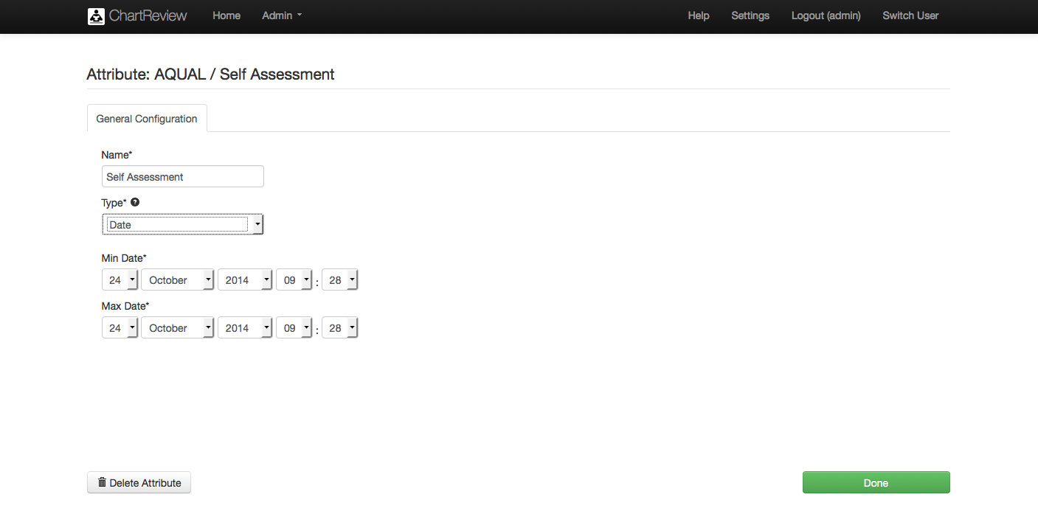

Table : Admin – Schema – Attribute – Create/Edit - Date

|  |  |
| --- | --- |
| Item/Action | Description/Result |
| Name | The name of the class attribute. |
| Type | When date type is chosen, Min Date and Max Date fields appear to specify a valid date range for the attribute. |
| Min Date | The minimum valid date value. |
| Max Date | The maximum valid date value. |
| Delete Attribute | Deletes the attribute! |
| Done | Saves the changes to the attribute and takes you to the Create/Edit Schema page. |

Figure . Admin – Schema – Attribute – Create/Edit - Option

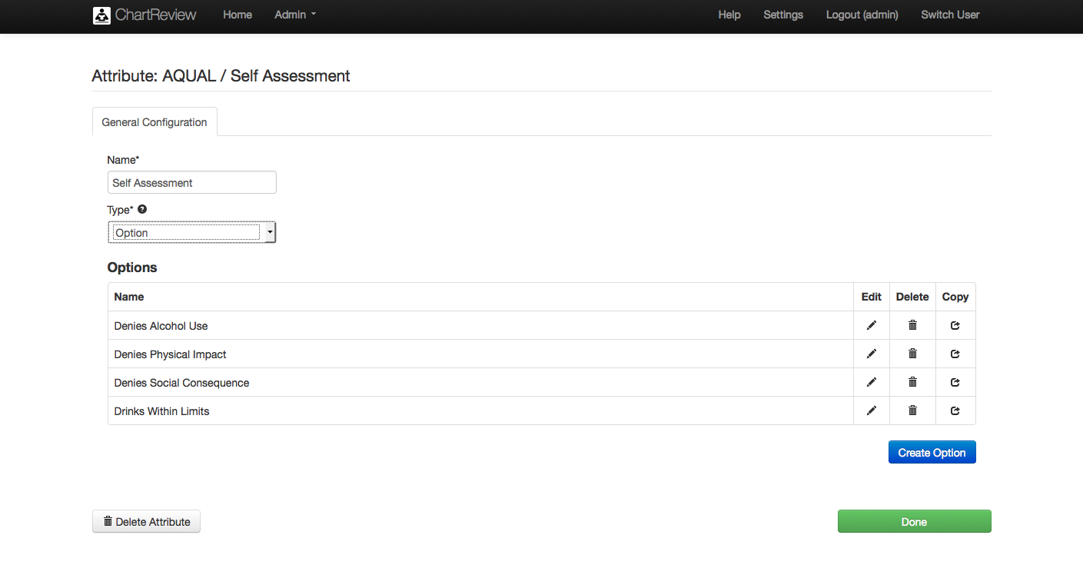

Table : Admin – Schema – Attribute – Create/Edit - Option

|  |  |
| --- | --- |
| Item/Action | Description/Result |
| Name | The name of the class attribute. |
| Type | When option type is chosen, an options list and create button appear to allow valid options to be specified. |
| Delete Attribute | Deletes the attribute! |
| Done | Saves the changes to the attribute and takes you to the Create/Edit Schema page. |
| Options | The list of valid option values for the option attribute. |
| Name | The name of the option. |
| Edit | Takes you to the pages to edit the specified option. |
| Delete | Deletes the specified option! |
| Copy | Copies the specified option and takes you to the pages to edit it. |
| Create Option | Creates an option and takes you to the pages to edit it. |

Figure . Admin – Schema – Attribute – Create/Edit - Option - Create/Edit Option

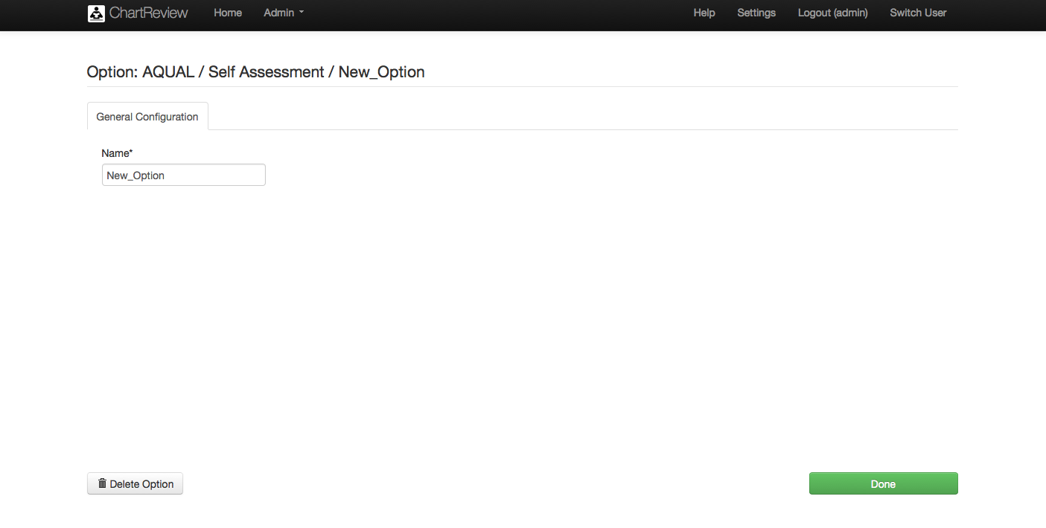

Table : Admin – Schema – Attribute – Create/Edit - Option

|  |  |
| --- | --- |
| Item/Action | Description/Result |
| Name | The name of the option. |
| Delete Option | Deletes the option! |
| Done | Saves the changes to the option and takes you to the Create/Edit Attribute page. |

Figure . Admin – Schema – Classifications

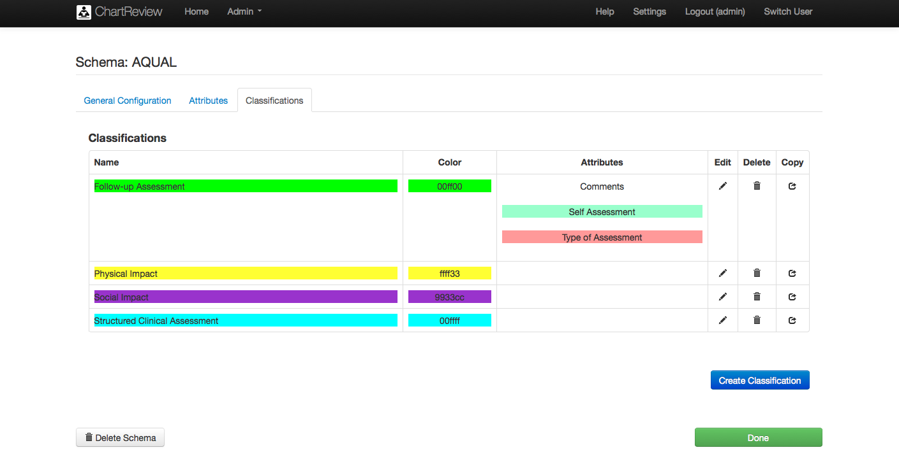

Table : Admin – Schema – Classifications

|  |  |
| --- | --- |
| Item/Action | Description/Result |
| Name | The name of the classification. |
| Color | The color of the classification. This is the highlight color of an annotation span with this classification. |
| Attributes | The list of attributes of this classification. |
| Edit | Takes you to pages to edit the specified class attribute. |
| Delete | Deletes the specified class attribute! |
| Copy | Copes the specified class attribute and takes you to the pages to edit it. |
| Create Classification | Creates a classification and takes you to the pages to edit it. |
| Delete Schema | Deletes the schema! |
| Done | Saves the changes to the schema and takes you to the Schema List page. |

Figure . Admin – Schema – Classification – Create/Edit – General Configuration

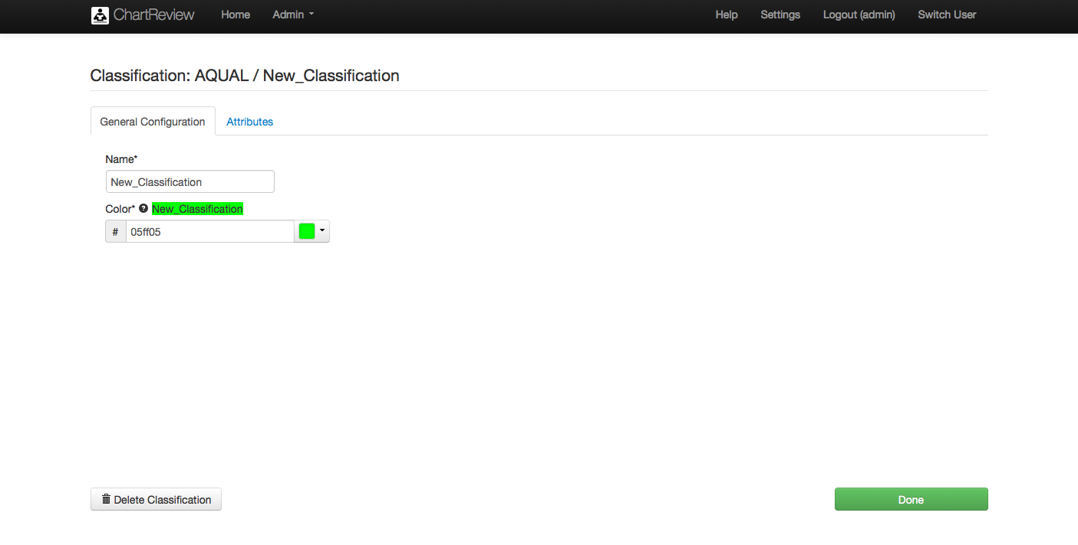

Table : Admin – Schema – Classification – Create/Edit – General Configuration

|  |  |
| --- | --- |
| Item/Action | Description/Result |
| Name | The name of the classification. |
| Color Label | Shows how the color will look in a highlight. |
| Color | The color of the classification. This is the highlight color of an annotation span with this classification. |
| Delete Classification | Deletes the classification! |
| Done | Saves the changes to the classification and takes you to the Create/Edit Schema page. |

Figure . Admin – Schema – Classification – Create/Edit – Attributes

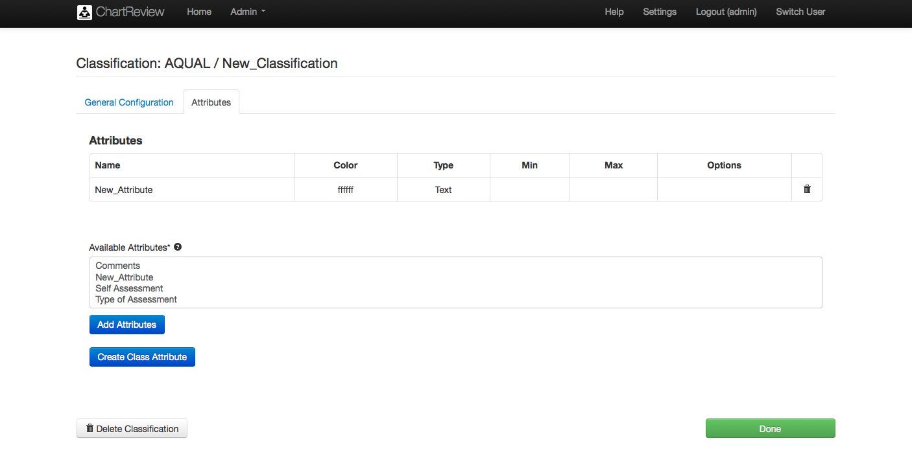

Table : Admin – Schema – Classification – Create/Edit - Attributes

|  |  |
| --- | --- |
| Item/Action | Description/Result |
| Name | The name of the class attributes. |
| Color | The color of the attributes. This is the highlight color of an annotation span with this classification. |
| Type | The type of class attribute (i.e. Text/Numeric/Date/Options). |
| Min | The minimum valid numeric or date value. |
| Max | The maximum valid numeric or date value. |
| Options | The list of options for an option type class attribute. |
| Delete | Deletes the specified class attribute! |
| Available Attributes | A list of reusable attributes defined at the schema level that can be added as class attributes. |
| Add Attributes | Add the selected attributes to the classification as class attributes. |
| Create Class Attribute | Creates a new available class attribute and takes you to the pages to edit it. The resulting attribute shows up in the list of Available Attributes, but still needs to be added to the classification. |
| Delete Classification | Deletes the classification! |
| Done | Saves the changes to the classification and takes you to the Schema Create/Edit page. |

## Failed Jobs (Admin only)

The Failed Jobs item in the Admin drop down menu takes you to a list of failed workflow processes.

Note that different annotators may be participating in different annotation workflows simultaneously.

Figure . Admin – Failed Jobs

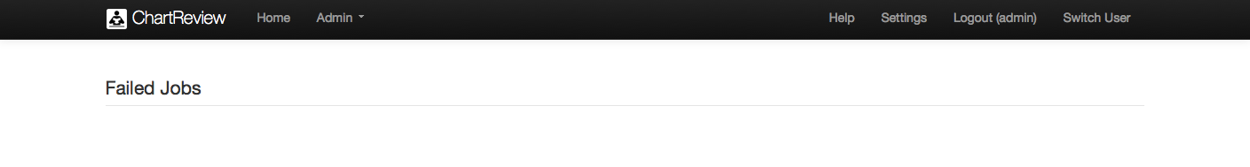

## Process Templates (Admin only)

The Process Templates item in the Admin drop down menu takes you to the pages that allow upload and definition of process pre-defined process templates that may be used in creating process instances for a given project. Any xml file containing a process definition that uses the BMP 2.0 standard can be loaded. For example, a process defined using Activi Designer will can be loaded. Simple single step and multi-step processes should work in Chart Review. More complex process configurations have not yet been tested.

Figure . Admin – Process Templates

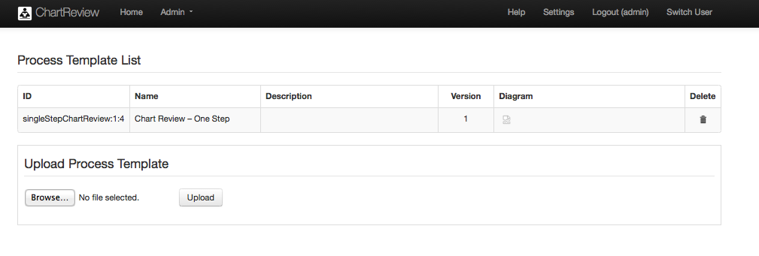

Table : Admin – Process Templates

|  |  |
| --- | --- |
| Item/Action | Description/Result |
| Process List | List of process templates available to use when creating a process for a project. This template describes the different tasks that need to be defined and executed as part of an annotation process workflow. It follows the BMP 2.0 process definition standard. |
| ID | The id of the process template. |
| Name | Name of the process template presented in the Project process definition. |
| Description | Description of the process template. |
| Version | Version of the process template. |
| Diagram | Diagram of the process template. Clicking on the diagram button opens a new browser window and displays the diagram. |
| Delete | Deletes the process template! |
| Upload Process Template | Allows upload of any xml file containing a process definition that uses the BMP 2.0. For example, a process defined using Activi Designer will can be loaded. Simple single step and multi-step processes should work in Chart Review. More complex process configurations have not yet been tested. |
| Browse | Find the BMP 2.0 xml process definition file in the browser’s local file system. |
| Upload | Uploads the process template to the database. |

## Tools and Utilities (Admin only)

The Process Templates item in the Admin drop down menu takes you to the pages that provide tools and utilities to kill processes and view API documentation, for example.

Figure . Admin - Tools and Utilities

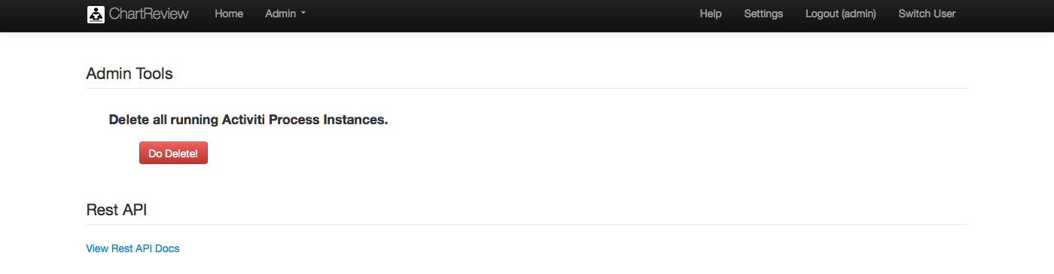

Table : Admin – Tools and Utilities

|  |  |
| --- | --- |
| Item/Action | Description/Result |
| Admin Tools | Area for various system administration activies. |
| Delete all running Actviti Process Instances – Do Delete | Deletes all processes and tasks from all projects!!! Annotations from any of those tasks will not be deleted, but an annotation’s association with the task for which it was generated will no longer exist. |
| Rest API | Area to access various API documents. |
| View Rest API Docs | Takes you to pages to view the Chart Review API documents generated by the JSONDoc subsystem. To get back from these pages, press the browser back button, because the Chart Review banner will not be available in this page space. |

Figure . Admin - Tools and Utilities – API Docs

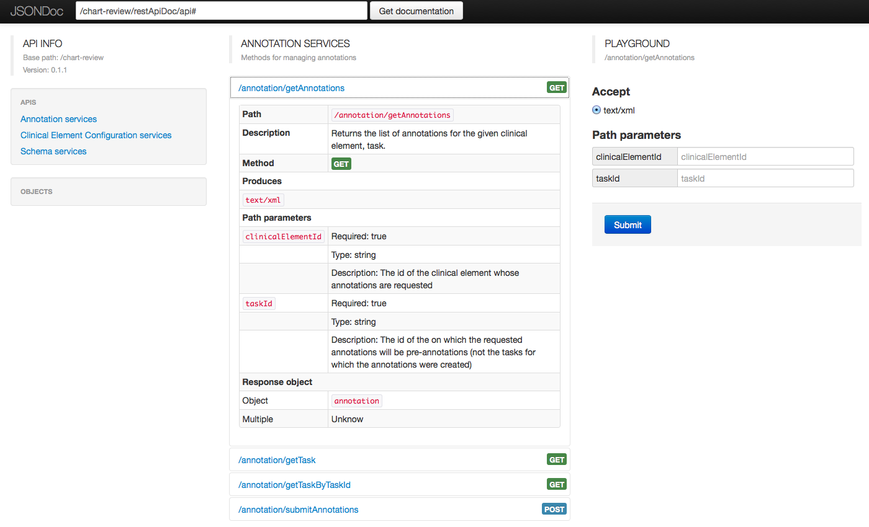

Table : Admin – Tools and Utilities – API Docs

|  |  |
| --- | --- |
| Item/Action | Description/Result |
| Various | These pages describe the web services the available in Chart Review to get and submit annotations, clinical element configurations, and annotation schemas programmatically. To get back from these pages, press the browser back button, because the Chart Review banner will not be available in this page space. A detailed description of how to use these pages is out of the scope of this document. Please see JSONDoc documentation for details. |

## Users (Admin only)

The Process Templates item in the Admin drop down menu takes you to the pages that allow user definition and maintenance.

Figure . Admin - Users

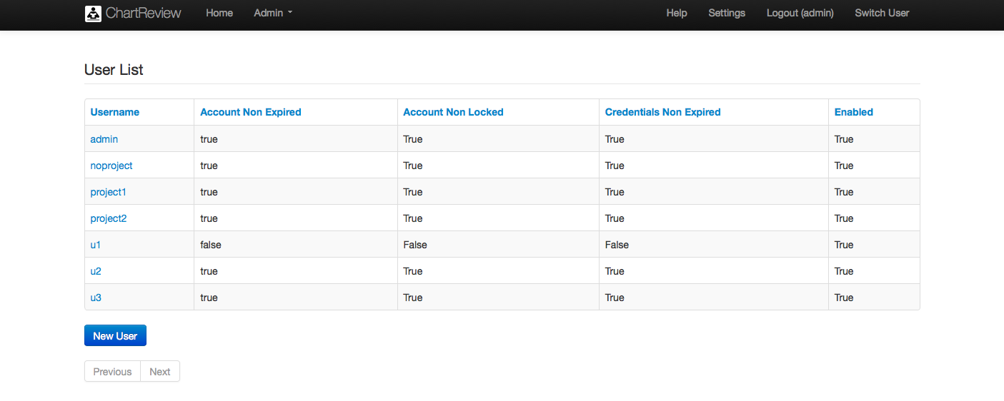

Table : Admin – Users

|  |  |
| --- | --- |
| Item/Action | Description/Result |
| Username Column | Sorts the user list by username. |
| Username | The name of each user. |
| Username link | Takes you to the pages to show user information. |
| Account Non Expired Column | Sorts the user list by account non-expired status. |
| Account Non Expired | True if the user account is active. False if the user account exists but is expired. The user cannot use the account. See the system administrator to reset. |
| Account Non Locked Column | Sorts the user list by account non-locked status. |
| Account Non Locked | True if the user account is NOT locked. False if the user account exists, but is currently locked. This is usually automatically set because of invalid login attempts. The user may not used the account. See the system administrator to reset. |
| Credentials Non Expired Column | Sorts the user list by credentials non-expired status. |
| Credentials Non Expired | True if the current password is not expired. This is set this to False to force the user to enter a new password. |
| Enabled Column | Sorts the user list by enabled status. |
| Enabled | True if the user account is enabled. False if the user account has been disabled by the system administrator. See the system administrator to find out why. |

Figure . Admin – Show User

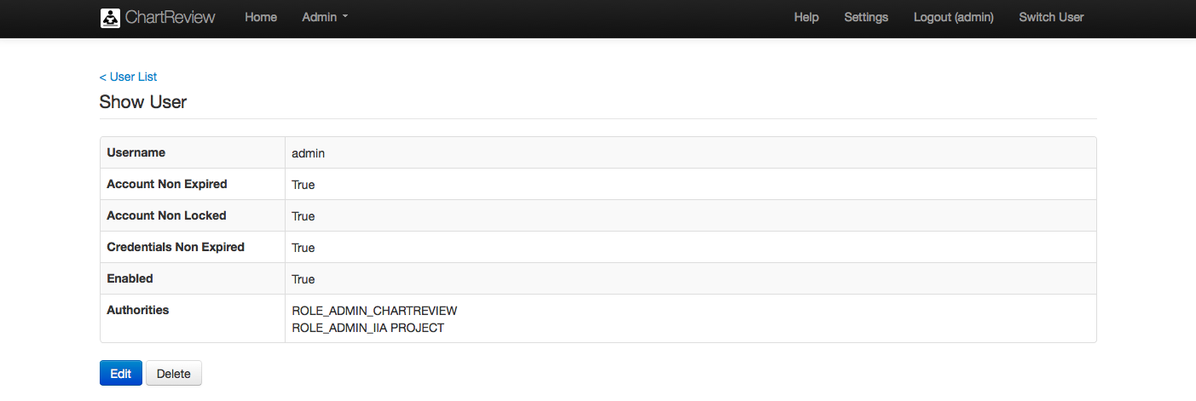

Table : Admin – Show User

|  |  |
| --- | --- |
| Item/Action | Description/Result |
| User List link | Takes you back to the User List. |
| Username | The name of each user. |
| Account Non Expired | True if the user account is active. False if the user account exists but is expired. The user cannot use the account. See the system administrator to reset. |
| Account Non Locked | True if the user account is NOT locked. False if the user account exists, but is currently locked. This is usually automatically set because of invalid login attempts. The user may not used the account. See the system administrator to reset. |
| Credentials Non Expired | True if the current password is not expired. This is set this to False to force the user to enter a new password. |
| Enabled | True if the user account is enabled. False if the user account has been disabled by the system administrator. See the system administrator to find out why. |
| Authorities | A list of the roles that the user has on various projects. |
| Edit | Takes you to the pages to edit the user account definition. |
| Delete | Deletes the user! |

Figure . Admin – Edit User

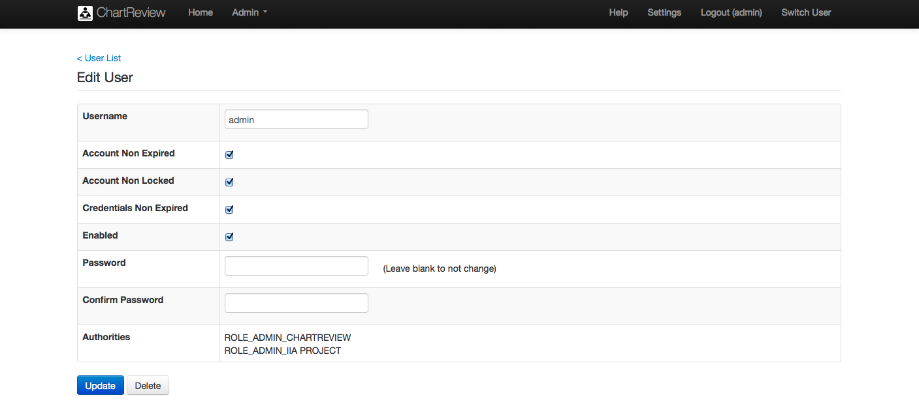

Table : Admin – Show User

|  |  |
| --- | --- |
| Item/Action | Description/Result |
| User List link | Takes you back to the User List. |
| Username | The name of each user. |
| Account Non Expired | True if the user account is active. False if the user account exists but is expired. The user cannot use the account. See the system administrator to reset. |
| Account Non Locked | True if the user account is NOT locked. False if the user account exists, but is currently locked. This is usually automatically set because of invalid login attempts. The user may not used the account. See the system administrator to reset. |
| Credentials Non Expired | True if the current password is not expired. This is set this to False to force the user to enter a new password. |
| Enabled | True if the user account is enabled. False if the user account has been disabled by the system administrator. See the system administrator to find out why. |
| Authorities | A list of the roles that the user has on various projects. |
| Update | Saves the changes to the User account. |
| Delete | Deletes the user! |

## About (Admin only)

The About item in the Admin drop down menu takes you to the pages that show information about the application, its version, structure, dependencies, and components.

Figure . Admin - About

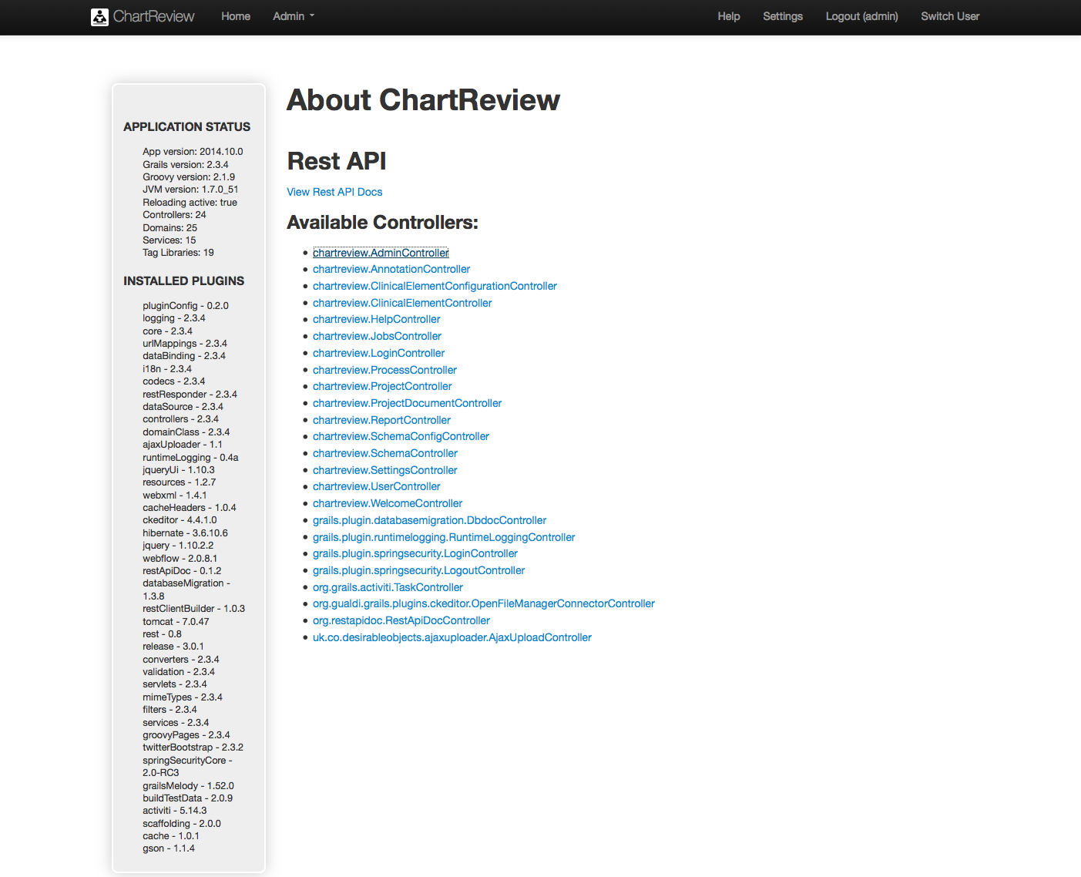

Table : Admin – About

|  |  |
| --- | --- |
| Item/Action | Description/Result |
| Application Status | Version information about Chart Review and its major technology subsystems. Counts of system components. |
| Installed Plugins | A list of the plugin components used by this application with their version numbers. |
| View Rest API Docs | Takes you to pages to view the Chart Review API documents generated by the JSONDoc subsystem. To get back from these pages, press the browser back button, because the Chart Review banner will not be available in this page space. |
| Available Controllers | These links call the various controllers they represent. These may be used for system understanding and programmer testing. |

Figure . Admin - About – API Docs



Table : Admin – About – API Docs

|  |  |
| --- | --- |
| Item/Action | Description/Result |
| Various | These pages describe the web services the available in Chart Review to get and submit annotations, clinical element configurations, and annotation schemas programmatically. To get back from these pages, press the browser back button, because the Chart Review banner will not be available in this page space. A detailed description of how to use these pages is out of the scope of this document. Please see JSONDoc documentation for details. |

## Log Level (Admin only)

The Log Level item in the Admin drop down menu takes you to the pages that allow control over the various levels of system logging available.

Figure . Admin - Log Level

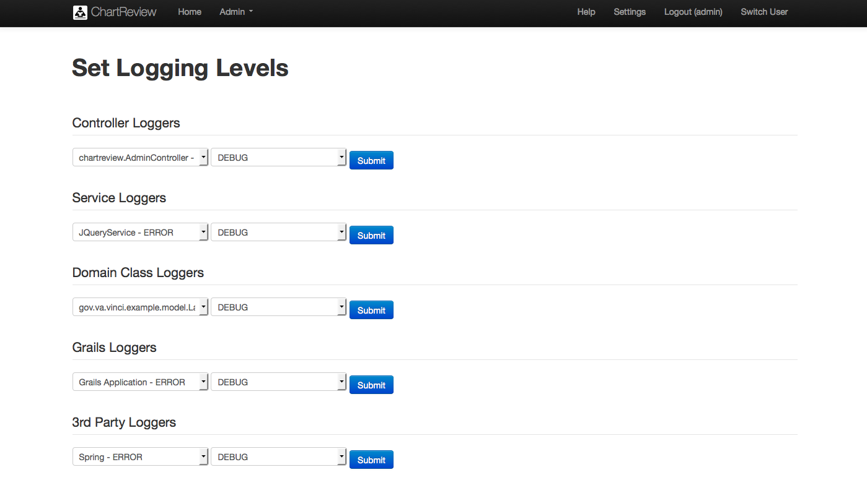

Table : Admin – Log Level

|  |  |
| --- | --- |
| Item/Action | Description/Result |
| Controller Loggers | Allows you to set the logging level that Grails controllers use to log to the chart-review log file found in the Tomcat logs directory. |
| Service Loggers | Allows you to set the logging level that Grails services use to log to the chart-review log file found in the Tomcat logs directory. |
| Domain Class Loggers | Allows you to set the logging level that Grails domain classes use to log to the chart-review log file found in the Tomcat logs directory. |
| Grails Loggers | Allows you to set the logging level that Grails itself uses to log to the chart-review log file found in the Tomcat logs directory. |
| 3rd Party Loggers | Allows you to set the logging level that Grails 3rd party plugins use to log to the chart-review log file found in the Tomcat logs directory. |

## Performance Monitoring (Admin only)

The Performance Monitoring item in the Admin drop down menu takes you to the pages that show performance monitoring analytics about the Chart Review system itself.

Figure . Admin – Performance Monitoring – Top

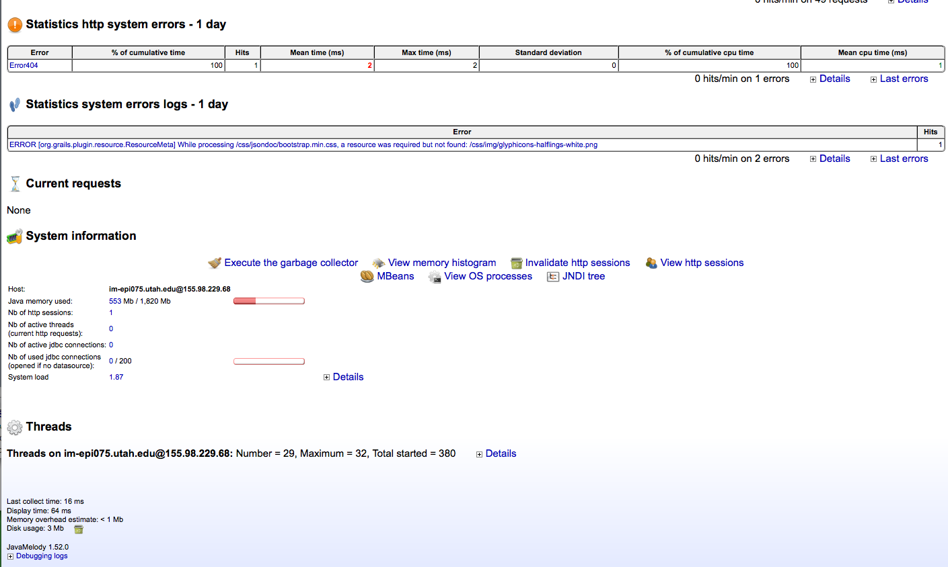

Figure . Admin – Performance Monitoring - Bottom

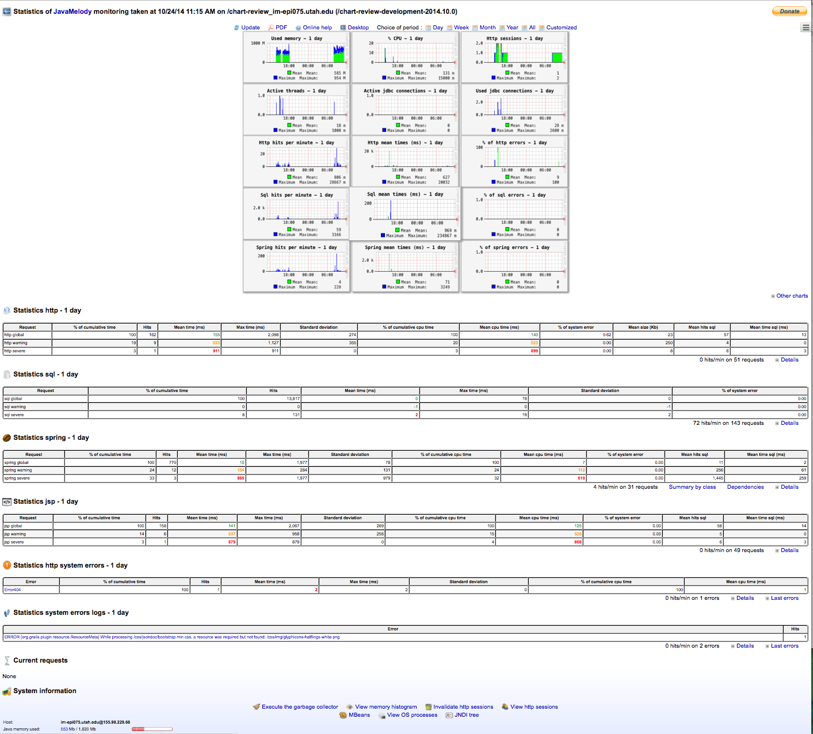

Table : Admin – Performance Monitoring

|  |  |
| --- | --- |
| Item/Action | Description/Result |
| Various | These pages describe the performance of the Chart Review system as tracked by the JavaMelody monitoring subsystem. To get back from these pages, press the browser back button, because the Chart Review banner will not be available in this page space. A detailed description of how to use these pages is out of the scope of this document. Please see JavaMelody documentation for details. |

# Chart Review

## Overview

Chart Review is a web application that allows manual annotations to be made on multiple elements and multiple levels of a medical chart simultaneously. The task of classifying a cohort of patients can be done as a patient is reviewed in the full context of his clinical notes, labs, procedures, problems and medications. Or a corpus of notes can be annotated in the context of the patient, labs, problems, procedures and medications that clarify the notes. The type and set of clinical elements that can be viewed as part of an annotation task is completely customizable and configurable by an annotation project administrator.

Figure . Chart Review

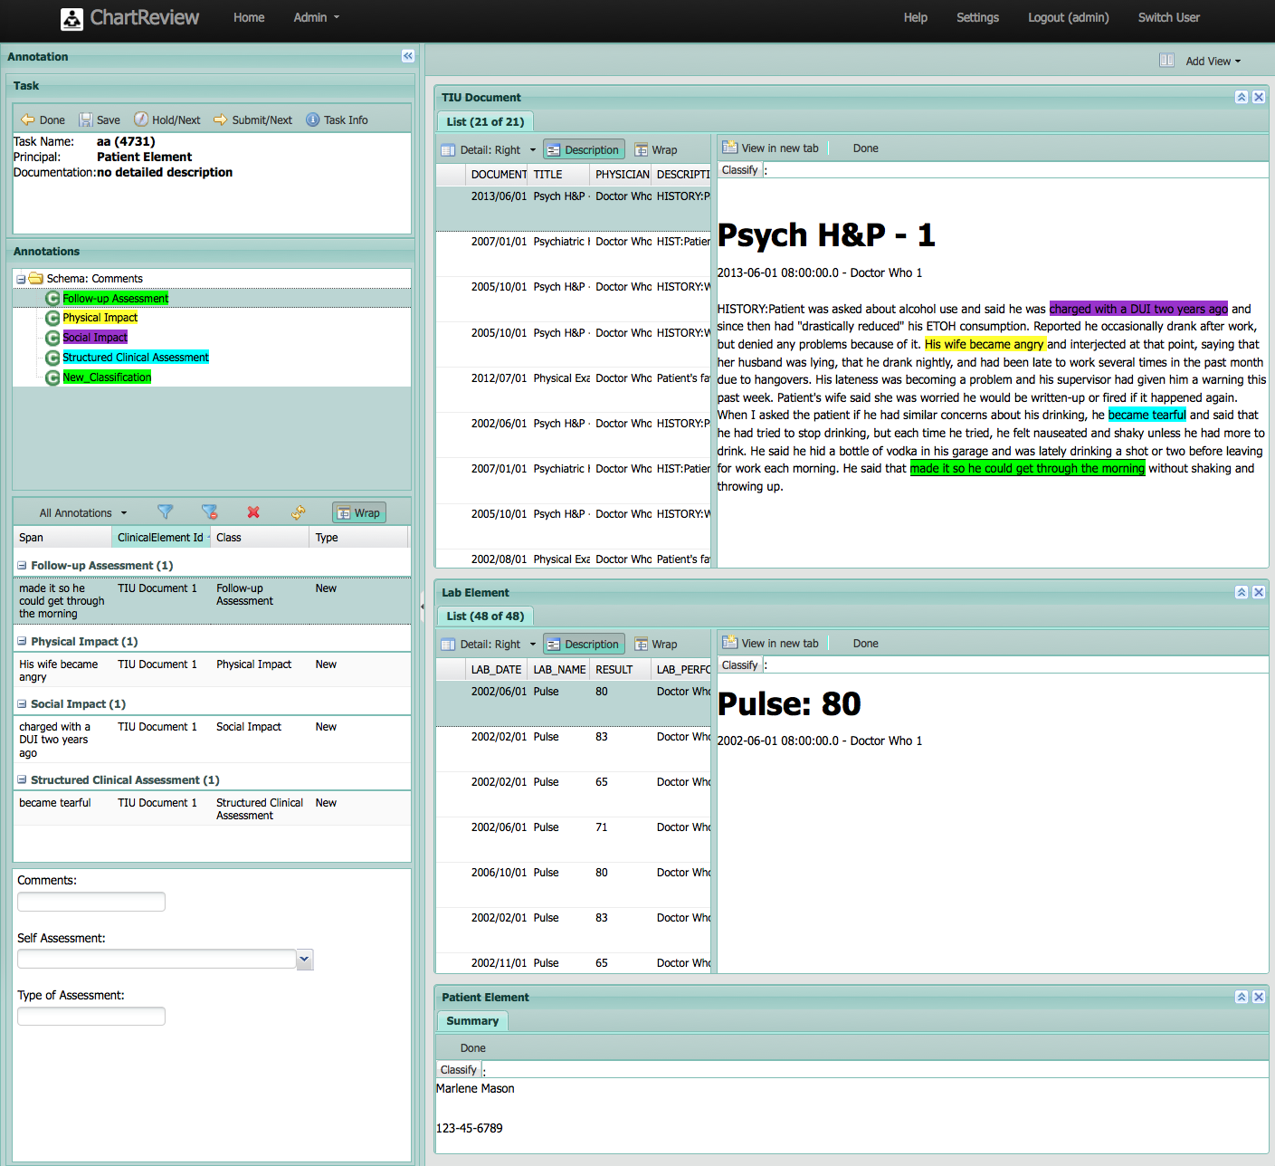

Annotators who have been assigned to an annotation project can open Chart Review with a new or previous assignment that they have been given from the an annotation process defined in the project and see the requirements of the task and all of the information necessary to perform the annotation task that has been assigned. Annotators can finish a task, move to another task, or put a task on hold. Within the Chart Review tool, an annotator can peruse a chart independent of the annotation task at hand (he can collapse the annotation panel entirely), or he can be taken to the parts of the chart that have been pre-annotated by sorting, filtering, grouping, and selecting annotations from the annotation list that show features of interest in the chart. In addition, the annotator has control over the content and layout of the chart presentation as well as the annotation list. The following sections describe how the Chart Review tool can be used to accomplish an annotation task.

## Quick-Start

The following outlines the basic annotation workflow steps, starting from the Chart Review Home page:

1. **Pick** a **project and process**
2. Press **Get Next Assignment**
3. Find out what annotation is required by **press**ing the **Task Info** button in the task panel
4. **Select** the appropriate schema **classification** for the task
5. **Scroll** to the clinical element **view**
6. **Select** a clinical element **item**
7. **Scroll** to the desired place in the **content** text
8. **Highlight** the desired **text** (an annotation will appear in the annotations list on the left)
9. **Fill out** any annotation attribute **features** presented in the annotation editor panel on the lower left
10. When annotation is finished, **press Submit/Next** to submit the annotations and get the next task

That’s it!

## Initiating a Chart Review

A user can see his recent task work for a given project and process, including work on completed processes. A user can fetch a new task assignment or work on existing open assignments, or assignments that have been put on hold.

Figure . Chart Review – Initiating a Chart Review

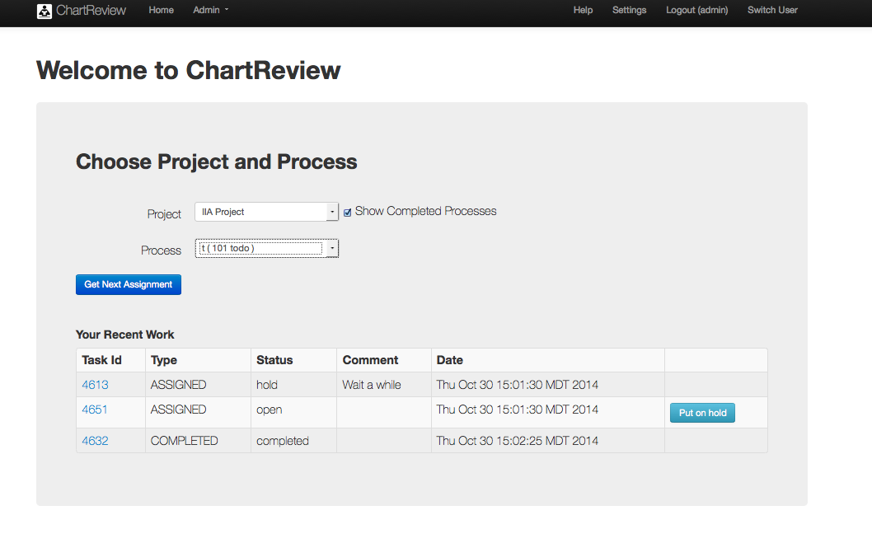

Table : Chart Review – Initiating a Chart Review

|  |  |
| --- | --- |
| Item/Action | Description/Result |
| Project | The project you want to perform an annotation task on. |
| Show Completed Processes | If checked, completed processes are provided in the Process dropdown as well as incomplete processes. |
| Process | The project process workflow you want to perform an annotation task on. |
| Get Next Assignment | Gets a new task assignment from the chosen project process and initiates chart review on that task. The task moves to an ASSIGNED state.  Macintosh HD:Users:bradadams:Desktop:Info.pngNote that the processes listed in the Process dropdown show how many unassigned tasks they have left. |
| Your Recent Work | This is a list of tasks that have been assigned to you for the specified project process. These tasks may be open, on hold, or completed. |
| Task Id link | Initiates chart review on the specified task. |
| Task Id | The id of the task. |
| Type | ASSIGNED/COMPLETED |
| Status | open/hold/completed |
| Comment | A comment that was added for a hold. |
| Date | The date/time the task was assigned or completed. |

## Layout Options

A reviewer has several layout options available, including:

### Two Column Mode

Two column mode allows a user to have two instances of the same type of clinical element view open side by side for comparison. For example, a user could open a note that was annotated well, according to the task standard and use it to guide annotation of another note of the same type of clinical element.

Figure . Chart Review – Two Column Mode

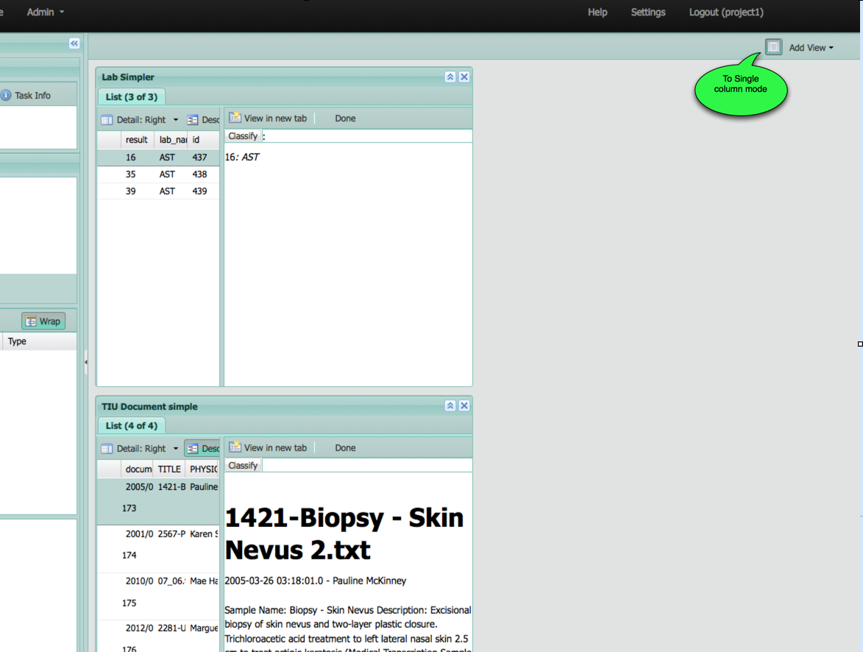

Figure . Chart Review – Single Column Mode

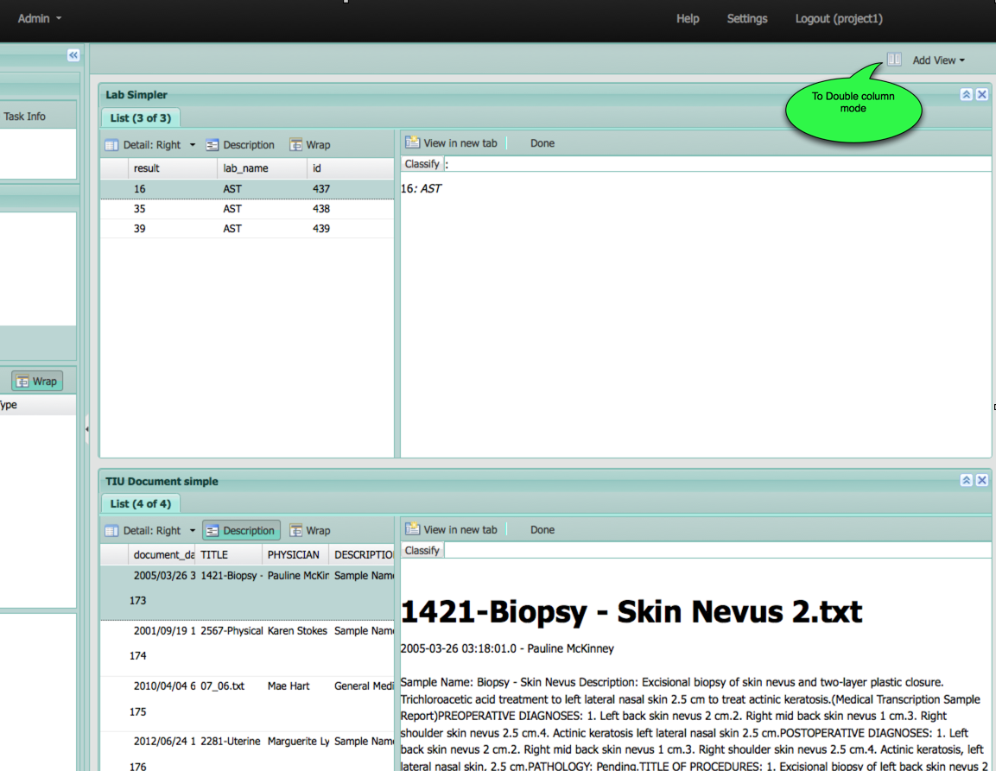

Table : Chart Review – Two Column Mode

|  |  |
| --- | --- |
| Item/Action | Description/Result |
| Two Column Mode Toggle (app upper right) | Toggles between two columns and one column, distributing the views between the two columns or coalescing them into one column. |
| Auto-Select |  |

### Variable Height Views

View height can be adjusted by dragging the bottom or top borders of the view window.

Figure . Chart Review – Variable Height Views

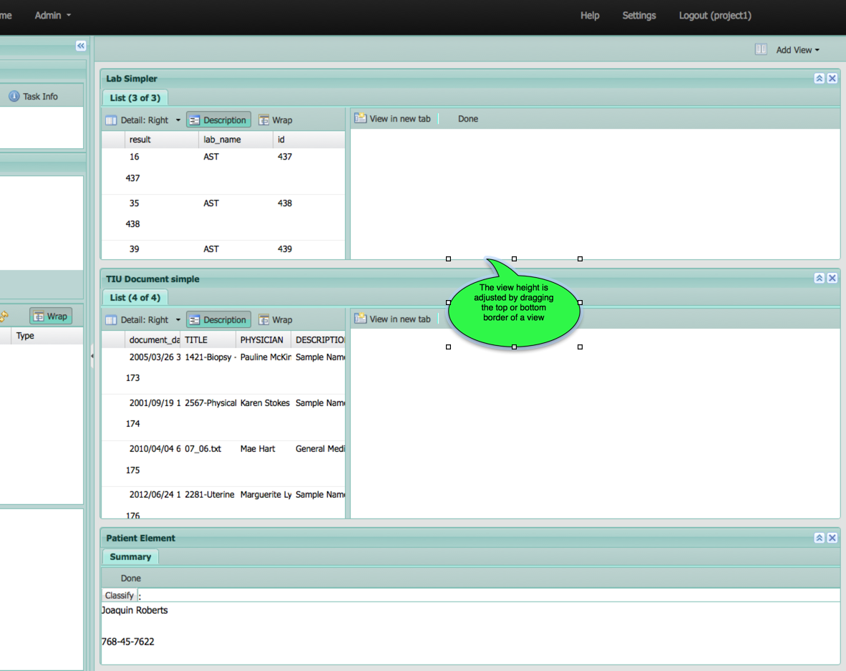

Table : Chart Review – Variable Height Views

|  |  |
| --- | --- |
| Item/Action | Description/Result |
| Drag View Top/Bottom | Adjusts the height of the view. |

### View Detail Docking/Hiding Options

A clinical element view of type LIST has a grid part and a detail part. The user may change the docking of the detail panel to the right or the bottom. He may also choose to hide the detail panel altogether through the Detail dropdown button

Figure . Chart Review – View Detail Docking/Hiding Options

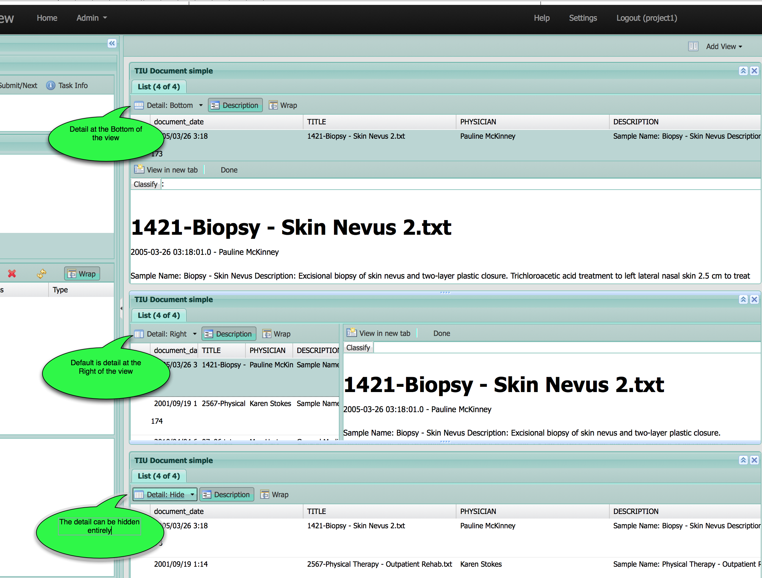

Table : Chart Review – Variable Height Views

|  |  |
| --- | --- |
| Item/Action | Description/Result |
| Detail Right (default) | Shows the detail at the right of the view. |
| Detail Bottom | Shows the detail at the bottom of the view. |
| Detail Hide | Hides the detail from the view. |

### Optional Column Inclusion

Columns may be optionally included/excluded from the grid view. Column inclusion/exclusion is toggled through the column header dropdown menu.

Figure . Chart Review – Optional Column Inclusion

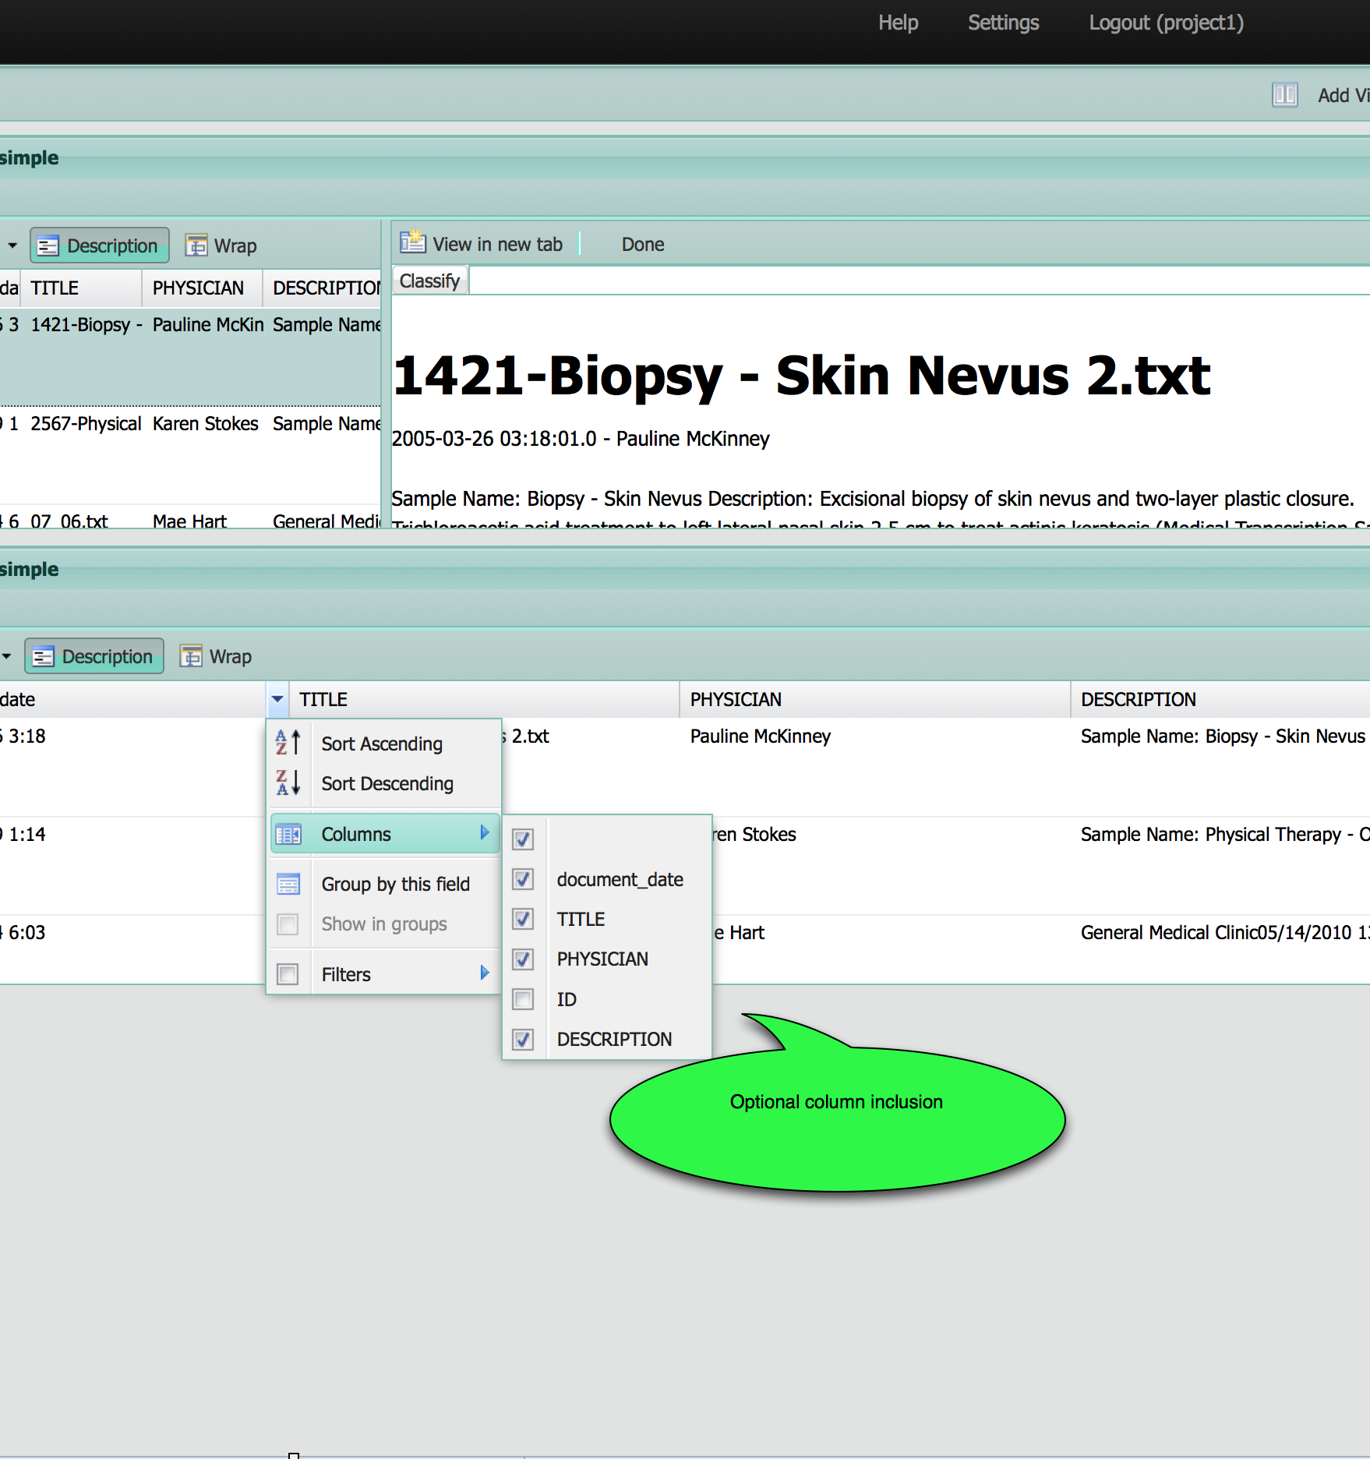

Table : Chart Review – Optional Column Inclusion

|  |  |
| --- | --- |
| Item/Action | Description/Result |
| Dropdown on Right of Colum -> Columns | Toggles the visibility of each column that has Include checked in the process task definition. |

### List Sorting

The grid list may be sorted ascending/descending by any of the columns. Column sorting is toggled through the column header dropdown menu.

Figure . Chart Review – List Sorting

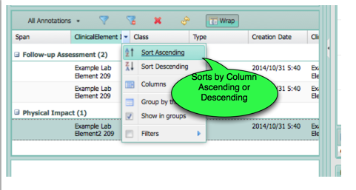

Table : Chart Review – List Sorting

|  |  |
| --- | --- |
| Item/Action | Description/Result |
| Dropdown on Right of Column -> Sort Ascending/Descending | Sorts by the column values ascending or descending. An indicator is displayed on the column header to show column sort and direction. |

### List Grouping

The grid list may be grouped by any of the columns. Column grouping is toggled through the column header dropdown menu.

Figure . Chart Review – List Grouping

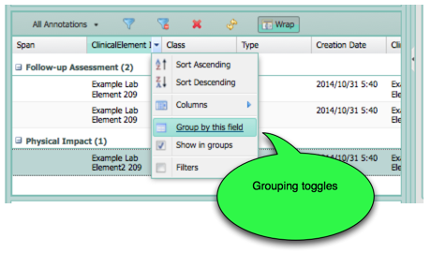

Table : Chart Review – List Grouping

|  |  |
| --- | --- |
| Item/Action | Description/Result |
| Dropdown on Right of Colum -> Group by this Field | Groups the grid list by the specified column.  Macintosh HD:Users:bradadams:Desktop:Info.pngNote: The list can be both grouped and sorted simultaneously. |
| Dropdown on Right of Column -> Show in groups | Toggles the grouping by the specified column. |

### Variable Column Order and Size

Figure . Chart Review – Variable Column Order and Size

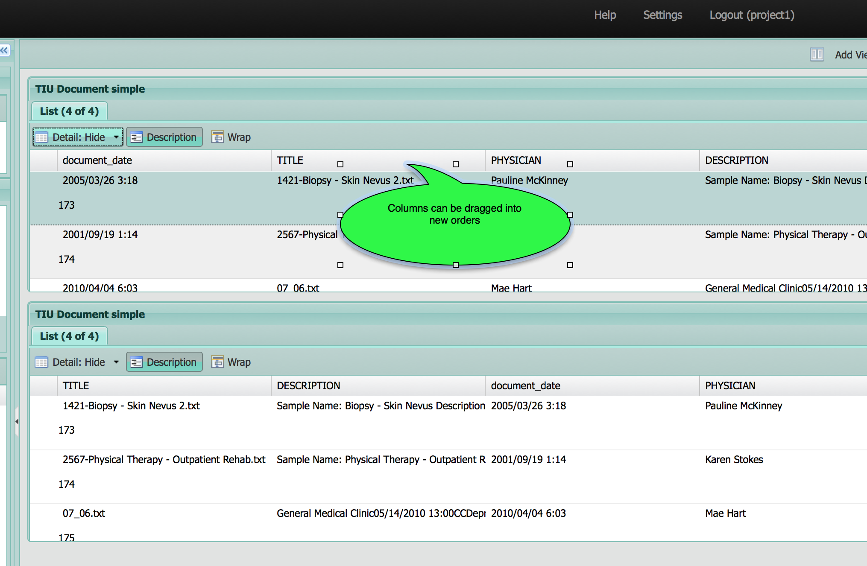

Table : Chart Review – Variable Column Order and Size

|  |  |
| --- | --- |
| Item/Action | Description/Result |
| Drag Column Order/Size | Columns can be reordered by dragging and they can be resized by grabbing the edge of the column headers. These changes persist until the view is closed. Two views of the same type may have different column layouts. |
|  |  |

### Collapsible Views

Figure . Chart Review – Collapsible Views

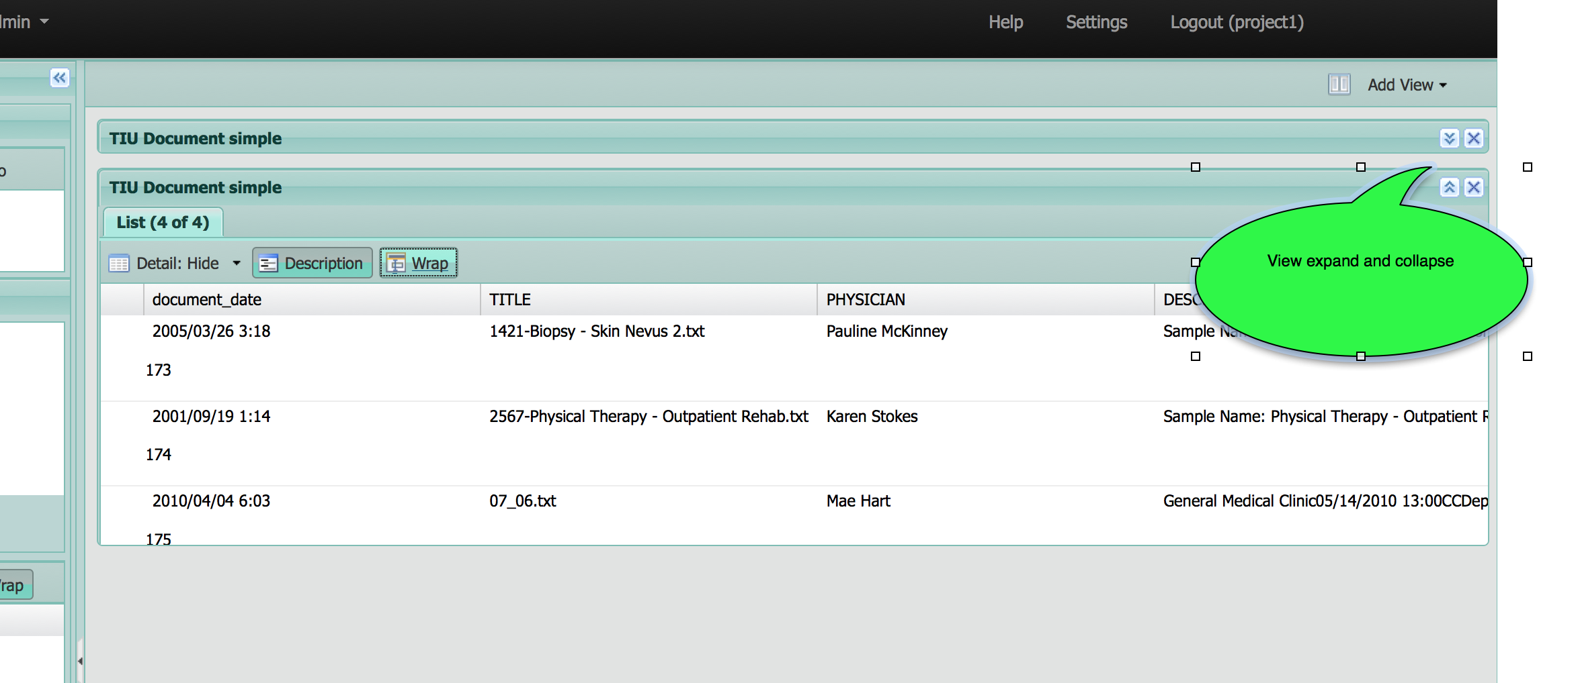

Table : Chart Review – Collapsible Views

|  |  |
| --- | --- |
| Item/Action | Description/Result |
| Collapse/Expand View | Collapses or expands a view. |

### Delete View

Figure . Chart Review – Delete View

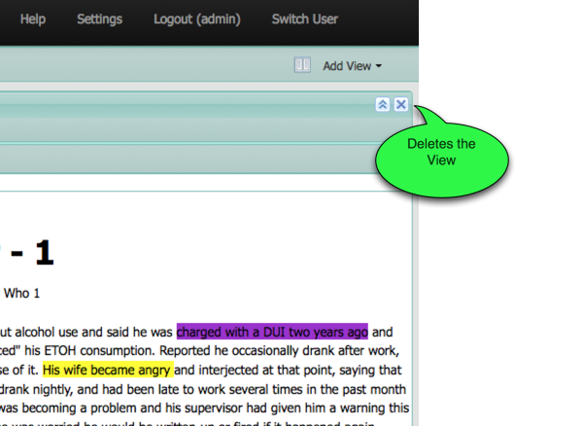

Table : Chart Review – Delete Views

|  |  |
| --- | --- |
| Item/Action | Description/Result |
| Delete View | Deletes the view. Another instance of a view type can be added through the Add View dropdown menu. |

### Add View

Figure . Chart Review – Add View

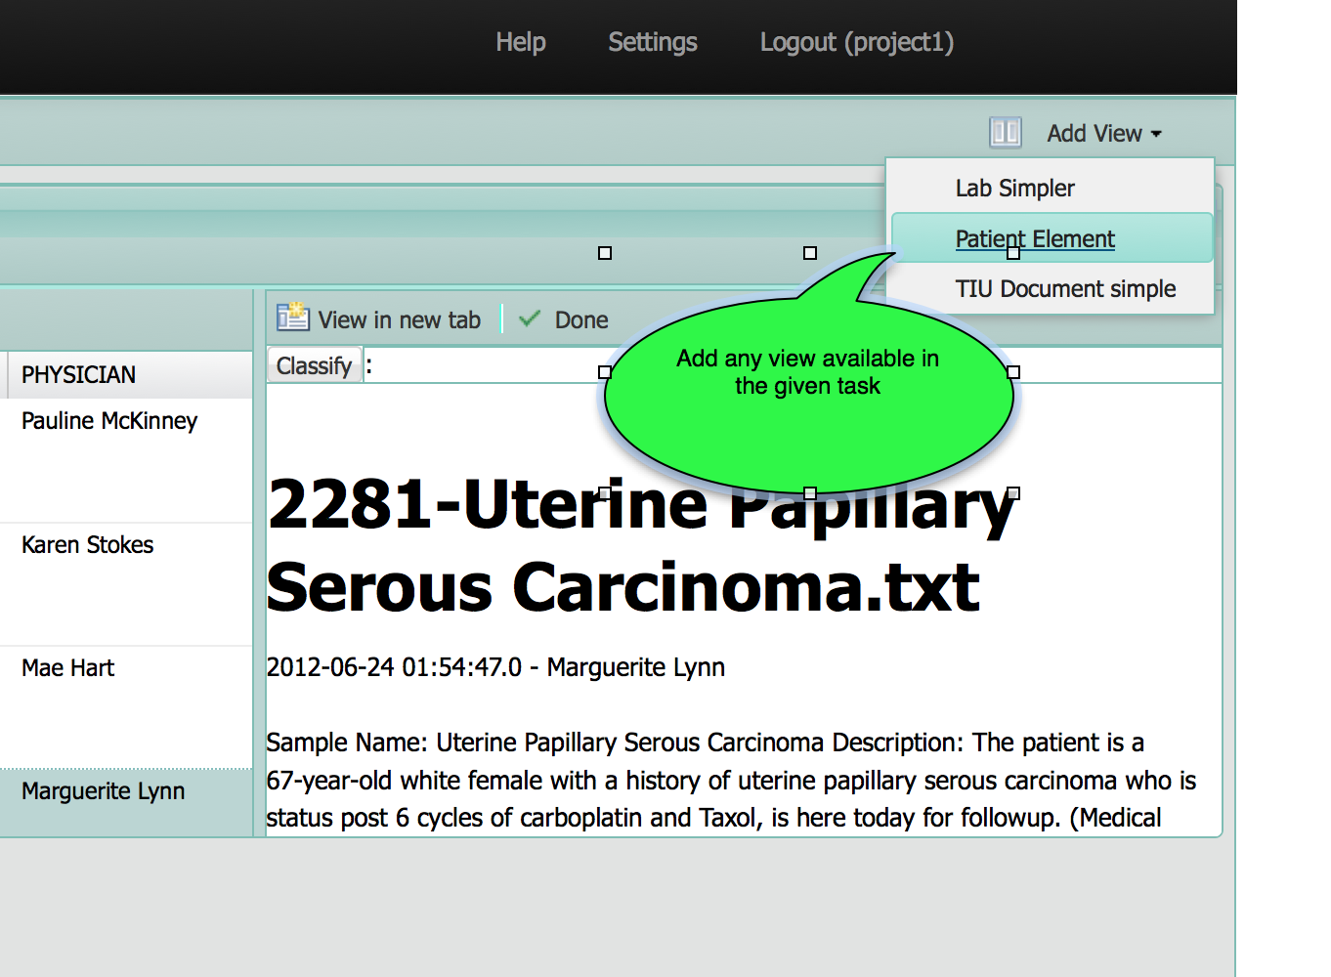

Table : Chart Review – Add View

|  |  |
| --- | --- |
| Item/Action | Description/Result |
| Add View | Adds an instance of the specified view type. Multiple instances of the same view type are allowed. |

### Multiple Instances of the Same View (comparison) and the Auto-select Toggle

Two instances of the same type of view can be opened simultaneously, affording a comparison capability where the annotation on one document of a given type may be used as a model for annotating another document of a given type, for example.

Note that when an annotation is created on one type of clinical element, all views of that type of clinical element will be auto-selected to show the annotation, unless the Auto-select toggle is OFF. Turn the Auto-select toggle off when comparing two documents of the same clinical element type so that the reference document will not be changed as annotations are added to the second document of that type.

Figure . Chart Review – Multiple Instances of the Same View (Comparison)

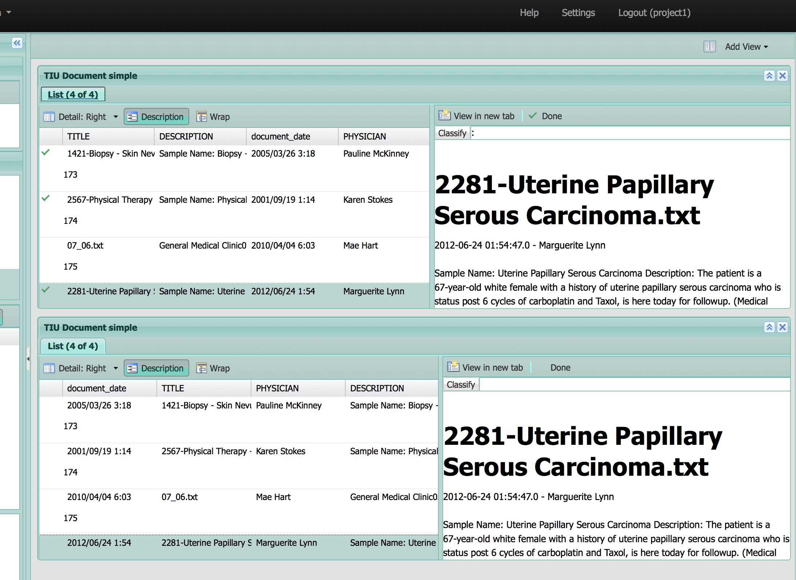

Figure . Chart Review – Auto-select Toggle

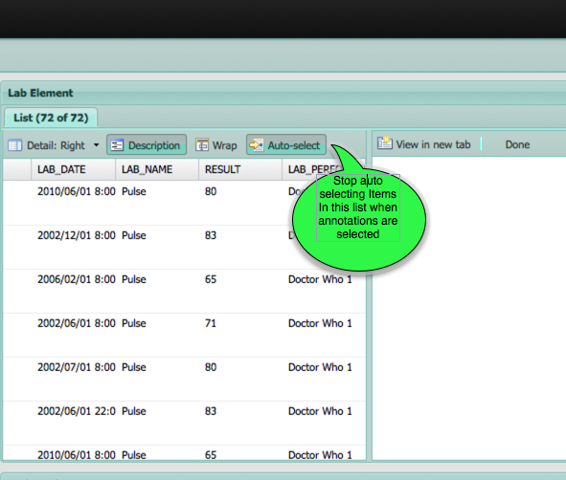

### Closable Annotation Panel

The annotation panel can be collapse if the user wants more room for chart review activities.

Figure . Chart Review – Closable Annotation Panel

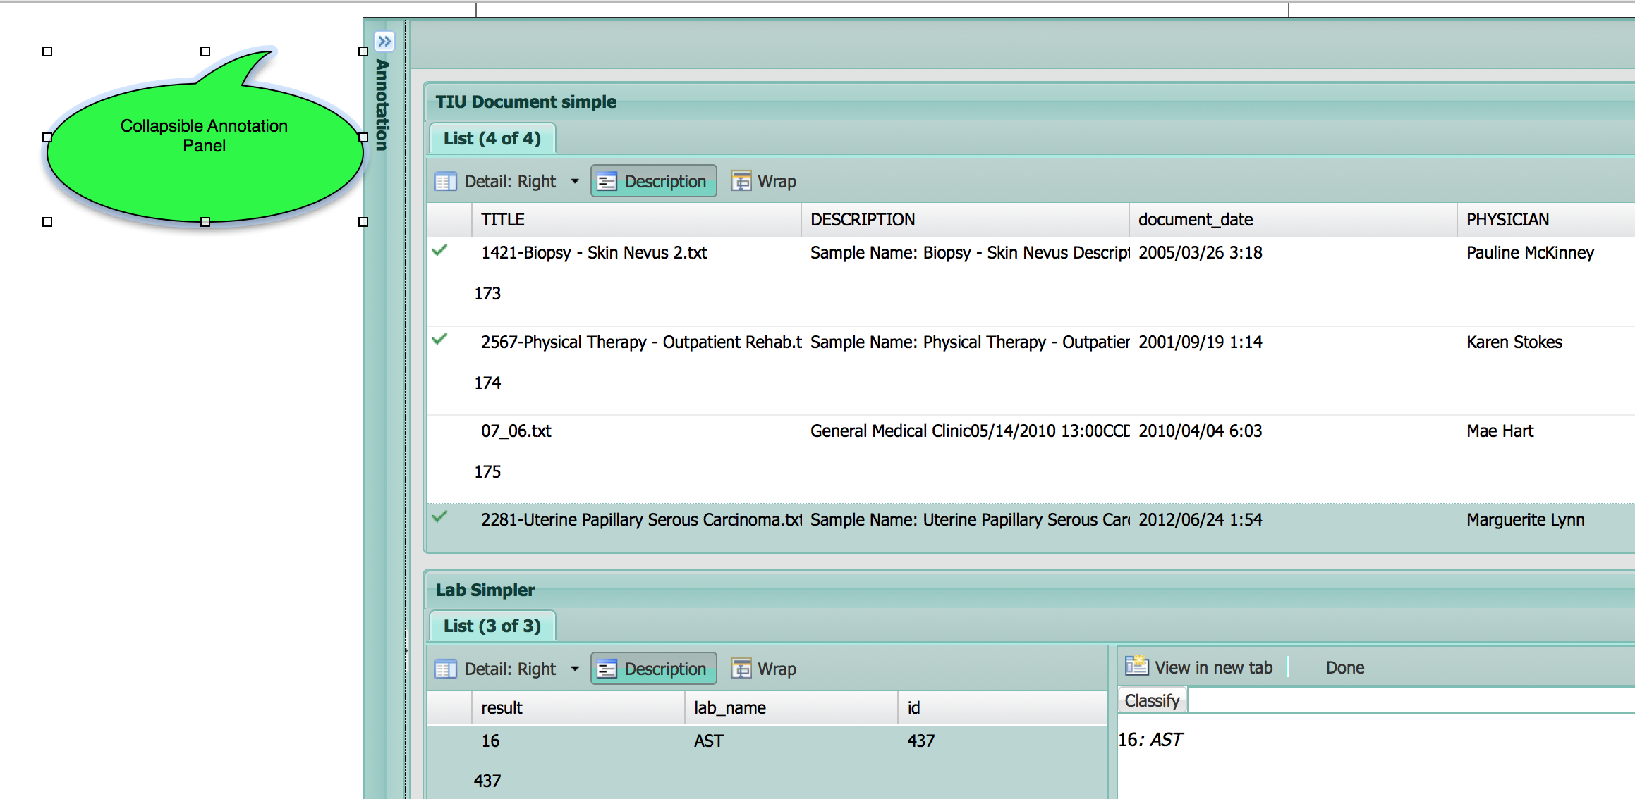

Table : Chart Review – Closable Annotation Panel

|  |  |
| --- | --- |
| Item/Action | Description/Result |
| Collapse Annotation Panel | Collapses/expands the annotation panel. |

## Workflow Support

There are several features of the Chart Review interface that support project workflow issues, including saving a detail view as a separate tab to refer to later, and a Done button to keep track of items for which the task has been completed.

### View In New Tab

A user can save a detail view as a separate tab so that he may come back to it at a later point.

Note: The column that is displayed as the tab title is specified in the Title Field of the clinical element definition.

Figure . Chart Review – View in New Tab

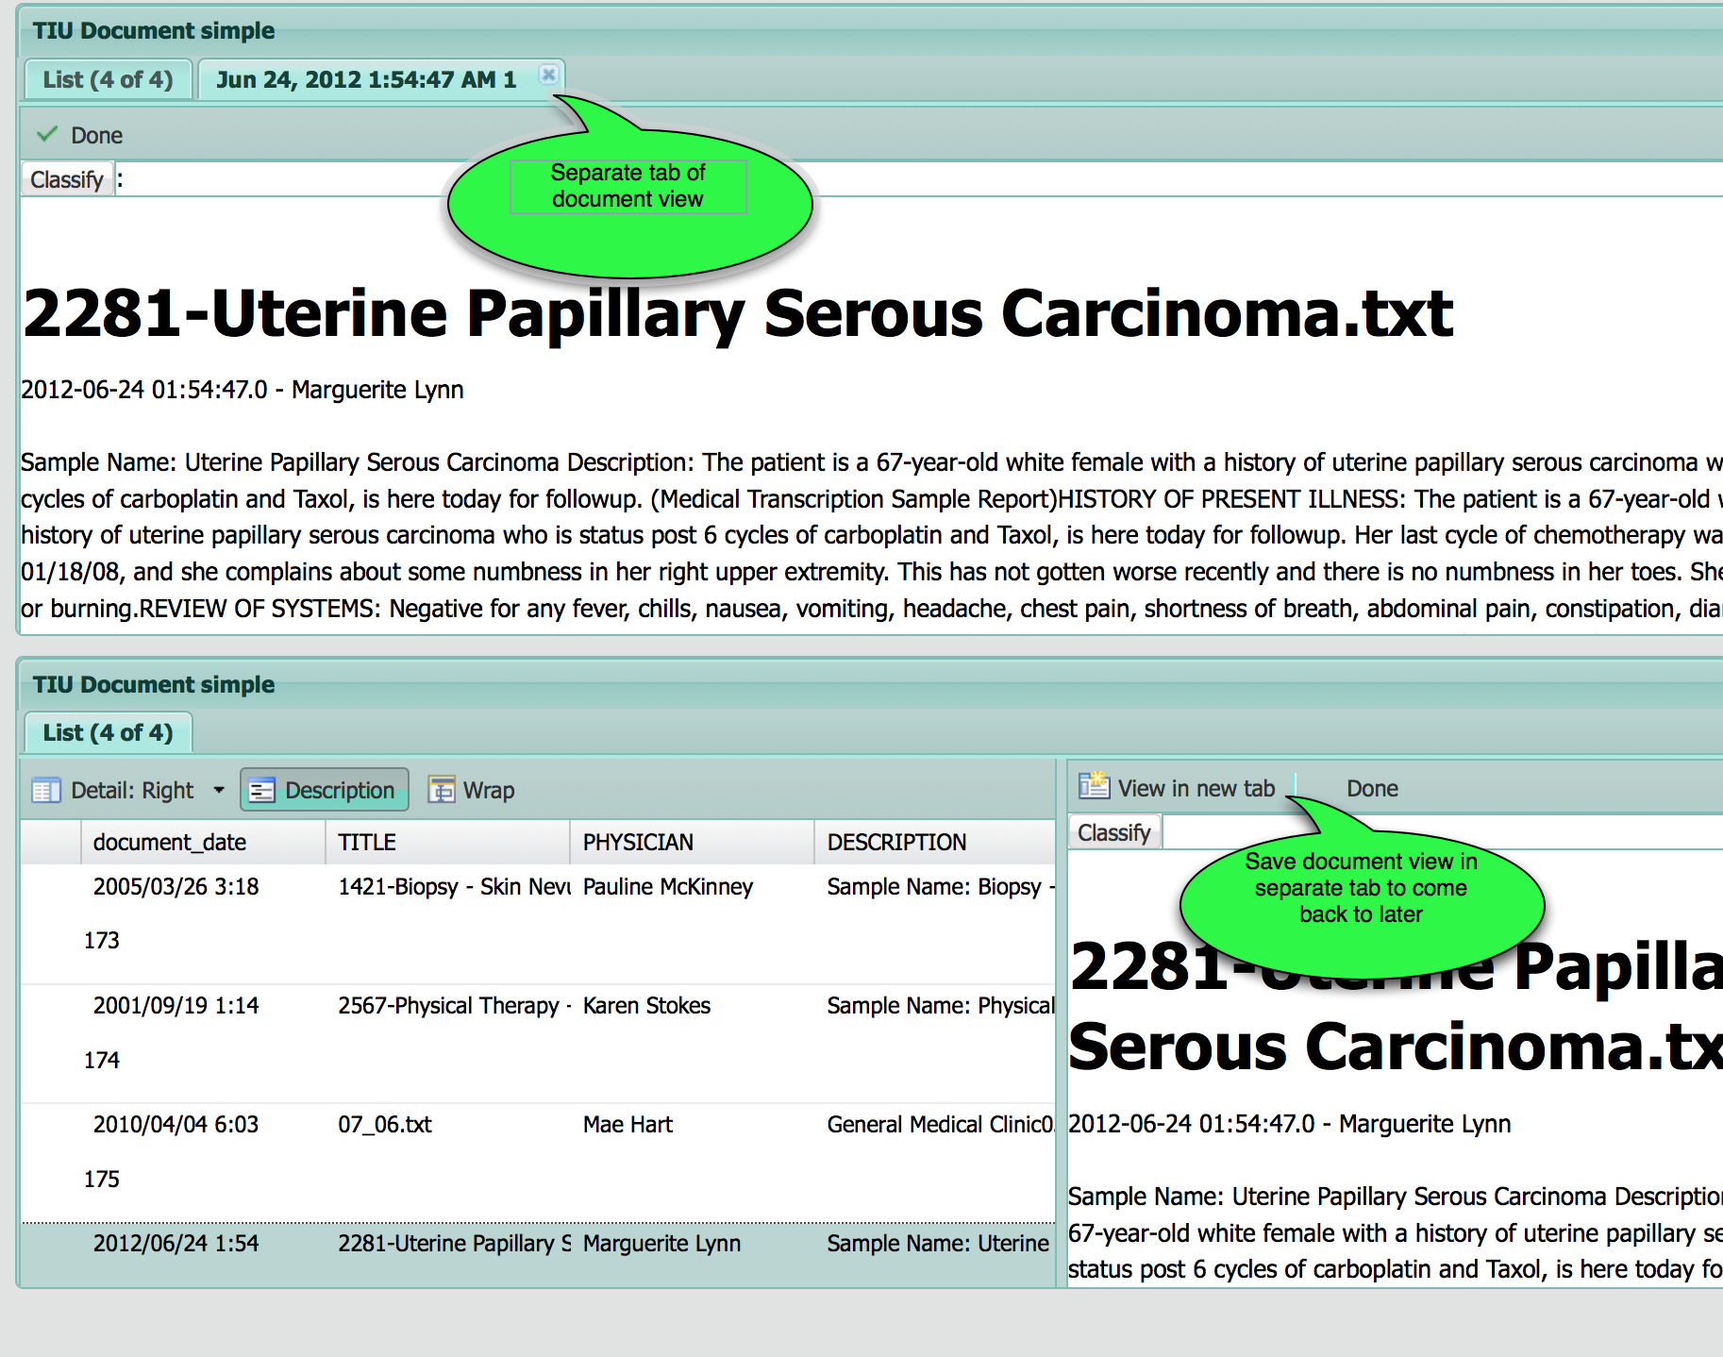

Table : Chart Review – View In New Tab

|  |  |
| --- | --- |
| Item/Action | Description/Result |
| View in new tab | Opens the current detail in a separate tab. Annotations selected in the annotation list will be auto-selected and viewed in a separate tab, if there is a separate tab opened for that clinical element. If there is not a separate tab for that clinical element, the auto-select view will show it in the detail panel as usual. |

### Marking Records As Done

To help a user keep track of which clinical elements he has already performed the annotation task on, he may mark the element as Done. Clinical elements that are done have a check mark by them in the grid.

Note that the task may be marked as done by pressing the Done button in the Task panel. The task is marked as completed and the user is returned to the Chart Review home page.

Figure . Chart Review – Marking Records As Done

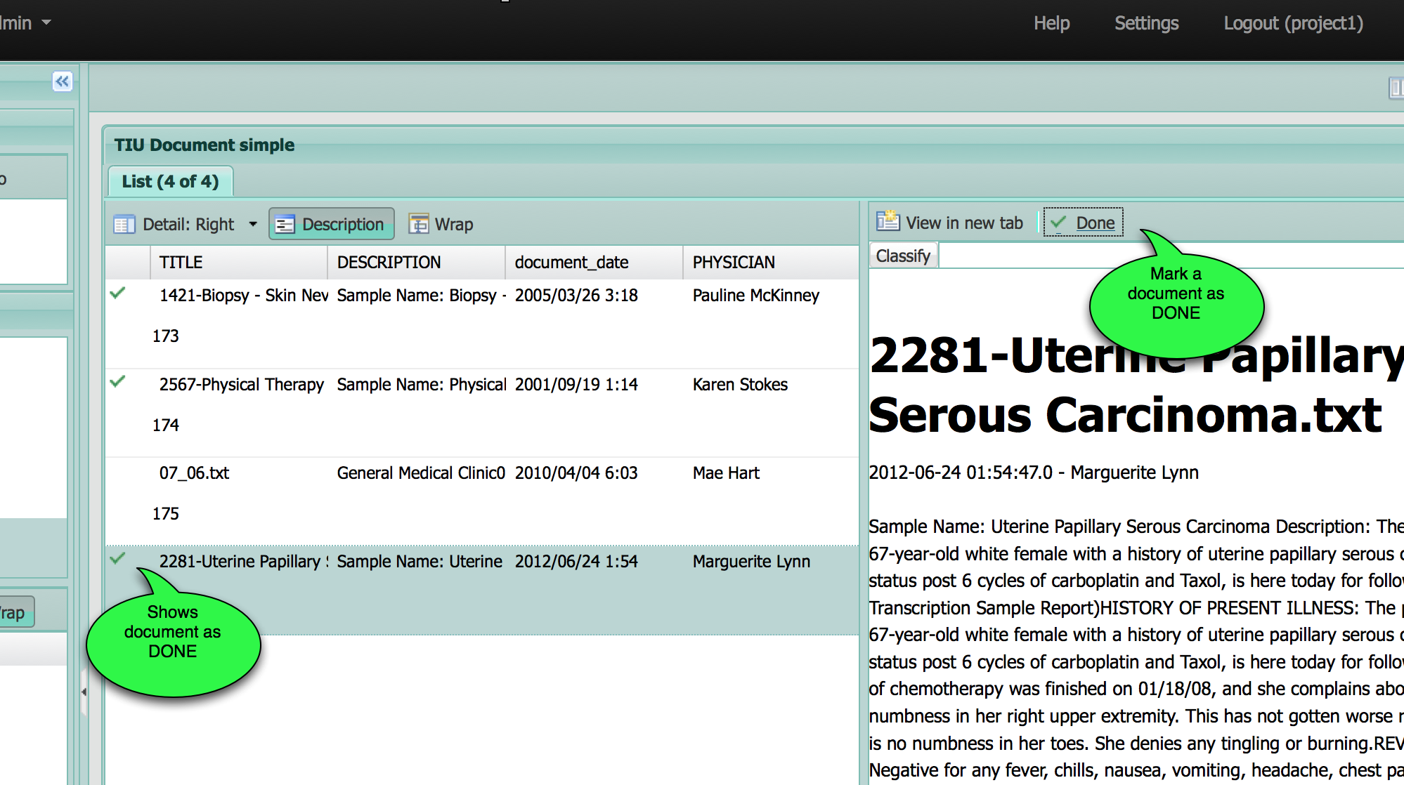

Table : Chart Review – Marking records as Done

|  |  |
| --- | --- |
| Item/Action | Description/Result |
| Done | Toggles the clinical element between done and not done. Done is indicated by a green checkmark in the grid. |

### Optional Text Wrapping

The user may allow cell text in a clinical element view grid to be wrapped or truncated.

Figure . Chart Review – Optional Text Wrapping

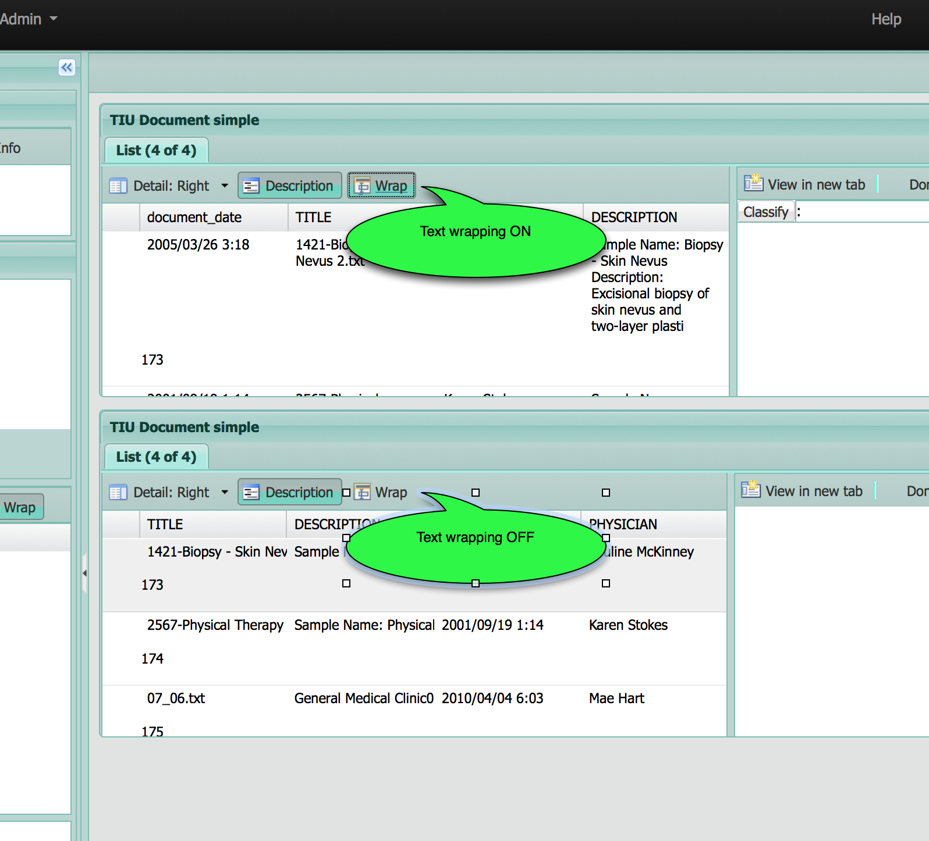

Table : Chart Review – Optional Text Wrapping

|  |  |
| --- | --- |
| Item/Action | Description/Result |
| Wrap | Toggles wrapping of text in the grid cells. If wrapping is off, the text in a cell is truncated. If wrapping is on, cell text is wrapped and the row height is increased. |

### Description Hiding

Each row of a clinical element view grid may display a description or not by toggling with the Description toggle button.

Note: The column that is displayed as the description is specified in the Description Field of the clinical element definition.

Figure . Chart Review – Description Hiding

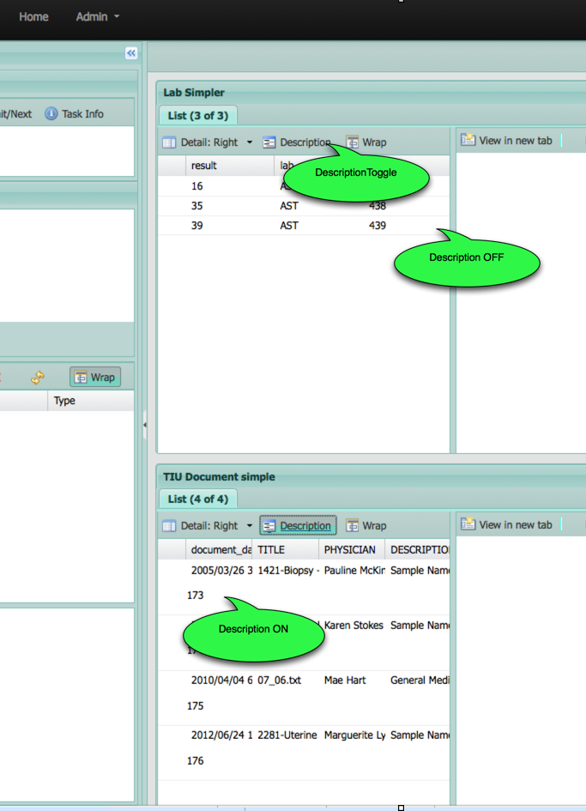

Table : Chart Review – Description Hiding

|  |  |
| --- | --- |
| Item/Action | Description/Result |
| Description | Toggles display of the clinical element description in the grid as a preview. |

## Annotation Workflow

All interaction with the task that is being performed in Chart Review is displayed in the Task panel in the upper left part of the application screen, at the top of the Annotation panel. The name of the task is displayed, along with the task id in parenthesis. The task id may help in referencing the task in reports and when choosing the task again from the Chart Review Home page’s Your Recent Work list. A user may also view a brief description of the task, or a detailed description of the task to understand the nature of the work he has been assigned. Finally, the user may choose how to change the task status after the task is done being performed.

Figure . Chart Review – Task Panel and Toolbar

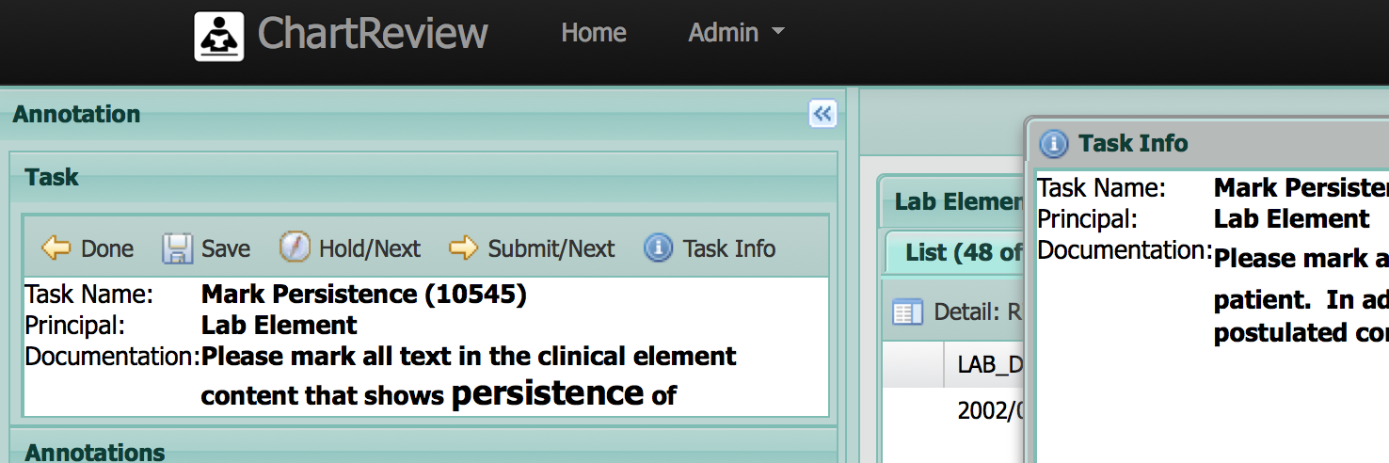

Table : Chart Review – Task Panel and Toolbar

|  |  |
| --- | --- |
| Item/Action | Description/Result |
| Task Name and Task Id | The name of the task and the task id (in parenthesis).  Macintosh HD:Users:bradadams:Desktop:Info.pngNote The task id may help in referencing the task in reports and when choosing the task again from the Chart Review Home page’s Your Recent Work list. |
| Principal | The type of the principal clinical element upon which the task is being performed. |
| Documentation | A somewhat brief description of the task to be performed.  Macintosh HD:Users:bradadams:Desktop:Info.pngNote: The Task panel is scrollable, allowing the user to view a longer description. |
| Done | Prompts for save, if needed, and exits Chart Review. |
| Save | Save annotations, but keeps the current task open. |
| Hold/Next | Save annotations and submit the task as being on-hold until later. Get the next task assignment. |
| Submit/Next | Save annotations and submit the task as completed. Get the next task assignment. |
| Task Info | View the detailed task information. A poup-up window is displayed with task information in it. Press close to close the task information window.  Macintosh HD:Users:bradadams:Desktop:Info.pngNote: If a pdf document, for example, is included in the process task definition as documentation for the task, a separate tab will be opened in the browser to display that document. |

## Annotation Schema

The annotation schema associated with the given task is displayed in a collapsible tree in the Annotations schema panel. All classifications available in that schema are displayed and may be selected. To annotate a clinical element text, first select the desired classification and then highlight the text. To annotate a whole clinical element, first select the desired classification and then press the Classify button on the selected clinical element.

Figure . Chart Review – Annotation Schema

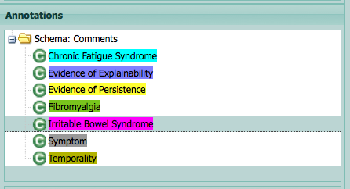

Table : Chart Review – Annotation Schema

|  |  |
| --- | --- |
| Item/Action | Description/Result |
| Select Classification | The currently selected classification will be used in creating annotations on clinical element text and on whole clinical elements.  Macintosh HD:Users:bradadams:Desktop:Warning.pngNote: If you try to highlight before picking a classification from the annotation schema, an error message is displayed. |

## Annotation of Clinical Element Text

Clinical element text may be annotated by selecting an annotation schema classification in the Schema panel and then highlighting the text with a swipe. Annotation spans may overlap in all combinations of ways. Annotation span colors are blended to show overlaps. An annotation appears in the annotation list for every highlight swipe made in the text. Features for that annotation are displayed and able to be edited in the Annotation Editor panel at the lower left of the screen.

Figure . Chart Review – Annotation of Clinical Element Text

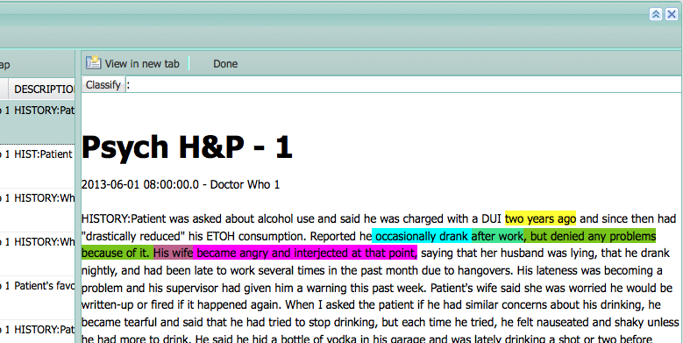

Table : Chart Review – Annotation of Clinical Element Text

|  |  |
| --- | --- |
| Item/Action | Description/Result |
| Highlight | Creates an annotation which is displayed in the list on the left.  Macintosh HD:Users:bradadams:Desktop:Info.pngNote: When you create an annotation by highlighting the text, an annotation will be created in the annotation list and annotation features that need to be filled in will be displayed in the Annotation Editor panel at the bottom left of the screen. |
| Select Annotation from Text | When you click on an annotation span in the text, the corresponding annotation item will be selected in the Annotation List to the left.  Macintosh HD:Users:bradadams:Desktop:Info.pngNote: A selected annotation is show with black under and over lining in the text. |
| Select Annotation from List | When you select an annotation in the Annotation List on the left, the clinical element to which the annotation belongs will be opened and the annotation will be scrolled into view and shown as selected.  Macintosh HD:Users:bradadams:Desktop:Info.pngNote: A selected annotation is show with black under and over lining in the text. |

## Annotation of Whole Context Clinical Element (i.e. Note, Lab)

A whole clinical element may be annotated by selecting a classification in the Schema panel and pressing the Classify button found in the detail area of the clinical element view. A clinical element may have multiple classifications. Each classification is displayed to the right of the Classify button.

Figure . Chart Review – Annotation of Whole Clinical Element

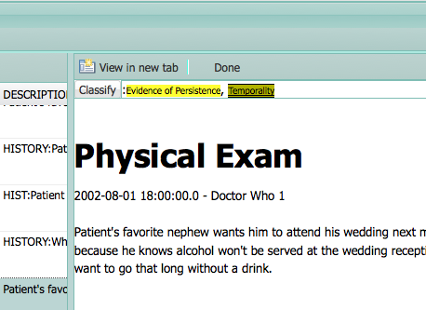

Table : Chart Review – Annotation of Clinical Element Text

|  |  |
| --- | --- |
| Item/Action | Description/Result |
| Classify | Creates an annotation for the whole clinical element record which is displayed in the list on the left.  Macintosh HD:Users:bradadams:Desktop:Info.pngNote: When you create an annotation by pressing the Classify button, an annotation will be created in the annotation list and annotation features that need to be filled in will be displayed in the Annotation Editor panel at the bottom left of the screen. |
| Select Annotation from Classify panel | When you click on an annotation classification label in the are next to the Classify button, the corresponding annotation item will be selected in the Annotation List to the left.  Macintosh HD:Users:bradadams:Desktop:Info.pngNote: A selected annotation is show with black under and over lining in the text. |
| Select Annotation from List | When you select an annotation for a whole clinical element in the Annotation List on the left, the clinical element to which the annotation belongs will be opened and the annotation will be shown as selected.  Macintosh HD:Users:bradadams:Desktop:Info.pngNote: A selected annotation is show with black under and over lining in the text. |

## Annotation of Principal Clinical Element (i.e. Patient)

The principal clinical element of a task may be displayed (or not) in a view just like the context clinical elements. It is commonly displayed with a Summary tab rather than with the default grid/detail display because the principal clinical element is only one element (i.e. patient), not a list of elements like may of the context clinical elements. It is annotated in the same way as any other clinical element displayed.

Figure . Chart Review – Annotation of Principal Clinical Element

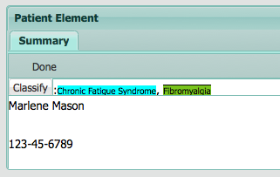

## The Annotation List

All annotations associated with a given task whether they be on the principal clinical element itself or any of the context clinical elements, are displayed in a grid in the Annotation panel. This grid may be grouped, sorted, filtered, and deleted. Selecting annotations in this list will open the corresponding clinical element view (if not already open) and will auto-scroll to the selected annotation. As annotations are created they appear in the list and their features are displayed in the Annotation Editor panel below the list. The grid may be sorted, grouped and filtered by accessing a dropdown menu on the right of the column header.

Figure . Chart Review – Annotation List

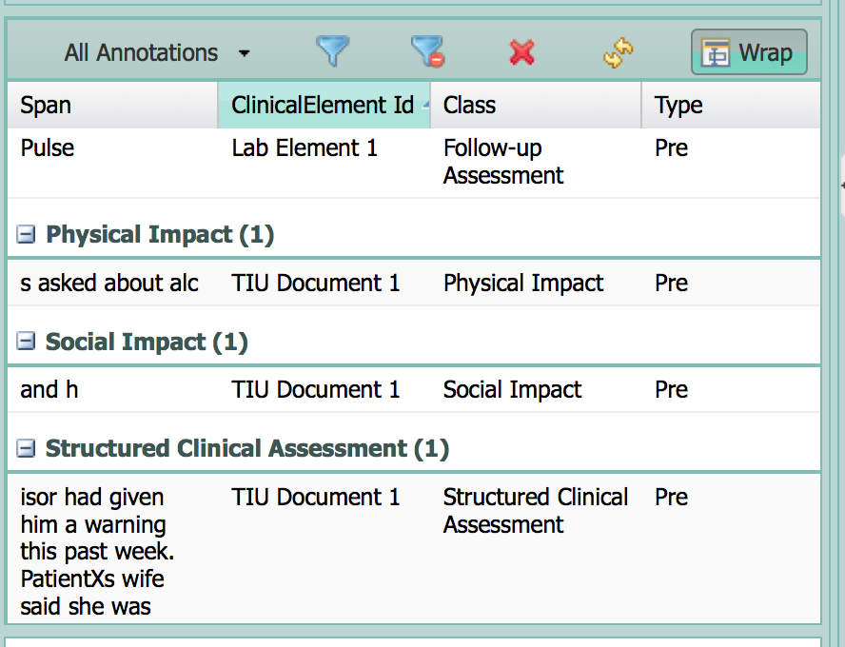

Table : Chart Review – Annotation List

|  |  |
| --- | --- |
| Item/Action | Description/Result |
| All Annotations / Selected Document Annotations | Toggles between showing all annotations belonging to the task (and all of its clinical element documents) and showing only those annotations belonging to the currently selected clinical element document in the views to the right. |
| Show Column Filters | Shows the current column filters in a popup message. |
| Clear Column Filters | Clears all column filters. |
| Delete Selected Annotations | Deletes all currently selected annotations.  Macintosh HD:Users:bradadams:Desktop:Info.png Macintosh HD:Users:bradadams:Desktop:Warning.pngUnless one of the save buttons is pressed, an unintended delete will not be saved to the database. So an unintended delete may be undone by exiting going back to the Chart Review Home page without saving – but, this will not save any other changes as well. |
| Refresh | Refreshes the annotation grid.  Macintosh HD:Users:bradadams:Desktop:Info.pngThe annotation grid may be refreshed to display edits that have been made in the Annotation Editor. |
| Wrap | Toggles wrapping of text in the grid cells. If wrapping is off, the text in a cell is truncated. If wrapping is on, cell text is wrapped and the row height is increased. |

## Editing Annotation Attributes

Annotations have attributes features that may be edited when an annotation is created or modified at a later time. The attributes are displayed in the Annotation Editor panel immediately when an annotation is created or selected. After editing the attributes, you may need to refresh the Annotation list.

Figure . Chart Review – Editing Annotation Attributes

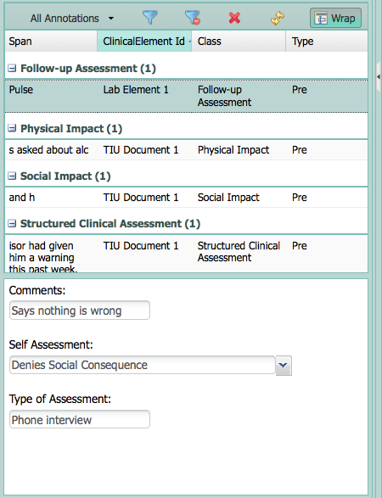

Table : Chart Review – Editing Annotation Attributes

|  |  |
| --- | --- |
| Item/Action | Description/Result |
| Text | Text attributes may be edited by entering text in a simple text field. |
| Numeric | Numeric attributes may be edited by entering a valid number in a simple text field. If the number is out of range, an indication of the invalid state of the field will be indicated with a red border and a popup stating what is invalid. |
| Date | Date attributes may be edited by entering a valid date in a simple text field or by picking a date from a date picker. If the date is out of range, an indication of the invalid state of the field will be indicated with a red border and a popup stating what is invalid. |
| Option | Option attributes may be edited by choosing an option from the dropdown menu. |

Index

3

3rd Party Loggers, 72

A

About, 69

About – API Docs, 70

Account Non Expired, 65, 66, 68

Account Non Expired Column, 65

Account Non Locked, 66, 67, 68

Account Non Locked Column, 65

Active, 9, 10

Active link, 9

Add, 29

Add Attributes, 60

Add Process, 27

Add Process – Step 1 – Choose the Process to Add, 30

Add Process – Step 2 – Process Parameters, 31

Add Process – Step 3 – Users and Clinical Elements In This Process, 34

Add View, 89

Admin Tools, 63

All Annotations, 104

All Annotations / Selected Document Annotations, 104

All Elements By Patient Id Query, 11, 13, 17

Annotation, 101, 103

Annotation Attributes, 105, 106

Annotation Group, 33

Annotation List, 103, 104

Annotation of Clinical Element Text, 99

Annotation of Principal Clinical Element, 102

Annotation of Whole Clinical Element, 101

Annotation of Whole Context Clinical Element, 101

Annotation Panel, 91

Annotation Schema, 98, 99

Annotation Type, 39

Annotation Workflow, 97

Annotations Per Annotator Detail, 38

Annotations Per Annotator Detail – Clinical Element, 40

API Docs, 64, 70

Application Status, 69

Architecture, 1

Assignment Style, 35

Associated Project Document For This Task, 34

Assumptions, xiii

Attribute – Create/Edit, 53

Attribute – Create/Edit - Date, 55

Attribute – Create/Edit - Numeric, 54

Attribute – Create/Edit - Option, 56

Attribute – Create/Edit - Option - Create/Edit Option, 57

Attributes, 52, 60

Authorities, 67

Auto-Select, 80

Auto-select Toggle, 91

Available Attributes, 60

Available Controllers, 70

B

Back to reports, 37, 39, 40, 41, 42, 43, 45, 46, 47, 48

Browse, 10, 11, 50, 63

C

Change, 37, 40, 41, 42, 43, 46, 48

Chart Review, i, 75

ChartReview, 4

Choose the Process to Add, 30

Chose Project and Processes For Reports, 36

Classification, 99

Classification – Create/Edit – Attributes, 60

Classification – Create/Edit – General Configuration, 59

Classifications, 58

Classify, 101

Classify panel, 102

Clear Column Filters, 104

Clinical Element, 33, 39

Clinical Element Configurations, 4

Clinical Element Content, 40

Clinical Element Group, 32

Clinical Element Text, 99, 100

Clinical Elements, 32

Closable Annotation Panel, 91, 92

Collapse Annotation Panel, 92

Collapse/Expand View, 87

Collapsible Views, 87

Color, 59

Color Label, 59

Colum, 83

Column, 84

Column Filters, 104

Column Name, 14, 18

Column Order and Size, 86

Column Order/Size, 86

comparison, 90

concordence, 47, 49

Connection String, 16

Content Template, 15, 20, 21

Content Template Toggle, 19

Context Clinical Element, 101

Controller Loggers, 71

Controllers, 70

Conventions

Documentation, xiii

Copy, 27

Copy To Project, 10

Covered Text, 39, 40

Create Class Attribute, 52, 61

Create Classification, 58

Create Clinical Element Configuration – Step 1 –Define Test Connection and Queries, 16

Create Clinical Element Configuration – Step 2 – Data Set Column Definition & Other Metadata, 18

Create Clinical Element Configuration – Step 3 – Preview Output, 20

Create Clinical Element Configuration – Step 4 – Name and Description, 21

Create Option, 57

Create Schema, 50

Create Siman Tables, 24

Create Tasks and Finish, 35

Create/Edit, 53

Create/Edit – Attributes, 60

Create/Edit - Date, 55

Create/Edit – General Configuration, 59

Create/Edit - Numeric, 54

Create/Edit - Option, 56

Create/Edit - Option - Create/Edit Option, 57

Created By, 11, 13

Created Date, 11, 12, 13

Credentials Non Expired, 66, 67, 68

Credentials Non Expired Column, 66

D

Data Set Column Definition & Other Metadata, 18

Database Connection, 28

Database Connection URL, 23

Date, 55

Define Test Connection and Queries, 16

Delete all running Actviti Process Instances – Do Delete, 63

Delete Attribute, 53, 54, 55, 56

Delete Classification, 59, 61

Delete Option, 57

Delete Project, 24

Delete Schema, 51, 53, 58, 59

Delete Selected Annotations, 104

Delete View, 88

Description, 25

Description Field, 11, 13, 19

Description Hiding, 96, 97

Description link, 9

Detail Bottom, 82

Detail Hide, 82

Detail Right, 82

Disclaimers, xii

Display Name, 14, 18

Do Delete, 63

Documentation

Conventions, xiii

Symbols, xiii

Documentation Conventions, xiii

Documents, 25

Domain Class Loggers, 71

Done, 51, 53, 54, 55, 56, 57, 59, 94

Drag Column Order/Size, 86

Drag View Top/Bottom, 81

Drop Siman Tables, 24

Dropdown on Right of Colum, 83, 84

E

Edit, 67

Edit – General Configuration, 28

Edit - Project Users, 29

Edit User, 67

Editing Annotation Attributes, 105

Enabled, 68

Enabled Column, 66

Example Patient Id, 17

Exclude, 14

Export, 10

Export to CSV, 39, 41, 42, 43, 45, 46

F

Failed Jobs, 5, 61

Figures, v

Find User, 29

Fleiss’ kappa, 47, 48

G

General Configuration, 10, 23, 28, 51, 59

General Configuration – Edit, 12

General Setup, 6

Get Next Assignment, 77

Grails Loggers, 72

Group, 84, 85

Grouping, 84

H

Hold/Next, 98

Home Page, 3, 4

How Many Annotations By Annotator And Type, 37, 42

How Many Annotations By Type, 37, 41

How to

Use this Manual, xii

How to Use this Manual, xii

I

ID, 62, 63

Include/exclude all clinical elements, 32, 33

Initiating a Chart Review, 76, 77

Inquire

Inquire to File Entries Option, 61, 62, 65

Installed Plugins, 69

Integration, 2

Intended Audience, xii

Inter-Annotator Agreement, 38

Inter-Annotator Agreement – Original Report, 47

J

Jdbc Driver, 16, 24, 28

JDBC Password, 24, 28

JDBC Username, 24, 28

Jdbc Username/Password, 17

K

k, 47, 48

Key Field, 14, 19

L

Layout Options, 78

Left column values, 47, 49

Legal Requirements, xii

List Grouping, 84

List item name, 9

List Sorting, 84

Log, 71

Log Level, 5, 71

Loggers, 71

Logout, 6

M

Main Toolbar, 4

Marking Records As Done, 94

Max Date, 55

Min Date, 55

More…, 37, 39, 40, 41, 42, 43, 45, 46, 47, 48

Multiple Instances of the Same View, 90

Multiple Instances of the Same View (Comparison), 90

N

Name, 9, 25, 26, 51, 53

Name and Description, 21

Name Column, 50

Name link, 9, 50

New Clinical Element Configuration, 8

New Report, 48

Next, 17, 30

Numeric, 54

Numeric High, 54

Numeric Low, 54

O

Online Demo, xiii, 1

Option, 56, 57

Option - Create/Edit Option, 57

Optional Column Inclusion, 82, 83

Optional Text Wrapping, 94

Options

Inquire to File Entries, 61, 62, 65

Orientation, xi, xii

Original Report, 47

P

Patient Count, 44

Patient Id, 45, 46

Patients Per Annotator and Process, 37, 43

Patients Per Annotator and Process Detail, 38, 44

Patients Reviewed by More Than One Annotator, 38

Patients Reviewed More Than Once, 46

Performance Monitoring, 5, 6, 72

Plugins, 69

Position, 33

Preview Output, 20

Previous, 35

Previous…123…Next, 50

Previous…Page Numbers…Next, 40, 42, 43, 44, 45, 47

Principal Clinical Element, 102

Process, 77

Process List, 62

Process Name, 32

Process Parameters, 31

Process Steps, 32

Process Templates, 62

Processes, 5

Project – Add Process – Step 1 – Choose the Process to Add, 30

Project – Add Process – Step 2 – Process Parameters, 31

Project – Add Process – Step 3 – Users and Clinical Elements In This Process, 34

Project – Edit – General Configuration, 28

Project – Edit - Project Users, 29

Project – Run SQL Query, 35

Project - Show – Documents, 25

Project – Show – General Configuration, 23, 27

Project - Show – Processes, 27

Project - Show – Project Users, 26

Project Clinical Element Configurations, 8, 9

Project List, 22

Project Name, 23, 28

Project Users, 26, 29

Projects, 5

Q

Quick-Start, 76

R

References, xiii

Refresh, 105

Report – Annotations Per Annotator Detail, 38

Report – Annotations Per Annotator Detail – Clinical Element, 40

Report – How Many Annotations By Annotator And Type, 42

Report – How Many Annotations By Type, 41

Report – Inter-Annotator Agreement – New Report, 48

Report – Inter-Annotator Agreement – Original Report, 47

Report – Patients Per Annotator and Process, 43

Report – Patients Per Annotator And Process DETAIL, 44

Report – Patients Reviewed More Than Once, 46

Reports, 36, 37

Requirements

Legal, xii

Rest API Docs, 70

Reviewed Count, 46

Run SQL Query, 24, 35

Running/Historic, 27

S

Same View, 90

Schema, 99

Schema – Attribute – Create/Edit, 53

Schema – Attribute – Create/Edit - Date, 55

Schema – Attribute – Create/Edit - Numeric, 54

Schema – Attribute – Create/Edit - Option, 56

Schema – Attribute – Create/Edit - Option - Create/Edit Option, 57

Schema – Attributes, 52

Schema – Classification – Create/Edit – Attributes, 60

Schema – Classification – Create/Edit – General Configuration, 59

Schema – Classifications, 58

Schema – General Configuration, 51

Schema List, 49

Schemas, 49

Search, 39, 41, 42, 43, 44, 45, 46

Select Annotation from Classify panel, 102

Select Annotation from List, 100, 102

Select Annotation from Text, 100

Select Classification, 99

Select process, 30

Selected Document Annotations, 104

Service Loggers, 71

Setting up your Browser for Chart Review, 6

Show – Documents, 25

Show – General Configuration, 23

Show – Processes, 27

Show – Project Users, 26

Show Clinical Element Configuration – Columns, 14

Show Clinical Element Configuration – Content Template, 15

Show Clinical Element Configuration – General Configuration, 10

Show Clinical Element Configuration – General Configuration – Edit, 12

Show Column Filters, 104

Show Completed Processes, 77

Show N entries, 39, 41, 42, 44, 45, 46

Show User, 66

Showing x to y of N entries, 40, 41, 43, 44, 45, 47

Siman Tables Do Not Exist, 24

Siman Tables Exist, 24

Single Column Mode, 79

Single Element Query, 11, 13, 17

Single Sign On (SSO) Setup, 6

Sort, 84

Sorting, 84

Start Over, 21, 22

Submit Query, 50

Submit/Next, 98

Switch User, 6, 7

Symbols

Found in the Documentation, xiii

T

Table of Contents, iii

Tables, viii

Task, 39

Task Creation Query, 35

Task Documentation, 33

Task Id, 45, 78

Task Id link, 78

Task Info, 98

Task Name, 33

Task Name and Task Id, 97, 98

Task Panel, 97

Task Panel and Toolbar, 97

Task Pre-Annotation Group, 33

Task Principal Clinical Element, 33

Text, 107

Text Wrapping, 94, 95

Title Field, 11, 13, 19

Toolbar, 4, 97

Tools and Utilities, 5, 63

Tools and Utilities – API Docs, 64

Top row values, 48, 49

Two Column Mode, 78, 79

Two Column Mode Toggle, 80

Two instances, 90

Type Name, 14, 18

U

Update, 14

Update Annotation Text, 24

Upload Document, 25

Upload New Clinical Element Configuration, 10

Upload New Schema, 50

Upload Process Template, 63

User List link, 66, 68

Username, 29, 65

Username Column, 65

Username link, 65

Users, 5, 65

Users and Clinical Elements In This Process, 34

V

Variable Column Order and Size, 86

Variable Height Views, 80, 81

View Detail Docking/Hiding Options, 81, 82

View In New Tab, 92, 93

View Rest API Docs, 64, 70

W

What is Chart Review?, xi

Whole Context Clinical Element, 101

Workflow, 97

Workflow Support, 92

Wrapping, 95

Y

Your Recent Work, 78